Colton Hills Community School medium term planning
Topic title:  ‘Flora and Fauna’  OCR Art GCSE | Year: 11  Term: Autumn |  | Why we teach this:  For students to produce creative work, exploring their ideas and recording their experiences inspired by the jungle. | Why we teach this here:  Students work through the art and design process, consolidating prior learning and selecting materials, processes, and techniques appropriate to their choice of theme and skills set.
Big questions:  What are the requirements for GCSE Art and Design?  What does flora and fauna mean?  How has nature inspired artists/designers/craftspeople?  How can I show an artist’s influence in my own work?  What makes a good observation drawing?  What am I good at and where/how can I improve my skills further?  How can I present my work effectively?  How should I combine images from nature with my own portrait?  How do you create an effective outcome using Photoshop? |  |  | Builds on previous topics:  The design process – analyse, create, review, develop, realise intentions. | Links to future topics:  Consolidate and improve skills in the formal elements of art, address the 4 GCSE assessment objectives in controlled assessment unit.
Key knowledge:

• To know and understand the GCSE assessment objectives.
• A range of different drawing styles, materials and techniques.
• To be able to analyse the work of artists, designers and craftspeople.
• To be able to present work effectively.
• To be able to create an effective outcome using Photoshop.
• To show an understanding of the work of a range of artists who were inspired by flora and fauna.
• To learn how to develop original ideas influenced by research material and observation studies.
• To review, modify and adapt designs to create effective 2D outcomes.
• To learn how to create a personal and meaningful outcome.
• To evaluate work and progress in order to improve further and inform future work.

Skills developed:

We give the opportunity for students to analyse the work of artists, designers and craftspeople and create personal and meaningful practical outcomes in a range of media. Students will conduct research in order to develop their ideas and realise intentions. Students will be taught to be analytical, questioning, and independent learners reviewing and refining their work to produce effective outcomes.

AO1 - Develop your ideas through investigations informed by contextual and other sources, demonstrating analytical and cultural understanding. |  | AO2 - Refine your ideas through experimenting and selecting appropriate resources, media, materials, techniques and processes. | Independent study tasks/resources:  - Mlle Hipolyte  - Irene Guerriero  - Mark Powell  - Wayhu Romdhini  - Angie Lewin  - Claudine O’Sullivan  - Lara Meissirel  - Abby Diamond  - Helen Wells  - Daniel Mackie  - Zinia King  - Hiroki Takeda | Key vocabulary:  Jungle  Ceramics  Tropical  Observation  Experimental  3D  Colour  Animals  Record  Pattern  Markmaking  Nature  Portrait  Weather  Printmaking  Analyse  Design  Organic  Develop  Evaluate
AO3 - Record ideas, observations and insights relevant to your intentions in visual and/or other forms. |  | AO4 - Present a personal, informed and meaningful response demonstrating analytical and critical understanding, realising intentions and making connections between visual or other elements.
Cultural capital opportunities:  - Students to research meaning and purpose of artists work and consider their influences, including symbolism/tradition.  - Working with Laura Beech (freelance designer) to develop ideas in Photoshop.  - Visit to Dudley Zoo. |  |  | Whole school Curricular Concept links:  - Precious Planet  - Artistic Creativity

Learning objectives | Tasks
(End of year 10)  Weeks 1-3  - To understand the requirements of the course and GCSE assessment objectives.  - To develop an understanding of layout when presenting research and work.  - To learn how to create visually interesting pages in your sketchbook. | 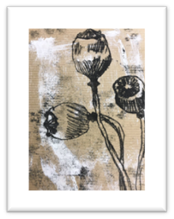  - Intro to new topic ‘Flora and Fauna’  - Students to create multiple monoprints on a range of different backgrounds using flora and fauna imagery to inform their project. | - Small questions  What is monoprinting? What is polystyrene press print? What is the main difference between both techniques?
- Retrieval focus
Printmaking
Polystyrene press print process
- Independent study
Complete any unfinished work
Summer
(Start of year 11)  Weeks 4-6  - To be able to present research material effectively and show a range of skills and knowledge to meet the assessment objectives.  - To be able to create visually interesting pages and demonstrating your understanding of the artists' work. | - Complete 1 A2 or 2 A3 artist research page on their chosen artists.  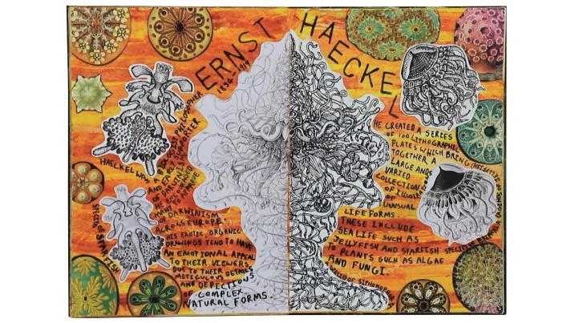 | - Small questions  - Who are your chosen artists? How do you present research material effectively?
- Retrieval focus
Research and presentation skills
- Independent study
Complete any unfinished work
Week 7 | - Present photographs and drawings from Dudley Zoo.  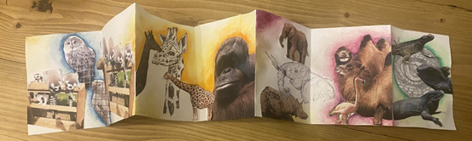 | - Small questions  How do you plan on presenting your photographs and drawings?
- Retrieval focus
Presentation skills
- Independent study
Complete any unfinished work
Weeks 8-10  - To learn how to create initial composition ideas influenced by your chosen artists.  - To learn how to analyse the style of artists work through in order to create a range of different of ideas. | - Design 3-4 different ideas inspired by their chosen artists.  - Add colour using preferred media in the style of chosen artists. | - Small questions  How are you going to take inspiration from your chosen artist?
- Retrieval focus
The design process
- Independent study
Complete any unfinished initial ideas in colour including annotation

Weeks 11-12  - To learn how to develop and refine ideas, selecting artists influence, media and techniques.  - To learn how to develop and refine ideas, selecting artists influence, media and techniques.  - To learn how to finalise ideas by making informed decisions about scale, colour and materials. | 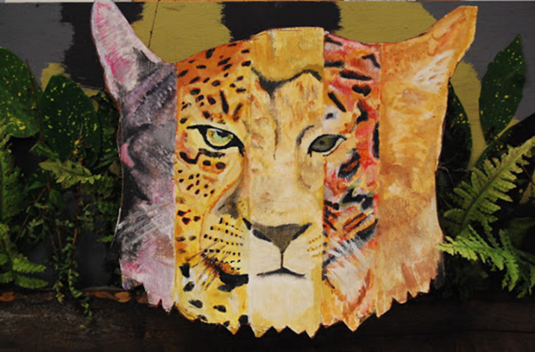  - Develop ideas by modifying shape, detail, and colour scheme in the style of their chosen artist. | - Small questions  Which are your preferred ideas? How do you plan to do develop them further?
- Retrieval focus
Reviewing and refining ideas and technical skills with media
- Independent study
Complete any unfinished development ideas in colour including annotation
Weeks 13  - To learn how develop ideas further to be able to realise final intentions.  - To learn how to finalise ideas by making informed decisions about scale, colour and materials. | - Sthd  - Students to create a final piece plan on their preferred development idea. Students can modify and make any changes in order to realise final intentions. | - Small questions  How are you going realise your final intentions? What do you want your final piece to look like?
- Retrieval focus
The design process
- Independent study
Complete any unfinished work
Weeks 14-17  - To learn how to finalise ideas by making informed decisions about scale, colour and materials.  - To consolidate how to present research material effectively and show a range of skills and knowledge to meet the assessment objectives.  - To be able to respond to teacher feedback to gain more marks to meet assessment objectives. | 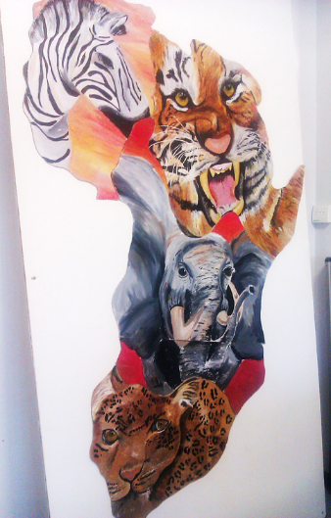  C  - Students to create a final piece to realise intentions and make informed decisions about scale, colour and materials.  - Complete any unfinished work to gain more marks to meet assessment objectives. | - Small questions  What changes are you going to make to your final piece?
- Retrieval focus
The design process
- Independent study
Complete any unfinished work

