BTEC DIT
Component 3 Effective Digital practices

Learning Aim A1: Modern Technologies
Knowledge and Assessment Organiser
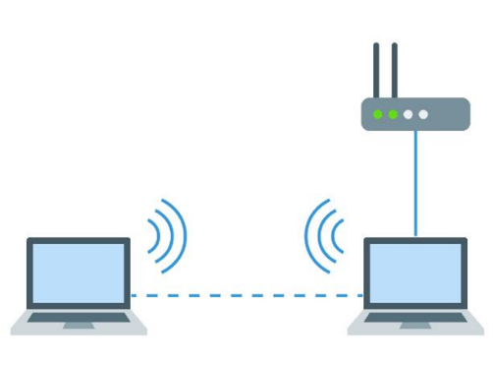
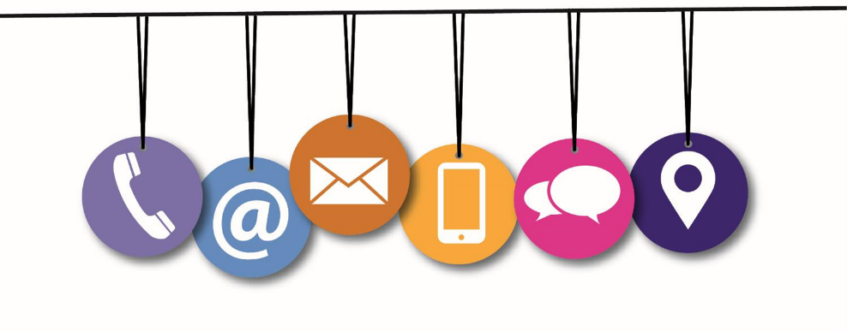

Student name: ………………………………….
How and why modern technologies are used by organisations?

Contents

Exam question command words and examples | 3
Key vocabulary | 6
Big Question and Small Question breakdown | 8
What is an Ad Hoc Network?  Advantages/Disadvantages of ad hoc network  Performance issue  Security Issues  Issue affecting network availability | 9
Cloud Storage and Cloud Computing  Selection of cloud technologies | 15
Using traditional and cloud together | 20
Implications for organisations when choosing cloud technologies | 22
Exam Questions | 24
Articles for wider reading and flipped learning | 25

Exam question command words and examples
Give/ State/ Name
Recall something that you know. These are short answers with 1 mark for each point | Give three types of malware (3) | Virus (1), Trojan (1), Spyware (1)

Identify
Select some key information from something you are given | Mia uses her home computer to go on the internet.  Identify one item of network equipment that Mia uses (1) | A router (1)

Explain
An explain question needs two parts.  First give an example and then give a reason why this example answers the question.  Make sure to use words like ‘because’ or ‘so in this type of question. | Cecilia is concerned about her customers’ personal data being stolen from her laptop.  Explain one security feature Cecilia should use to protect her data. (2) | She should encrypt the hard drive (1) so that is the computer is stolen, the thief won’t be able to understand the data on it (1)

Describe
Give an account of something.  This will often be the steps in a process | Milo wishes to start his own online shop. He needs to collect personal customer data.  Describe the actions he must take before collecting personal data (3) | Register with the information commissioners officer (1)  Make sure his customer database is secure (1)  Create a privacy policy for the website (1)

Annotate the diagram
Label the diagram and add an explanation for each label | 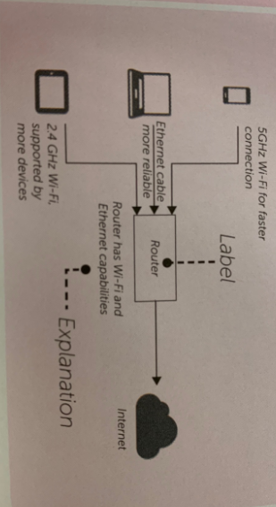  Janice has a laptop, tablet and smartphone.  Label the diagram to show how these can all connect to the same internet connection.

Assess
- Write down all the factors or events that apply.  - Identify those that are most important.  - Assess the importance of the factors.  - Give a conclusion.  You should use full paragraphs in your answers.  A full answer will usually be around a page of text. | A company want staff to use their smartphones to monitor their social media.  Assess the impact of smartphone use for monitoring social media accounts.  You must provide a conclusion as to whether you think that providing smartphones for this use is a good idea (8) | Monitoring social media account on a smartphone will encourage staff to work whilst at homes as the devices will constantly be giving notifications for new posts. This is a serious problem as it will affect their work life balance.  The company could mitigate the work life balance problem by explaining to staff when they should and shouldn’t be monitoring the accounts.  In conclusion, this is only a good idea if the company makes it clear when they should be used. Even then, they should make sure that staff agrees to the request before implement it.

Discuss
Identify the problem or issue in the question.  Explore the relevant points that relate to the problem or issue with logical thoughts or arguments.  You should use full paragraphs in your answers.  A full answer will usually be around a page of text. | Virtual PA provide laptops and headsets to all their remote workers.  Discuss how remote workers can help protect the environment (6) | They could change the power settings so that the display turns to suspend mode if the computer hasn’t been used for 10 minutes.  The hard disk platter could be made to stop spinning.  As remote workers’ pay for their own electricity they would have the incentive of lower energy bills and the result would be a reduced impact on the environment.

Draw
Draw a process using a data flow diagram, information flow diagram or flowchart.  The drawing should be annotate. | A health app has a number of steps a user walks as an input. It then calculates the number of mile walked and outputs it.  Draw a flowchart of this process. | 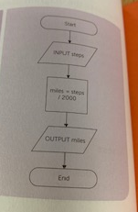

Evaluate
Give a logical evaluation that considers different and competing points.  Include strength, weaknesses, relevant data or information.  Give a conclusion that is supported by the evaluation.  You should use full paragraphs in your answers.  A full answer will usually be around a page of text. | SmartGym want all their personal trainers to have a computer device. The options are a smartphone, tablet or laptop.  Evaluate the advantages and disadvantages of the different devices, stating which would be best for their personal trainers to use. | A smartphone is small and portable meaning that it can be used when monitoring people as they train. It makes use modern wireless Wi-Fi standards which enable it be connected to a network via an access point.  Smartphones have small screens, which make it’s hard to show results or video to their clients.  In conclusion tablet would be the best device as it offers portability and screen size that can display more content.
Did you know…?
Over 3.8 billion people use the internet today, which is 40% of the world’s population.
8 billion devices will be connected to the internet by 2020.
Key Vocabulary
Bluetooth ​ | A short range technology (10 metres or less) that can connect multiple devices. e.g. mobile phones & speakers
Ad hoc Network | A wireless network that does not rely on fixed hardware such as routers in wired networks. ​
Personal Area Network | Used for data communication between devices.​
Tethering | Where a smartphone acts as an access point, allowing other devices to connect to it to share its mobile broadband connection to the internet.​
Personal hotspot | Using a phone’s internet connectivity to access the internet from the laptop.​
PIN | Acronym meeting Personal Identification Number​
Encrypted | Information or data has been converted to a type of code that cannot be understood without a translation key.​
USB | Universal Serial Bus.  A standard for connection sockets on computers, connecting devices such as mice, keyboards, printers, external hard drives, etc.​
Insecure | A connection where data maybe intercepted by other users.
Streaming | Data is sent to your device in a continuous flow when connected to the internet.

Server | A computer that delivers data between machines that are connected to a local network.​
Downloading | A file or document can be used when you are not connected to the internet. ​
Uploading | A file or documents can be used by you or other with access when connected to the internet. ​
Synchronising | Is when files held on two devices are updated to make sure that both have the same content.

Stakeholders | These are people with a financial interest or investment In a business or organisation
Downtime | A period of time when a computer and its services are unavailable.
Geo-data | Geographical information stored in a way it can be used by your device. i.e. Your location.
Synchronisation | Process of making two or more data storage devices or programs (in the same or different computers) having exactly the same information at a given time.
Virtual Machines | Software applications that are designed to behave as if they are a whole computer.
System administrator | A person who is responsible for a technology to make sure they are maintained and reliable.
Spam | Electronic junk mail, usually sent with a commercial purpose.

What is my big question?
`
How and why modern technologies are used by organisations?
How can performance be restricted?
What are the security threats to an ad hoc network?
What is an ad hoc network?
What is cloud computing and cloud storage?
How can traditional systems work alongside modern systems?
What is an Ad Hoc Network?
Ad hoc networks are temporary networks with two or more computing devices. It does not rely on fixed hardware such as routers in wired networks.
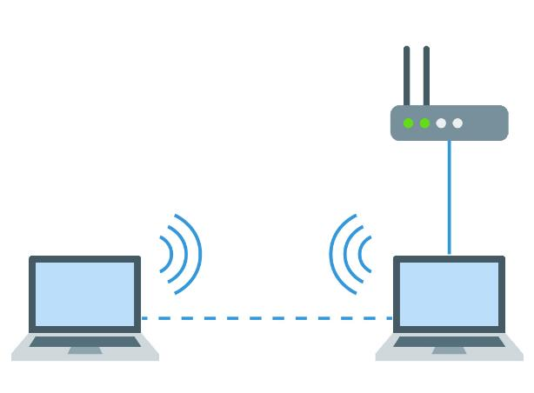
An ad hoc network could be used between two laptops to connect them together so they can share:
- Files
- Internet access
Different ad hoc networks include, WIFI, Personal Area Networks, Hotspots, Bluetooth.

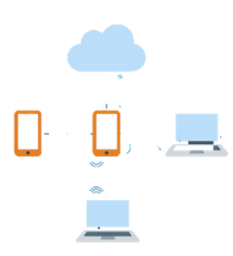
Personal Area Network (PAN)
Personal Area Networks (PANs) connect computers or devices together using Bluetooth or Wi-Fi. These networks have a range of few meters. Additionally they also require pairing.
Tethering/Personal Hotspot
This created using mobile device such as a smartphone. The device will connect to the data network using cellular phone networks such as 4G or 5G connection.

Open Wi-FI
Open WFi is a wi-fi hotspot that that doesn’t require a password to access. This means that they don’t have encryption and so data sent over them is insecure. We commonly find these in places like restaurants, cafés and hotels.
As these open wi-fi networks can be connected to without a password and don’t use encryption on the data transmitted over the network you must be aware that anybody within signal range can connect to the network also and could steal your data.

Advantages / disadvantages of Ad Hoc Network

Advantages | Disadvantages
- Easy to set up  - No specialist hardware required such as routers | - Less secure  - No central device has control which can make them unmanageable
Performance issues
Exam Question:
Jamil is a journalist reporting from a remote location with no Internet connection. He is required to send his report to Head Office from his laptop. He has a smartphone with a good signal.
Explain how Jamil could send the report electronically. (2)
……………………………………………………………………………………………………………………………………………………………………
…………………………………………………………………………………………………………………………………………………………………..
………………………………………………………………………………………………………………………………………………………………..…
…………………………………………………………………………………………………………………………………………………………………..
………………………………………………………………………………………………………………………………………………………………..…
PG Online

Ad hoc networks are normally less reliable than traditional ones
- Maximum Speed – ad-hoc networks cannot transfer data as fast as networks in infrastructure mode as they have a smaller maximum data transfer speed.
- Maximum Range – wireless routers have higher powered antennas and so can provide much greater ranges than wireless connections directly between devices. Other methods of ad-hoc networks like Bluetooth and USB cables have very short ranges too. Further, when in ad-hoc mode, operating systems usually hide the signal strength indicator.
- Interference – ad-hoc networks produce a lot more interference when many devices are connecting as each has its own connection with devices often moving around and crossing signals. This can reduce range, lead to dropped connections and reduce speed

Security issues

Open networks are typically less secure than private networks. All data on an unsecured network is sent unencrypted. This means that anyone who intercepts data that is sent across the network can read and understand it. This includes passwords and credit card numbers for example.
WPA encryption (Wi-Fi Protected Access) should be used with Wi-Fi networks to prevent any data form being understood if it is intercepted.
(WPA2 is an updated version of encryption for WAP.)
(WEP is for Wired Equivalent Privacy)

Issues affecting network availability

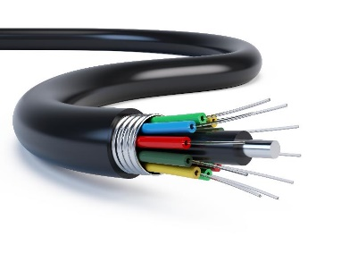
Available infrastructure
For communication technologies, the most important infrastructure today is the method of connecting to the Internet
The following methods can be used:
  - Cables (copper or fibre)
  - Mobile
  - Satellite
Internet connections
Most UK homes and businesses connect to the Internet using a copper cable
Fibre connections often only provide fibre to the green cabinet in the street. This is known as Fibre To The Cabinet (FTTC). Speeds are typically up to a maximum of 80 Mbps.
Some businesses and homes have fibre to the premises .Speeds are up to 300 Mbps or more

Mobile
Some locations will not have cell phone towers located within a close enough distance to provide access to a 4G connection. You may not have a mobile broadband connection at all.
Generally speaking 4G broadband covers around 90% of the UK landmass, but this can vary a bit depending on the provider.

Blackspots
The country is divided into areas called cells which each have a mobile phone transmitter. If no transmitter is present in the cell then there will be no signal. This is called a blackspot
Hills and buildings can also block signals and create blackspots.

Rural vs city locations
City locations normally have faster internet than rural ones.
The cost of installing infrastructure such as fibre cables can be shared by many customers if the population is denser
City locations often have the option of fibre to the home, copper and mobile.
Some rural locations may not have fibre or even a mobile signal. Commonly, they will use 4G or 5G dongles.

Developing countries
Many developing countries do not yet have good connections to the Internet.
Developed countries will likely provide excellent network coverage as money will be appropriately put into developing these networks.
Developing country often won’t have enough money devoted to its countries network infrastructure to provide coverage across the country and modern broadband speeds.

Task 1
What will happen to the performance of the laptop when the second laptop is added to make the ad hoc
network? Why will this happen?

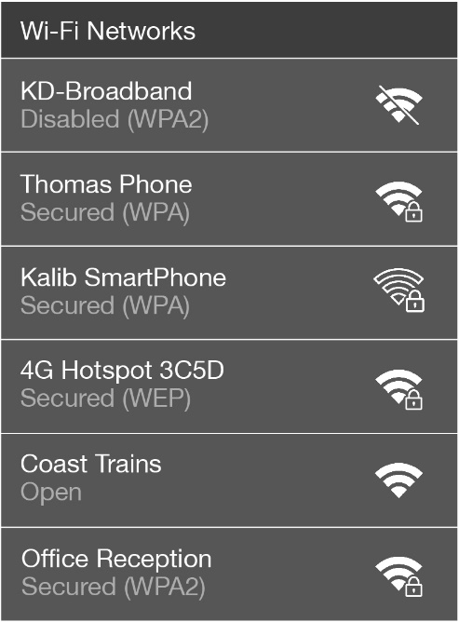
Ellie is working on her laptop on the train. She will be editing documents in the cloud. She needs to connect to the Internet and has the following choice of Wi-Fi networks available.

(a) Complete the table below to show how secure each of the available networks are. Place one tick in each row to show the security level.

Network name | Security level
 | No security | Weak security | Strong security
KD-Broadband
Thomas Phone
Kalib SmartPhone
4G Hotspot 3C5D
Coast Trains
Office Reception

(b) Ellie wishes to use the Coast Trains network. How can she make this a secure connection?

Cloud Storage and Cloud Computing
The cloud is another name for services offered via the Internet
The name comes from network diagrams that use a cloud symbol to represent the Internet
The cloud can be split into two major areas:
- Cloud storage
- Cloud computing

Cloud storage is where data is stored on remote servers in Data centres and is accessed via the Internet. Services like OneDrive or Dropbox are common examples of this.
It tends to be more sophisticated than offline storage
Features often include:
- Data stored in multiple locations
- A professional company will manage the data storage

Features:
Synchronisation of devices to the cloud - Whenever you make changes to a file while using a service like Google Drive or OneDrive, it can be configured to automatically save and synchronise your changes directly with the main server where your files are stored.
This means that if you were to make changes on one device and immediately check another, you would see your files up-to-date, provided both were connected to the Internet.
24/7 Availability - Cloud servers are always online so if you have a stable Internet connection, you will be able to connect to one and manage your own files. Even if there are outages, there are likely to be several backup servers from which the service can operate off, meaning it is truly online 24/7.
Access rights - Settings that allow different users different abilities (such as read/modify) with each file.
Only pay for storage used – most companies offer free storage space, if additional space is needed you can pay for the extra storage. For example, for £10/month you can get 3 terabytes of storage space in Dropbox.
Scalability - is the ability of the storage system or cloud computing resources to increase in size.
A home PC doesn’t have scalable storage. It may be possible to have two or three hard disks, but not two or three hundred
Redundancy - Having more than one copy of files stored on a different hard drive or at a different location

Data centres is a large temperature controlled building that houses computer servers. Professional engineers will maintain the hardware.
Task 2
Match the words on the left to their meaning on the right.

Word |  | Meaning
Server |  | Storing data on the Internet
Data centre |  | An item of hardware which responds to requests by processing data and sending replies
Cloud storage |  | The ability to easily increase the size of computing storage or processing power
Scalability |  | A centralised collection of servers stored in on building
Redundancy |  | Settings that allow different users different abilities (such as read/modify) with each file
Access rights |  | Having more than one copy of files stored on a different hard drive or at a different location

Complete the table below to show whether each statement is an advantage or a disadvantage of cloud storage.
 | Advantage | Disadvantage
Easy to increase the amount of storage available without buying new servers (scalability)
Data stored by a 3rd party company so processes aren’t known and less control
Data stored in multiple locations (redundancy)
Highly trained professionals to keep data secure and available
It can take a long time to upload or download files
Many devices can synchronise to the same files

Cloud computing is online applications that do most of their computing and processing in the cloud. For example Google docs and Office 365.
Applications are typically accessed either through:
- A web browser
- An app on the user’s device
Online Applications - Google and Microsoft both offer the ability to access applications through your browser. Commonly this is used for Office productivity software. Others include photo editing, webmail clients (Gmail and Outlook), and appointments calendars.
These are accessed through a web browser over the internet which means that we can use our software on any computer that has an internet connection.
Consistency of versions between users - A great benefit of using cloud computing software in a business is to ensure that all users are running the same version of that software. When subscribed to cloud computing the provider will keep your software up-to-date and all users will be accessing the exact same version. This means all users have the same features.
This also helps to ensure all users are using the same file types, by having consistent versions of the software. This is further helped due to working on shared instances of a file.

Single Shared Instance of a File - A single file can be shared to many people all at once for them to view or modify. This viewing can be done simultaneously with somebody editing the file, with that change appearing on other users screens in real-time. This way you do not need to worry about people loading up a file at the same time and overwriting each other’s changes, as you can see the changes as they’re happening.

You can also allow several users to edit the file all at once, with all their changes being registered as they go. This means that you can work together collaboratively on a file, while on different computers, even in different countries

Collaboration Tools/Features - Many cloud computing services have excellent features built-in to allow users to work collaboratively. For example, Google Slides allows multiple users to edit a single presentation at the same time. This means two co-workers could work on a presentation together while in different countries.
Some additional tools include those that track changes or add comments. This allows you to see what changes somebody has made to a file while you’ve not been accessing it, allowing you to catch up and see what they’ve done and edit any of the changes they’ve made (or indeed reject and remove those changes
Exam Question:
Clare uses cloud storage for her designs.
One benefit to Clare of using cloud storage is that she can access her designs anywhere that has internet access.
State two other benefits to Clare of using cloud storage. (2)
…1………………………………………………………………………………………………………………………………………………………………
…………………………………………………………………………………………………………………………………………………………………..
…2……………………………………………………………………………………………………………………………………………………………..…
…………………………………………………………………………………………………………………………………………………………………..
Sept 2018

Selection of Cloud Technologies

Choosing a cloud service isn’t always a simple task as there are many similar services out there. This can sometimes make it difficult to decide which to go with. However, each service usually has unique characteristics that help you to make this decision. Below are few things that can be considered:
Interface design of the cloud service being used is particularly important as it affects how easy it can be used. If somebody has trouble navigating their way throughout the interface, they may move to a different service. Therefore, cloud service providers should consider the following:
- Layout – some cloud services provide a familiar interface. Word Online is very similar to Word on your computer, which might make it easier for users to use than Google Docs.
- Accessibility – ensuring that the cloud service is accessible to those with individual needs, such as a visual impairment, is often a key consideration for a business.
- Mobile vs Desktop – nowadays, most cloud services are available on both kinds of platforms, but some may not have a mobile app to make it easier to use on smartphones & tablets.
Number & Complexity of Features – online services tend to offer features that are not always available with offline counterparts. These include:
- Collaborative working
- AutoSaving files and settings with a version history available to look back through
- Different users may have different access rights to features. For example age filtering is used on streamed content by user account for family services such as Netflix and YouTube.

Paid for versus free service – free versions of cloud services often provide a way to attract new customers with a limited service. This may be time limited, feature limited, space limited or device limited. Once a premium price is paid the user may be able to access more features on more device or see advert free versions.
Paid versions for applications are not always better, Careful consideration needs to be made. For instance some free versions may require paid support.

Available devices some software may not be available on certain devices on operating systems.

Exam Question:
Dexter uses cloud computing to provide his cousins with access to resources.
Discuss the benefits of using cloud computing to provide access to resources (6)
………………………………………………………………………………………………………………………………………………………………….
…………………………………………………………………………………………………………………………………………………………………..
………………………………………………………………………………………………………………………………………………………………..…
…………………………………………………………………………………………………………………………………………………………………..
………………………………………………………………………………………………………………………………………………………………….
…………………………………………………………………………………………………………………………………………………………………..
………………………………………………………………………………………………………………………………………………………………..…
…………………………………………………………………………………………………………………………………………………………………..
………………………………………………………………………………………………………………………………………………………………….
…………………………………………………………………………………………………………………………………………………………………..
………………………………………………………………………………………………………………………………………………………………..…
…………………………………………………………………………………………………………………………………………………………………..
………………………………………………………………………………………………………………………………………………………………….
…………………………………………………………………………………………………………………………………………………………………..
………………………………………………………………………………………………………………………………………………………………..…
………………………………………………………………………………………………………………………………………………………………
………………………………………………………………………………………………………………………………………………………………..…
………………………………………………………………………………………………………………………………………………………………
Feb 2020

Feb 2020

Using Traditional and cloud together
Choosing a cloud service doesn’t mean we have to completely forget our traditional computing technologies. In fact, they can often work in tandem very effectively and often it’s important to decide when to use each type of service and how we can make them work together.

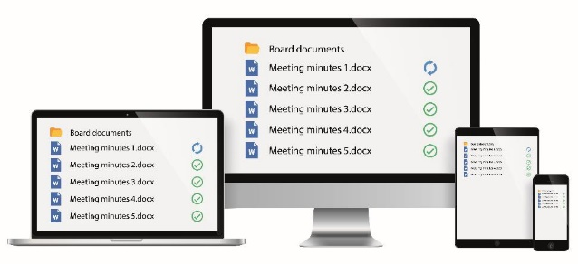
Device synchronisation - File synchronisation allows the same files to be copied to multiple devices via the cloud. The files are also backed up to servers on the cloud
Products that support file synchronisation
- Microsoft OneDrive
- Google Drive
- Dropbox

Online/offline working - Offline software does not involve the cloud or Internet at all. Some software that uses the cloud allows users to also work offline
- When working offline the data has to be manually backed up
Example: A constructor worker may be looking at building plan at a building site that has no communications infrastructure or they may be taking measurements in the countryside.
Services such as Dropbox, OneDrive save a copy of all files on local laptop/tablet. If any changes are made to a file, the new version will be uploaded and synchronised to the cloud as soon as an internet connection is available.
- When an Internet connection is found files and data will be synchronised
- Files and data could be lost before the data is synchronised

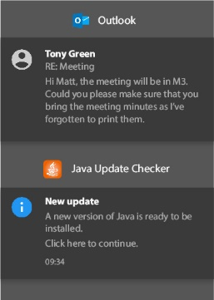
Notifications - are used to make users aware of new information and important actions they need to take
- Security updates and patches
- Email
What notifications do you get?

Task 3

- What do we mean by the term “device synchronisation”

2. Below are three statements regarding the use of cloud & traditional systems together. Identify which statements are true and which are false.

True False
1. Files can be synced between cloud & local storage so they can be worked on locally.

2. Files edited while offline can’t be synced with cloud storage.

3. Cloud software can give notifications when events occur like a file being synced.

- Explain one situation where traditional storage and software may be preferable to cloud software.

Knowitallninja – Selection of cloud

Disaster Recovery Plan
Implications for organisations when choosing cloud technologies
Cloud technologies have brought huge benefits to organisations but choosing the right ones can be difficult. Many factors will have to be contemplated to decide what kind of cloud service that will work best for a company. Implementation can be expensive and can cause disruption so getting things right the first time is important.

The loss of IT service or company files can be catastrophic for an organisation. Some companies may never recover again unless all eventualities have been planned for. Disaster may come in the form of:

- Loss of data form theft, corruption, a malware attack, accidental deletion or simply a loss of access
- Natural disaster, for example fire or flood
- Loss of staff with technical expertise.

Cloud technology providers have procedures to protect the data that they store, but users still need reassurance. Therefore cloud providers will hold copies of data on more than on hard drive in different locations. This is known as redundancy. This means that if one hard drive fails or is destroyed in one location, another can immediately be used.
Additionally companies will also have their own Disaster Recovery Policy in the event of a disaster
- Backups of data need to be available
- Hardware and alternative premises may also need to be purchased and rented
Cloud software and data is stored at remote locations
- It is usually easier to restore in the event of a disaster
People in the organisations should be assigned roles
- They will then know exactly what to do in a disaster
A disaster recovery plan might consider what a company does in a flood
- This could include lifting all IT equipment to a higher floor
A company that relies heavily on computers needs them to work even if the electricity supply fails
- UPS (Uninterruptable Power Supply) uses batteries to keep computers working
- Backup generators will generate electricity from diesel fuel

Security of Data

Data is crucial to most organisations survival. It may be sensitive or even sentimental to individuals too. For this reason backup copies of data should be stored at multiple locations and encrypted.
Data centres will typically have CCTV, security guards and fire suppression systems.
The policies and procedures of any cloud storage provider should be checked carefully to ensure they have sufficient security in place and to assess useful additional features such as historical version recovery.
The ability to select which countries the data can be stored in will also help ensure compliance with the Data Protection Act.

Compatibility
Software as a service will need to make sure that it is compatible with all different platforms that user may use such as PC, Mac and Android.

Maintenance
Cloud storage and computing facilities are maintained by highly experienced engineers. They aim to make services or data available with uptimes commonly above 99%.
Any issues, system administrators will receive alerts to fix as soon as possible.

Performance Consideration
Cloud based software needs to perform as well as any locally installed software to prevent any delay in processing request. Companies and their customers need to feel that the system they use are responsive.
A fast and reliable broadband connection is the most crucial component to the success of the cloud software and storage. Upload and download speed needs to be fast for collaborative working smoother.

Getting a service or storage facility up and running
If organisation will like to set up new system, many factors will need to be considered such as implementation, security, how long it will take to set up, training new staff etc. This can take up to many weeks.
However, setting up a cloud service system such like Office 365can be achieved in minutes by simply selecting which services are required for the company and making a card payment.

A1: Exam Questions
...........................................................................................................................................................................
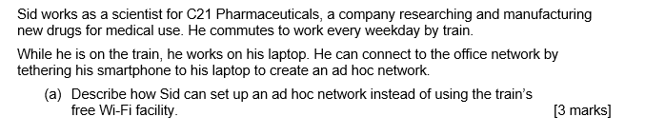
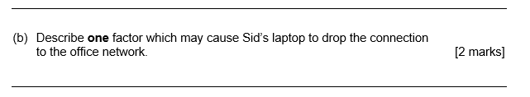
Describe – to give an account of something such as steps in a process.
Explain – identify a reason and then expand how.
Articles for Wider Reading and Flipped Learning
Subscribe and watch the YouTube clips to help you revise for BTEC Tech Award Component 3.
https://www.youtube.com/watch?v=tewbD0YL_QU&list=PLmyUnKEeJk-6gijRiVKEfcvZhwcj6LWpo&index=1

