BTEC Level 3
Unit 1: Information Technology Systems

Learning Aim C: Operating Online
Knowledge and Assessment Organiser

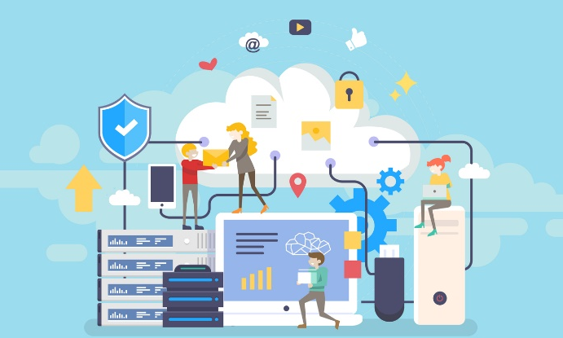

Student name: ………………………………………………….
How online systems have impacted individuals and organisations?

Key Command verbs
Contents
Big Question and Small Question breakdown
Essential knowledge
Articles for wider reading and flipped learning

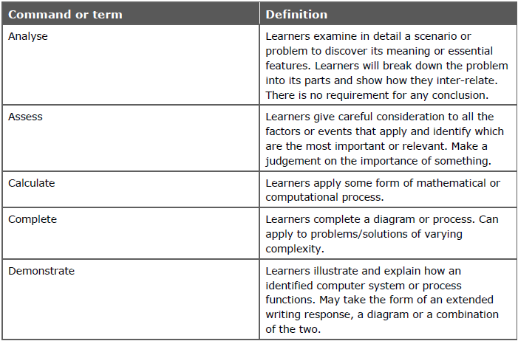
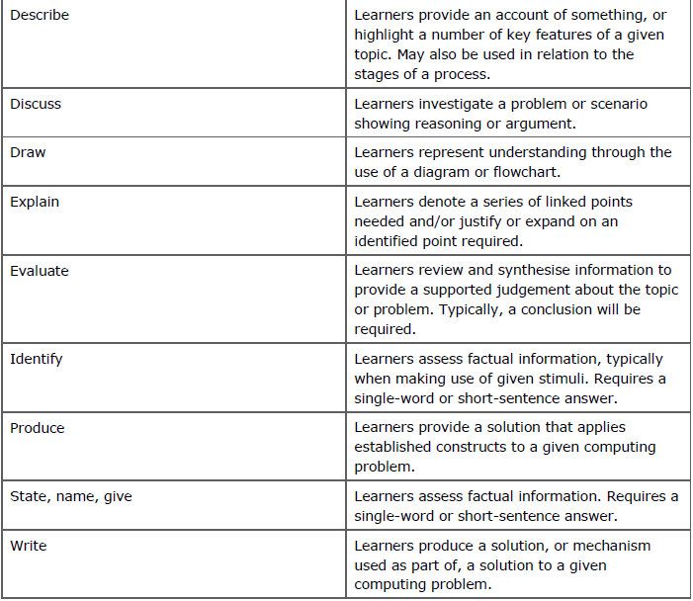
Key command words

What is my big question?
What are the implications of online communities to both individuals and organisations?
What are online communities?
How online systems have impacted individuals and organisations?

What is the difference between cloud storage and cloud computing?
What factors need to be considered when choosing to switch to an online system?
What is online systems?
C1: Online System
Cloud storage is a method of storage where data is being stored one remote servers, rather than on the user’s local computer or in an organisations own data centre.
Cloud computing is where software is stored on remote servers and accessed by users via their browser.
Both which can be used for personal and professional use.
Cloud Storage

Personal Use | Professional use
Store files, such as photos and videos.  These can be synced in to all user devices  These can be shared with other selected users. | Storing off site backups of business data  Allowing the access of documents off site

Cloud Computing

Personal Use | Professional use
Accessing software on a variety of computing devices | Accessing office applications and email without having to install the software on the workstation.

The impact of cloud storage and computing

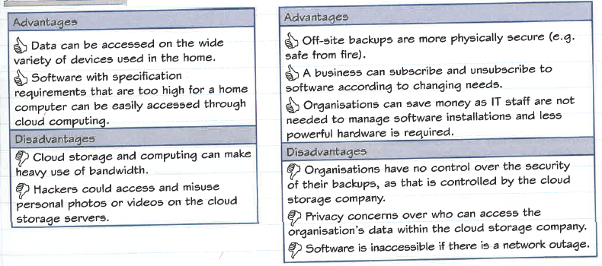
Individuals Organisations

Remote working

Online systems have allowed businesses to enable remote working. Two system that re particularly important in supporting remote working are:

- Virtual Private Networks (VPN)
- Remote Desktop Technologies

Virtual Private Networks | Remote Desktop Technologies
Is a private network that runs across the internet.  This is used in business to allow a user to connect to their work LAN while working remotely, such as from home. Usually, this is to access private business documents and data.  Without a VPN, if we were to access business data remotely, the data could be intercepted during transmission by a malicious user. The data could then be released to the public or used for corporate espionage or blackmail.  The key to a VPN is that the data transferring between your computer and the business is encrypted, so you don’t need to worry about a malicious user intercepting private business data. This is because even if they intercept the data they would not be able to read it as it could be in a coded form.  A downside to a VPN is that it can be difficult to configure and deploy for a business and will need specialist staff with an excellent understanding of network and security to set it up. | This is a technology that allows a user to access their work desktop from outside the business offices. An example of remote desktop software is the Microsoft Remote Desktop utility which comes with Windows operating systems.  This software will not only allow you to access the files and folders that you have stored locally on your work computer but can also allow you to access the business’ LAN, printers & even software applications. This way you can perform pretty much all the functions of your work life, without ever going into your businesses offices.  The downside to this type of software is that it is not good for graphically intensive tasks, as all data has to be transferred over the internet, which can be difficult to keep with and can cause lag. Also, if your business network or your home internet goes down you won’t be able to access any of the resources.

Factors affecting the use and selection of online systems

Using online systems, such as cloud computing and storage, can offer big benefits to organisations and individuals. However, there are factors that must be considered before switching to these online systems.
- Security
To make use of online systems, such as cloud storage, you need to transmit a lot of data over the internet. This may even be very private and confidential information.
This is a concern for business’ as there is a danger this data might be intercepted while being transmitted and misused. Also, your cloud storage account could be hacked into and the data stolen that way.
So if a business needs to transmit data privately then they will need a service that provides good security.
One method that online service providers use to ensure security is through the use of SSL. If you have ever seen a web page URL start with https:// instead of http:// then that website has been using SSL to encrypt the data being transmitted.
This makes it safer for the business as any data intercepted during transmission will be encrypted and so unreadable.
- Cost
Many online systems are free to use for individuals, however, organisations will normally need to pay a subscription fee to access the services.
These subscriptions can usually scale with the business, where you can increase or decrease your access depending on your business needs. This is why online systems like cloud storage are so popular, they are flexible with the business.
Additional costs that need to be considered include things like the cost of your internet access. Fast, reliable broadband connections are necessary for a business to make use of things like cloud computing software and cloud storage.
This may mean paying more for a better connection than they business would otherwise need.
- Ease of Use
Implementing new systems to a business can be difficult if they are not easy to use. Many employees will not be strong IT users and so the switch to using things like cloud computing software and cloud storage can be problematic.
To ensure employees make use of the new online systems a business has subscribed to it is important that the system is easy to use for their employees.
This can be achieved by ensuring the service providers website is accessible to the user. For example, the website may need to be responsive to the type of device they are using. If the user accesses the service on a smartphone it will need an interface designed for smartphones, not one designed for desktop computers.
Another accessibility issue is disability access. Has the online system provider implemented features to ensure the service is accessible to users with individual needs such as a visual impairment? An example would be ensuring that the site works well with screen reading software.
If the online system provider has good technical support and user documentation, this will help the ease of use as users can access help easily should they need it.
- Features
Likely the most important factor when choosing an online system is the features that it offers. For your business to perform its functions it needs the systems it uses to have certain features.
This is just like when purchasing regular software. You need to make sure that it has all the features that you need to perform the tasks you want to perform.
This might be things like the ability to collaborate simultaneously on a document, automatic syncing cloud storage files with local storage, specific functionality in online software and security features for protecting your data.
- Connectivity
As we looked at in cost, using online systems will require a fast, reliable broadband internet connection.
Cloud storage, in particular, requires a business to be able to transmit large quantities of data, as you need to upload files to your cloud storage when saving and download them when loading them. If your business works with large files, such as a company in the film industry, then a fast broadband connection will be especially important.
Similarly, if your internet connection goes down then you won’t be able to access your online systems. Many businesses cannot afford to go without access to these services as they cannot continue to operate without them. Therefore a very reliable connection is extremely important.

C2: Online Communication

An online community is a group of people who communicate over the internet about common interests. We use a wide variety of different online services to form and participate in these online communities.

Most common are:
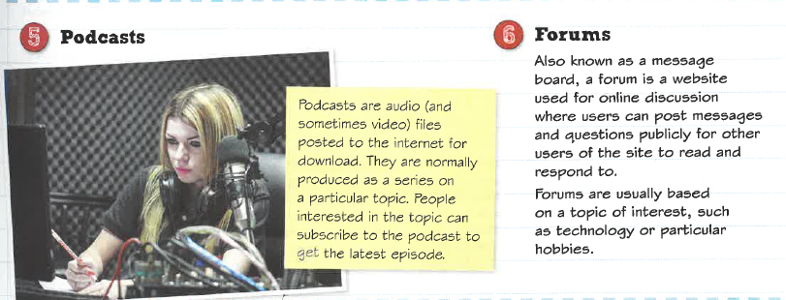
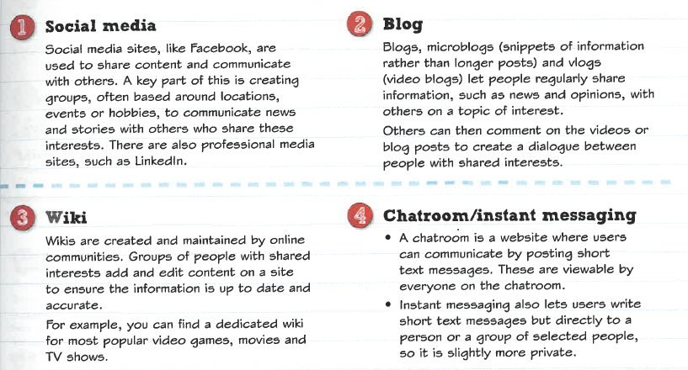

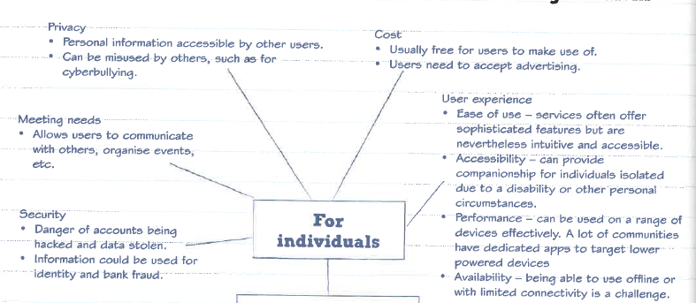
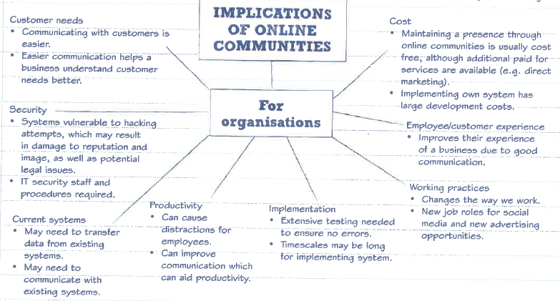
Implications of online communities for individuals and organisations

Articles for Wider Reading and Flipped Learning

Know it all Ninja
Read through the topics on:
- Online systems
- Online communities

Remember to complete the on-line quiz to gain house points and test your knowledge.
https://www.knowitallninja.com/

