Colton Hills Community School medium term planning
Topic title:  ‘Sea Life’ | Year: 8  Term: Autumn |  | Why we teach this:  For students to produce creative work, exploring their ideas influenced by a range of artists. Students will create a collaborative outcome to raise awareness of the environmental impact our actions are having on the oceans, in particular the issues surrounding plastic waste. | Why we teach this here:  Students work through the art and design process, consolidating prior learning and selecting materials, processes, and techniques appropriate to their choice of theme and skills set.
Big questions:  What is ‘Sea Life’?  How can I show an artist’s influence in my own work?  What makes a good observation drawing?  What am I good at and where/how can I improve my skills further?  What are the issues surrounding plastic waste?  How can we raise awareness of the environmental impact our actions are having on the ocean? |  |  | Builds on previous topics:  The design process – analyse, create, review, develop, realise intentions. | Links to future topics:  Consolidate the formal elements of art & observation drawing. Analysing the work of artists and showing an understanding in applying to their own designs.
Key knowledge:

• A range of different drawing styles, materials and techniques.
• To show an understanding of the work of a range of artists who were inspired by sea life.
• To learn how to develop original ideas influenced by research material and observation studies.
• To work collaboratively in order to create final outcome.
• To evaluate work and progress in order to improve further and inform future work.

Skills developed:

We give the opportunity for students to analyse the work of artists, designers and craftspeople and create personal and meaningful practical outcomes in a range of media. In order to realise intentions, we teach students to be analytical, questioning and independent learners reviewing and refining their work to produce effective outcomes.

AO1 - Develop your ideas through investigations informed by contextual and other sources, demonstrating analytical and cultural understanding. |  | AO2 - Refine your ideas through experimenting and selecting appropriate resources, media, materials, techniques and processes. | Independent study tasks/resources:  - Yellena James – https://yellena.com/  - Jason Scarpace https://ipaintfish.com/  - Abby Diamond  - Clare Youngs  https://www.clareyoungs.co.uk/  - Sharon Cummings  - Dolan Geiman  https://dolangeiman.com/ | Key vocabulary:  Sea Life  Sgraffito  Underwater  Observation  Experimental  Printmaking  Fish  Ocean  Record  Original  Jellyfish  Shells  Coral  Sea  Global warming  Analyse  Design  Organic  Develop  Evaluate  Environment
AO3 - Record ideas, observations and insights relevant to your intentions in visual and/or other forms. |  | AO4 - Present a personal, informed and meaningful response demonstrating analytical and critical understanding, realising intentions and making connections between visual or other elements.
Cultural capital opportunities:  Students to research meaning and purpose of artists work and consider their influences, including symbolism/tradition. |  |  | Whole school Curricular Concept links:  - Precious Planet  - Artistic Creativity

Learning objectives | Tasks
(Summer) Weeks 1-2  - To learn how to draw shells from observation.  - To learn and apply harmonious and contrasting colour schemes.  - To learn how to apply pencil crayon effectively.  - To gain an understanding about artist Johanna Basford. | 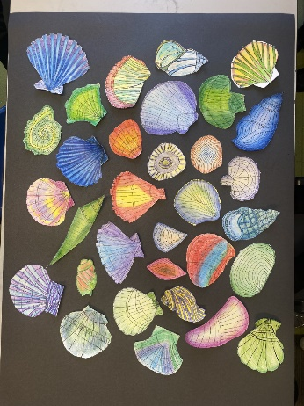  - Students to draw 2 shells from direct observation in the style of Johanna Basford.  - Students to gain an understanding of contrasting and harmonious colours using pencil crayon. | - Small questions  How would you describe Johanna Basfords’artwork? What media does she use? What is a harmonious and contrasting colour scheme?
- Retrieval focus
Drawing from observation and how to apply pencil crayon effectively.
- Independent study
To complete any unfinished work
(Autumn) Weeks 3-6  - To explore the work of ____ and demonstrate your understanding of their work.  - To demonstrate your ability of applying the appropriate media effectively.  - To be able to draw from secondary images accurately. | - Experimental drawing of a fish/crab/jellyfish from secondary images in the style of one of the following artists:  Jason Scarpace Sharon Cummings  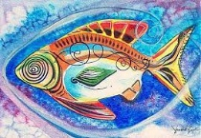  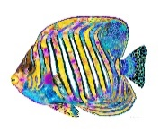  Dolan Geiman Clare Youngs  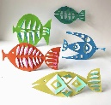  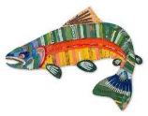  Abby Diamond  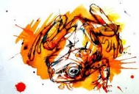 | - Small questions  Who is the artist? What media do they use? How can you create a drawing in the style of the chosen artist?
- Retrieval focus
Artist analysis
- Independent study
To complete any unfinished work
Weeks 4-6  - To learn the impact of global warming and gain an understanding about coral bleaching.  - To draw coral from direct observation.  - To explore a range of mark making in order to create a realistic drawing. | 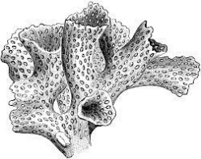  jj  - Observational drawings of coral using fine liner or dip pen and ink.  Students will gain an understanding of coral bleaching and the impact of Global warming. | - Small questions  What makes an effective observational drawing? What is mark making? What effect does mark making have on a drawing?
- Retrieval focus
Observational drawing techniques
- Independent study
To complete any unfinished observational drawings

Weeks 7-9  - To learn the process of polystyrene press print.  - To consider different colour schemes in order to create an effective press print.  - To understand what makes a successful polystyrene press print. | - Polystyrene press print of fish, turtle or crab.  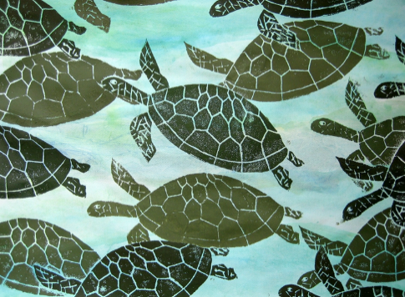 | - Small questions  What is polystyrene press print? How do you create an effective polystyrene press print?
- Retrieval focus
Colour theory and printmaking
- Independent study
To complete any unfinished work

Weeks 10-12  - To gain an understanding about artist Yellena James.  - To learn how to create your own scratchboard.  - To learn and understand the techniques of sgraffito.  - To learn how to finalise ideas by making informed decisions collaboratively. | 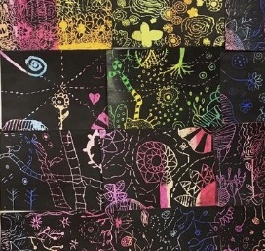  - Students to create their own scratchboard using oil pastels, black acrylic paint and washing up liquid. They will then draw into their scratchboard using the sgraffito technique to create their own design inspired by Yellena James.  - Students will create a collaborative outcome by combining their sgraffito pieces together and adding their sea life drawings over the top. | - Small questions  Who is Yellena James? Where does James’ get her inspiration from? What is sgraffito? How can you create your own work in the style of James’?
- Retrieval focus
Sgraffito and the design process
- Independent study
To complete any unfinished work
Week 13  - To be able to work independently in order to complete any outstanding work.  - To be able to improve your work by responding to teacher feedback. | - DIRT – Students to complete any unfinished work. | - Small questions  What work is incomplete? Can you improve any of your work? If so, how?
- Retrieval focus
All tasks above
- Independent study
To complete any unfinished work

