Colton Hills Community School medium term planning
Topic title:  .. What is Art? | Year: 7…  Term: Autumn… | Why we teach this: To encourage students to question what art is, to consider what makes something valuable r significant and to question purpose and meaning  … | Why we teach this here: This acts a s a baseline for the KS3 curriculum, encouraging students to broaden their views about art and articulate opinions as a basis for further discussion.  …
Big questions:  How do we define art?  How do we assess value in art?  How do we explain our views to others?  How do we respond to others when we disagree with their views?  What materials do different artists use?  What methods and techniques do artists use?  How do I create my own pieces of unique art? |  | Builds on previous topics:  No previous art at CHS but students will be asked to reflect upon what they learnt at primary school  … | Links to future topics:  …the ability to discuss value and meaning in art and the ability to articulate and justify opinions will be used throughout the secondary curriculum when discussing works of art.
 |  | Key knowledge & skills:  Action painting/abstract art  Op Art  Tonal drawing/photography  Observational drawing  Application of paint  Speaking and listening: Articulating views, justifying opinions, listening to other points of view. | Key knowledge continued:
Skills developed:
- Formal drawing skills, depiction of shape, form, tone, colour and texture.
- Modelling
- Recording 3D work
- Accurate use of fineliner

Mini/Interim assessments:  - Peer and self-assessments on practical tasks  Termly summative assessment:  …Formative assessment on progress towards track |  | Independent study tasks/resources:  …Research into art that students’ consider to be valuable artworks and those that they feel do not constitute Art. Justification of views | Key vocabulary 1:  …action painting  Abstract art  Observational  Tone  Texture  Form  Proportion  Texture | Key vocabulary 2:  … Justify  Opinions  Appreciate  Value  Materials  techniques
Cultural capital opportunities: …  Researching a range of Art in galleries online that may not previously have been considered. |  | Whole school Curricular Concept links:  …

Learning objectives | Tasks
Week 1  - To contemplate the question – what I art?.  - To learn about the key elements of creating an action painting.  - To learn how to articulate views and justify opinions in whole class discussion. | Discuss and consider the big question ‘what is art?’…Look at power point about Jackson Pollock, discuss materials, techniques, purpose and value.  Create own action painting on a smaller scale  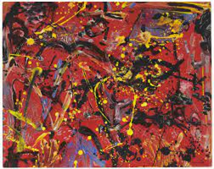 | - Small questions  What is Art? What is action painting – is it really art?
- Retrieval focus
What art did they look at in primary school? - discuss.
- Independent study
To complete any unfinished work
Week 2  - To gain an understanding of how people view art differently  - To question the value and purpose of different types of art  - To create a small-scale abstract assemblage with Lego bricks. | Look at power point about Carl Andre’s pile of bricks, discuss materials, techniques, purpose and value. Examine contrasting opinions at the time  Create own pile of bricks on a smaller scale using Lego. Record for sketchbook  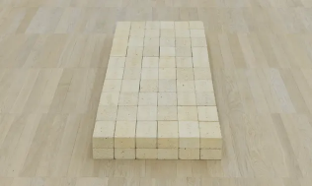 | - Small questions  Who is the artist? What media do they use? How can you create a piece of artwork like theirs
 |  | - Retrieval focus
- Independent study
…Find a piece of art that you think is a good example of quality work. Record information about the work. Justify opinions.
Week 3  - To understand what Op art is and how to create it  - To learn the techniques and processes of making an Op art piece of work  - To be able to create an effective black and white piece of Op art | Look at power point about Op art and Bridget Riley discuss materials, techniques, purpose and value.  Create own piece of Op art in fine liner pen  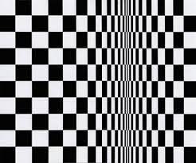 | - Small questions  What is Op art? What makes an effective piece of Op art? Who is Roy Lichtenstein?
- Retrieval focus
Working with geometric shapes
- Independent study
To complete any unfinished work.

Weeks 4-5  - To understand what a still life is and how to create your own  - To learn how to draw accurately from observation recording proportion properly  - To demonstrate accuracy in the application of paint | Look at power point about Michael Craig Martin, discuss materials, techniques, purpose and value.  - Create own still life painting on a smaller scale  - Demo use of water colours to create flat, opaque finish. Students apply t observational  - drawings from last lesson. | - Small questions  - What is observational art? What is a still life? Who is Michael Craig Martin? How can I paint in his style?
- Retrieval focus
The formal elements used in observational drawing. How to apply watercolour paint
- Independent study
Find a piece of art that you think is not really ‘Art’ Record information about the work. Justify opinions.

Week 6  - To understand how to improve own practical work  - To learn how to manage time effectively to complete work to deadlines | jj  D.I.R.T lesson  Complete any unfinished work, improving as necessary. | - Small questions  What do I need to finish? How can I improve my work further?
- Retrieval focus
Review own practical work – improve with reference to teacher feedback
- Independent study
To complete any unfinished work.

