BTEC LEVEL 1 / 2 TECH AWARD IN HEALTH AND SOCIAL CARE

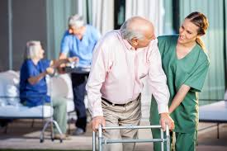

COMPONENT 3

LEARNING AIM B

Health and Wellbeing

TARGET GRADE:

Name:



|  |  |
| --- | --- |
| What’s the Story? | 3 |
| Big question and small question breakdown | 4 |
| Glossary | 6 |
| Essential knowledge | 7 - 25 |

**What’s the Story?**

Hi, I’m Nabil and I’m 14 years old. I live in a large block of flats in the middle of a busy city. I am from Syria, and I live with my aunt who has no family of her own, but there is other young people from Syria in my neighbourhood.

I have had a poor diet for the last five years. As a result, my growth and weight have been affected. I often feel tired and lacking in energy. My aunt takes me to see the GP regularly and to the school nurse clinic at the community health centre. I speak limited English.

I go to the local secondary school which is one mile away and I get the bus to school. I used to play football in Syria, but have not made any friends in my new school or neighbourhood. I tend to stay inside the flat and play computer games on my own. My aunt has difficult getting me to go to bed at a reasonable time and she then has difficulty waking me up in the mornings.

**Why does this matter?**

We are looking at everything we learned in year 10 and applying it to a case study

- We are looking at how different health indicators are affected by our lifestyle

- We are reviewing different health data and looking to interpret what that means for our health, both now and in the future

- We are researching long term health issues and how they can impact our health and welling

**Sounds familiar?**

You have already looked at lifestyle choices, expected and unexpected events, access to services and the importance of relationships in components 1 and 2.

To understand the factors that affect health and wellbeing



What are health indicators?



What are the risks to health?



How do I interpret lifestyle data?



How do I use published guidelines to interpret health indicators?



**Glossary**

|  |  |
| --- | --- |
| Physiological |  |
| Cardiovascular system |  |
| Blood pressure |  |
| Peak flow |  |
| Body mass index |  |
|  |  |

**Health indicators**

Health professionals measure a range of indicators to assess risk to health and wellbeing. Indicators may be physiological measurements such as blood pressure, or lifestyle date such as alcohol consumption.

|  |  |
| --- | --- |
| **Indicators**  Indicators may be physiological such as:   * Pulse * Blood pressure * Peak flow * Body mass index (BMI)   Or indicators may relate to lifestyle such as:   * Smoking * Alcohol consumption * Level of exercise | **Importance of understanding indicators**  Measuring and monitoring indicators helps health professionals to:   * Detect health problems at an early age * Track improvements or deterioration in health * Make recommendations about health and treatments * Give advice about future health risks * Support individuals to make different lifestyle choices |
| **Physiological indicators**  Physiological indicators show how well the body’s systems are functioning. Health professionals check a person’s health by taking measurements. They compare the results with published guidance from reliable sources such as the NHS, Royal College of Nursing or charities such as the British Heart Foundation or Asthma UK | **Lifestyle indicators**  Health professionals collect information about lifestyle choices by asking about a person’s:   * Weekly alcohol consumption * Smoking habits, if any * Levels of physical activity and exercise   These indicators can be used to assess risks to an individual’s health and wellbeing now and in the future |

**Measuring physiological indicators**

|  |  |
| --- | --- |
| Pulse – measures the number of heart contractions in one minute | Blood pressure – measure the pressure of blood as it circulates in the body |
| Peak flow – measures how well the lungs can expel air | BMI – indicates proportion of body fat using measurements of a person’s height and weight |

Milena, aged 26 has been feeling dizzy. She has booked an appointment with the GP.

Give two physiological measurements that the GP is likely to make and suggest two questions that the GP may ask Milena about her lifestyle.

Physiological measurements

1. _____________________________________________________________________________________

2. _____________________________________________________________________________________

Questions

1. _____________________________________________________________________________________

2. _____________________________________________________________________________________

**Positive and negative aspects of lifestyle**

Positive and negative aspects of lifestyle are less easily measured than indicators of health. One way of assessing aspects of lifestyle is to collect the information in a questionnaire or at an appointment with a health practitioner

|  |  |
| --- | --- |
| **Some positive aspects of lifestyle** | **Some negative aspects of lifestyle** |
| * Regular exercise | * Genetic inheritance |
| * Personal hygiene | * Existing chronic conditions |
| * Supportive relationships | * Substance abuse (e.g. alcohol, nicotine, illegal drugs and misuse of prescription drugs) |
| * Adequate financial resources | * Social isolation |
| * Stimulating work | * Stress |
| * Use of health monitoring and illness prevention services, e.g. screening and vaccination | * Reluctance to seek help or access services |
| * Use of services such as dentist and optician | * Poor housing |
| * Risk management to prevent accidents | * Environmental pollution |
| * Leisure activities | * Poverty and/or unemployment |
| * Education | * Unprotected sex |
| * Balanced diet |  |
| * Enough sleep |  |

Design a questionnaire a health practitioner might use to assess the positive and negative aspects of an individual’s health and wellbeing.

Example of a health questionnaire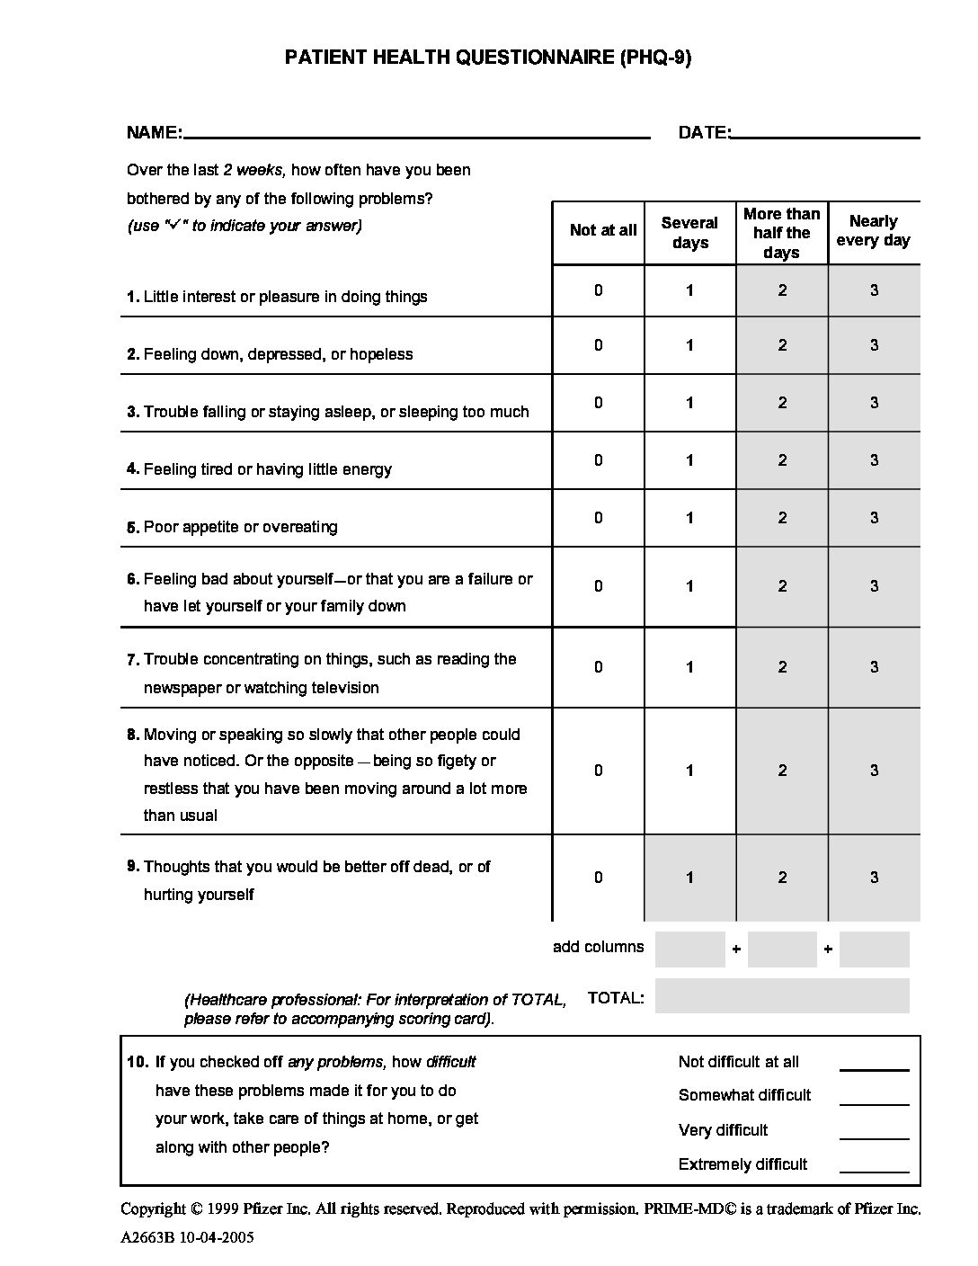

**Health profile**

Use a height measure, bathroom scales, a blood pressure monitor, a peak flow meter, a thermometer and measure your pulse.

Add these measure of health to the body outline, with an arrow pointing to the correct part of the body.

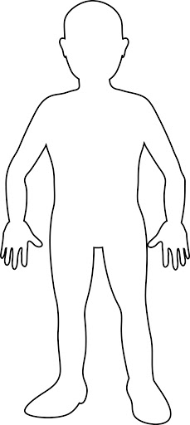

**Resting pulse rate and recovery after exercise**

A useful measure of health is to compare your resting pulse rate with the rate after exercise and see how long it takes to return to its normal resting rate.

Your pulse rate is the measure of how fast your heart is beating. In other words, your pulse rate is the same as your heart rate. This is because:

Every time your heart beats it pumps blood into your **cardiovascular system.**

These beats cause a pulse, or shock wave, that travels along the walls of the **arteries**.



This pulse is strong enough to be measured wherever an artery crosses a bone – most easily in the radial arteries in the wrist and the carotid arteries in the neck.

To measure your pulse rate:

* Put the tips of your fingers on the radial pulse (just below the base of your thumb) in your wrist
* Count how many beats there are in a certain time
* Use the number to work out your pulse rate in beats per minute (bpm)

Say, for example, you measure 12 beats in 10 seconds. Multiply 12 x 6 to the get the number of beats in 60 seconds. The answer is 72, which means you have a resting pulse rate of 72bpm. You must also use the tops of your fingers, because these are the most sensitive. And remember, the thumb has a pulse of its own, so do not use it to take your pulse anywhere else.

**Resting pulse rate**

The average resting pulse rate for an adult is about 60-100 bpm. The average for an athlete is lower, about 40-60 bpm. In other words, the fitter you are the lower your resting pulse rate. This is because the heart gets bigger and stronger with exercise, so it becomes more efficient at pumping blood around the body. It can pump more blood around the body with each beat, which means it needs fewer bpm to pump the blood around. Babies and children have faster pulse rates. A new baby’s rate can be 70-190 bpm.

The best way to measure your resting pulse rate is to:

* Sit quietly for about 5 minutes, so you are calm and rested
* Take at least three readings
* Work out the average by adding the readings together and divide by three.

Resting pulse rate 1st reading __________________

Resting pulse rate 2nd reading _________________

Resting pulse rate 3rd reading __________________ Average resting pulse rate _________________

Check your own resting pulse rate, then we are going to exercise for 2 minutes and measure your new pulse rate immediately afterwards. Keep taking a record of it every minute until it returns to normal and add how many minutes it took to your health profile.

Resting pulse rate __________________

Pulse rate after 2 minutes exercise __________________

Pulse rate after 1 minute resting __________________

Pulse rate after 2 minutes resting __________________

Pulse rate after 3 minutes resting __________________

Your pulse rate increases after exercise and then returns to normal, but this can happen at different rates.

Measuring your pulse rate before and after exercise and seeing how many minutes it takes to return to normal is a good way of measuring how fit you are. The shorter your recovery time, the more fit you are.

The predicted maximum pulse rate is 220 minus your age. A healthy pulse rate during or just after exercise is 60 to 80 per cent of this. Here’s an example for a 30 year old:

Predicted pulse rate = 220 – 30 =190

60% of 190 = 60/100 x 190 = 114

80% of 190 = 80/100 x 190 = 152

Look at the table below. What does the information tell you?

|  |  |  |
| --- | --- | --- |
|  | Before 6 months of regular exercise | After 6 months of regular exercise |
| Pulse rate (bpm) | 84 | 69 |
| Breathing rates (breaths per min) | 18 | 16 |
| Heart volume (cm3) | 128 | 141 |
| Volume of blood pumped out of the heart by each beat (cm3) | 64 | 76 |

____________________________________________________________________________________________________________________________________________________________________________________________________________________________________________________________________________________________________________________________________________________________

**Blood pressure**

Blood pressure is the pressure exerted by your blood against the walls of your arteries. It is measured in millimetres of mercury (mmHg) as two numbers shown one over the other.

* The top number is your systolic pressure – the maximum pressure in the arteries as the heart pumps blood out around the body
* The bottom number is your diastolic pressure – the minimum pressure as the heart relaxes between beats.

Normal healthy blood pressure is between 90/60 mmHg and 120/80 mmHg.

**High blood pressure**

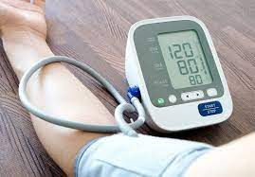If you have blood pressure between 120/80 mmHg and 140/90 mmHg, you are in danger of developing high blood pressure. High blood pressure is called hypertension. Hypertension is a risk to health and needs to be reduced as quickly as possible. This can be done by any of these things:

* Removing the source of stress causing it
* Treating conditions causing it
* Treating the blood pressure with medication

Hypertension doesn’t usually have any noticeable symptoms. However, if it is left untreated, it puts extra strain on blood vessels and organs, causing:

* 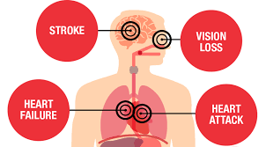Heart disease, attacks and failure
* Kidney disease
* Strokes
* Blindness
* Vascular dementia

Make a mind map, researching all the things that can possibly increase the risk of high blood pressure

**High blood pressure can be caused by these things:**

**Low blood pressure**

Low blood pressure is called hypertension and is 90/60 mmHg or below. Some people have naturally low blood pressure and this can lead to a longer lifespan. Low blood pressure does not normally need treating unless it is causing symptoms. However, reduced blood pressure can restrict the volume of blood flow to your brain, leading to dizziness, fainting or falls. Low blood pressure can also be the side effect of some medication or, more seriously, a sign of Parkinson’s disease.

Activity: Create a leaflet giving information about: what blood pressure is, high and low blood pressure and their risks, where people can get their blood pressure tested and how it is carried out. Finally your leaflet should explain how to control your blood pressure if it is too high.

1. What is the accepted healthy range for systolic pressure? __________________________________
2. What is the accepted healthy range for diastolic pressure? _________________________________
3. What is the name for high blood pressure? ______________________________________________
4. What is the name for low blood pressure? ______________________________________________

**Body mass index**

BMI is a measure of the amount of fat on your body in relation to your height to tell you if your weight is healthy.

We all carry some body fat. But someone who has too much (they are very overweight) is at risk of:

* Cardiovascular disease
* High blood pressure
* Diabetes
* Arthritis
* Stroke

Having low amounts of body fat (being very underweight) can indicate problems such as:

* An undiagnosed illness
* An eating disorder 9such as anorexia nervosa or bulimia nervosa)

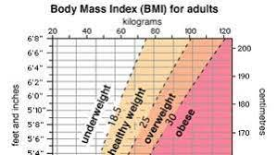

BMI is worked out using a formula, which divides an adult’s weight in kilograms by their height in metres squared,

BMI = weight in kg

(Height in m)2

The information about your hight and weight (and sometimes your age and gender) can be used directly to determine your BMI range.

|  |  |
| --- | --- |
| **BMI** | **Meaning** |
| Less than 18.5 | underweight |
| Between 18.5 and 24.9 | Healthy weight |
| Between 25 and 29.9 | overweight |
| Between 30 and 34.9 | obese |
| Between 35 and 39.9 | Severely obese |
| 40 or above | Morbidly obese |

**Activity: Suzie is worried about her weight, so has made an appointment to see Dr Martin, her general practitioner (GP)**

Dr Martin asks Suzie some questions and records the following information:

* Suzie eats too many takeaways and snacks
* Suzie binge drinks (drinks a lot of units of alcohol) at the weekend
* Suzie is not able to attend her usual exercise class as she is caring for her partner, Dave

**Physiological data**

Dr Martin records the following measurements

|  |  |
| --- | --- |
| Body mass index (BMI) | 29.3 kg |
| Blood pressure | 160/96 mm Hg |

Explain what the data provided by Dr Martin suggests about

• Suzie’s current physical health

• Risks to her future physical health

__________________________________________________________________________________________________________________________________________________________________________________________________________________________________________________________________________________________________________________________________________________________________________________________________________________________________________________________________________________________________________________________________________

___________________________________________________________________________

___________________________________________________________________________

**Peak flow**

Peak flow is a measurement of how quickly you can blow air out of your lungs. It is an important health indicator (as people with breathing difficulties may already know).

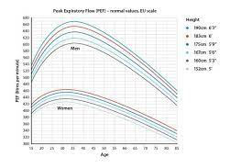

This is a measure of the maximum rate, or expiratory rate, in litres per minute, at which air is expelled from the lungs when you breathe out as hard as possible. Your peak flow reading shows if your airways are narrowed. It is measured using a handheld device called a peak flow.

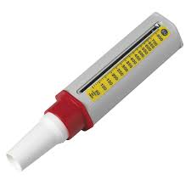

The most common reason for taking and recording peak flow readings is to monitor a person’s asthma, caused by narrowed airways. Peak flow can also be used to diagnose and monitor other lung problems, such as:

* Bronchitis (a chest infection
* Emphysema (damage to the lungs causing breathlessness)
* Cystic fibrosis (a genetic disorder that can affect the lungs)
* Lung cancer

Activity: Muhammad attends Brookmill surgery for a health check. Dr Wilson, his GP, asks some questions to find out the following information:

* Muhammad does not eat a healthy diet
* Muhammad smokes at least 40 cigarettes a day

**Physiological data**

Dr Wilson records the following measurements

|  |  |
| --- | --- |
| Height | 190cm |
| Blood pressure | 170/100 mm Hg |
| Peak flow | 466I/min |

**Guidance for physiological data**

Dr Wilson gives his guidance to help you interpret the physiological data

|  |  |  |
| --- | --- | --- |
|  | Systolic (top number) | Diastolic (bottom number) |
| High bp | 140-190 | 90-100 |
| Pre-high bp | 120-140 | 80-90 |
| Ideal bp | 90-120 | 60-80 |
| Low bp | 70-90 | 40-60 |

Explain what the data provided by Dr Wilson suggests about:

• Muhammad’s current physical health

• Risks to his future physical health

_________________________________________________________________________________________________________________________________________________________________________________________________________________________________________________________________________________________________________________________________________________________________________________________________________________________________________________________________________________________________________________________________________________________________________________________________________________________________________________________________________________________

**Risks to physical health of abnormal readings**

The word abnormal can sound worrying. Abnormal test readings might mean a risk to health. In fact, abnormal readings may indicate that your physical health could develop into something more serious.

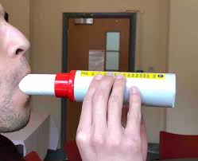Peak flow

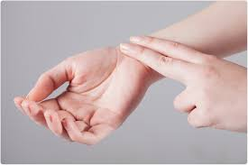

Resting pulse rate

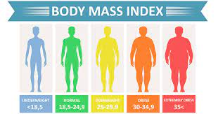

Body Mass Index

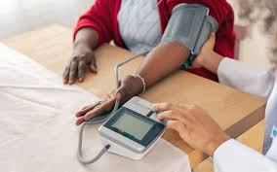

Blood pressure

Activity: pick one health indicator: resting pulse rate, peak flow, BMI or high blood pressure. Look back at and do more research into, the risks to physical health indicated by an abnormal reading in the health indicator you have picked. Create a fact sheet and poster. Hand it to the person next to you to peer assess.

**Interpreting lifestyle data**

Did you know that we can measure our own lifestyle choices against officially prepared data? This can include information about safe limits for smoking, drinking, alcohol and taking exercise.

**Interpreting lifestyle data on smoking**

Smoking is a lifestyle choice. But it comes with many risks to physical health, there is much lifestyle data associated with smoking.

The ONS collects data relating to smoking. It publishes both statistics and reports giving key findings.

ASH (Action on Smoking and Health), a public health charity, works towards eliminating the harm caused by smoking tobacco. It uses data about smoking to:

* Influence policy (guidelines)
* Inform, educate and raise awareness about the risks of smoking
* Campaign for tighter controls on the tobacco company

ASH receives funding from the British Heart Foundation and Cancer Research UK to persuade people to quit smoking and to provide information and to offer support to help people quit.

The data provides the UK government with evidence it can act on, such as passing laws about smoking and delivering anti-smoking campaigns.

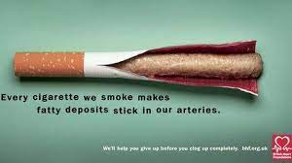



Activity: research what laws the UK government have made about smoking

____________________________________________________________________________________________________________________________________________________________________________________________________________________________________________________________________________________________________________________________________________________________

_______________________________________________________________________________________

_______________________________________________________________________________________

**What the data shows**

Ash identifies that:

* Smoking causes around 96,000 deaths in the UK annually
* Smokers under the age of 40 are up to five times more likely to have a heart attack than non-smokers
* Smoking causes around 80% of deaths from lung cancer, 80 per cent of the deaths from bronchitis and emphysema, and 14 per cent of deaths from heart disease
* More than 25 per cent of all cancer deaths are caused by smoking (for example, lung, mouth, lip, throat. Bladder, kidney, pancreas, stomach, liver and cervix.
* On average a smoker will die 10 years earlier than a non-smoker
* Women smokers are at greater risk of developing osteoporosis
* Smoking causes impotence and can lead to sperm abnormalities
* Smokers are more likely to develop facial wrinkles earlier and have dental problems

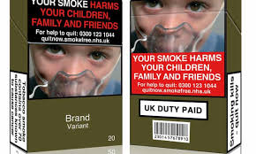

Activity: create a presentation to highlight the risks of smoking to physical health. Your presentation must include facts and figures about risks to physical health presented in picture and diagram form. Data is available from websites such as [www.ash.org.uk](http://www.ash.org.uk) and [www.nhs/smokefree/why-quit](http://www.nhs/smokefree/why-quit)

**Interpreting lifestyle data on alcohol**

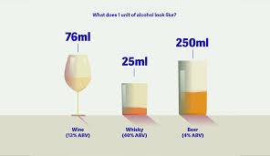Drinking alcohol is a lifestyle choice. It may seem appealing and social, but it comes with risks to physical health. Lifestyle data about alcohol helps to inform us about those risks

Activity: find out how much alcohol the UK government recommends an adult should drink in a week.

___________________________________________________________________________________

In January 2016, the UK government published new guidance on drinking alcohol. The guidance says that:

* Any amount of alcohol can increase the risk of cancer
* Men and women who drink regularly should consume no more than 14 units a week
* People should not binge drink all 14 units in one go

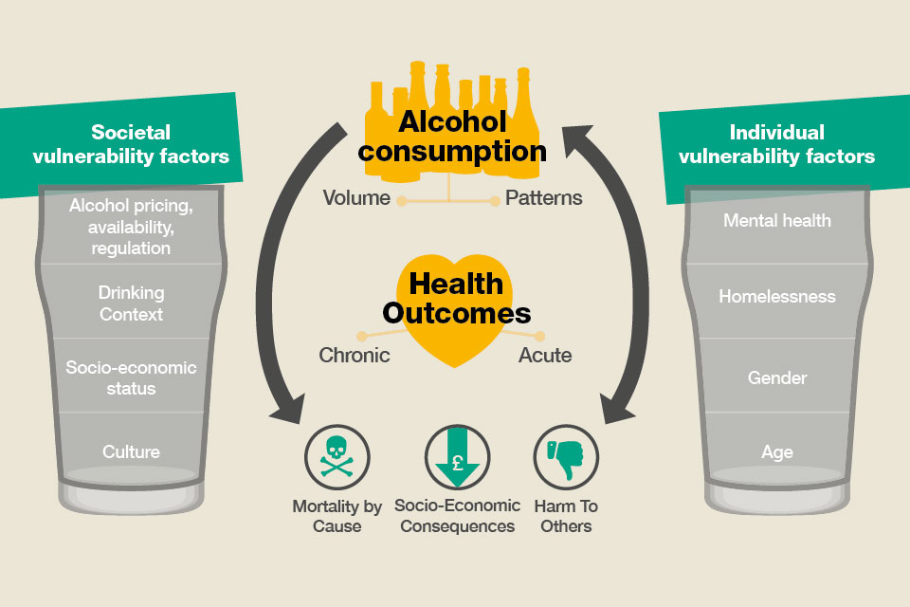

**What the data shows:**

Here are some examples of what current lifestyle data on alcohol shows:

* It is strongly linked to at least seven types of cancer. For example, a lifetime of drinking too much alcohol can increase your risk of bowel cancer by 23 per cent
* Alcohol related liver disease accounts for 37 per cent of liver disease deaths
* Each drink per day increases the risk of breast cancer in women by between 7 and 13 per cent.
* In 2011, 3000 cases of breast cancer were directly caused by alcohol consumption
* Less than one-third of the British public knows the link between alcohol and breast cancer
* You are between two and five times more likely to have an accident or injure yourself if you drink five to seven units of alcohol in one sitting.
* Two thirds of cases of chronic pancreatitis are caused by heavy drinking, most commonly in men aged between 45 and 54. (Pancreatitis is an inflamed pancreas that has damaged cells)
* More than 25,000 people were admitted to hospital with acute pancreatitis every year
* Around 1,000 people die from acute pancreatitis every year

Activity: Jacob has registered with the local GP practice

As part of this process he has completed a health questionnaire and has had a physical examination with the Practice Nurse

The Practice Nurse highlights the following information on Jacob’s completed health questionnaire:

* Jacob smokes cannabis once or twice a week
* Jacob binge drinks at the weekend, having as many as 10 pints of beer on both Friday and Saturday night
* Jacob does not take part in any physical activity

**Physiological data**

The Practice Nurse records the following measurements

|  |  |
| --- | --- |
| Body Mass Index (BMI) | 27kg |
| Resting pulse (heart rate) | 120 bpm |

Explain what the data provided by the practice nurse suggests about:

• Jacob’s current physical health

• Risks to his future physical health

___________________________________________________________________________________________________________________________________________________________________________________________________________________________________________________________________________________________________________________________________________________________________________________________________________________________________________________________________________________________________________________________________________________________________________________________________________________________________________________________________________________________________

**Interpreting lifestyle data on inactivity**

Lifestyle data relation to inactivity lets you know exactly what is meant by inactivity and what you need to do in order to be active enough to make you healthy.

Activity decreases the risk of many conditions such as stroke, diabetes, cancer, obesity, arthritis and cardiovascular disease.

The ONS produces data in the UK on levels of activity and how these relate to various risks of physical health. Other organisation such as the British Heart Foundation and Public Health England use it to plan health promotion campaigns that encourage people to be more active.

**The British Heart Foundation**

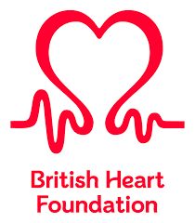The British Heart Foundation is a UK heart charity. It was founded in 1961 and is funded by donations and fundraisers. The BHF aims to prevent people dying prematurely for heart disease. It uses data to highlight the importance of physical activity for cardiovascular disease.

This data is broken down by UK country, gender, age and sedentary behaviour. Breaking it down this way means information can be used to target the groups that most need to become more active.

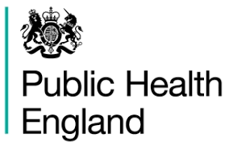**Public Health England**

Public Health England was established to protect and improve the nation’s health and wellbeing. It is sponsored by the UK Government’s Department of Health. It uses data sources like the annual Health Survey for England to provide information on inactivity. The information helps policymakers and practitioners deal with the risks to health such as obesity.

**Data on regular activity:**

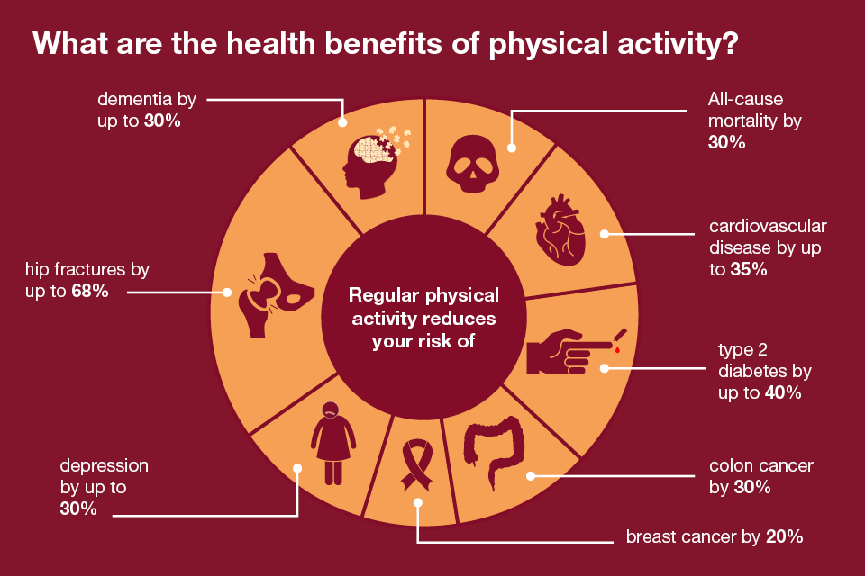

Activity: Flora is 9 years old. She is obese, hates exercise and uses any excuse she can to get out of PE. Do some research and draw up a set of recommendations on how much exercise she should be doing. What kinds of exercise would you recommend?

Highlight the benefits of each exercise type you suggest and include at least one relevant statistic, related to Flora’s future and current health.

Activity: how is data on inactivity used to try and reduce risks to the health of the nation?

__________________________________________________________________________________________________________________________________________________________________________________________________________________________________________________________________________________________________________________________________________________________________________________________________________________________________________________________________________________________________________________________________________