GCSE English

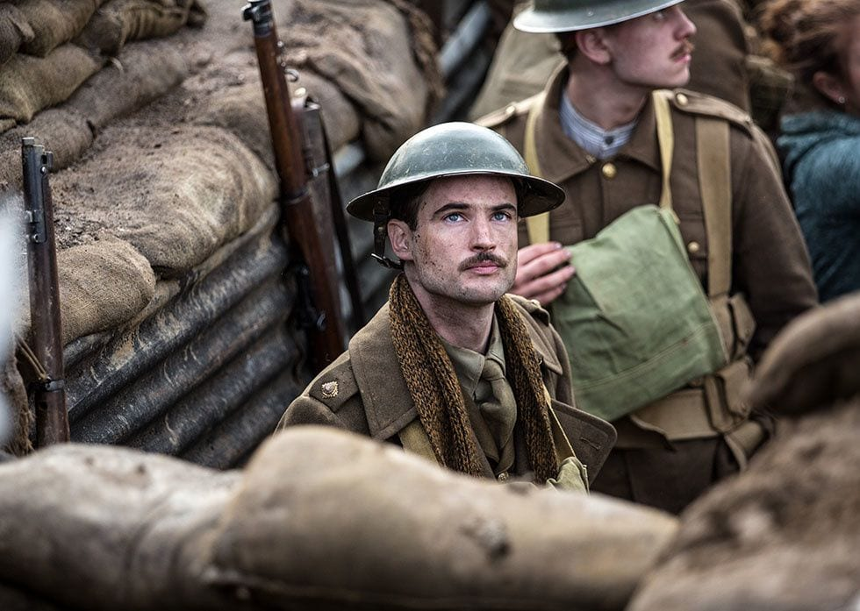

Journey’s End
Knowledge and Assessment Organiser

Student name: ………………………………….
How does Journey’s End explore the futility of war?
Contents

What’s the Story? | 3
Glossary | 4
Big Question and Small Question breakdown | 5
Essential knowledge | 7
Model Assessment Answer | 55
Examples of students’ answers | 55
Retrieval Quiz | 57
Articles for wider reading and flipped learning | 58

In 2017, a version of Journey’s End was transformed to the big screen. The release of this version was scheduled to coincide with the hundred-year anniversary of major battles. The original release coincided with the 100th anniversary of the battle of Verdun, and the wider release coincided with the 100th anniversary of the German offences, the events of which are depicted in the play.
Did you know…?
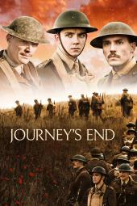

What’s the Story?

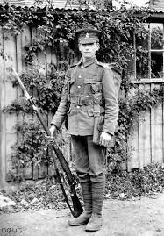
In the summer of 1914, families found themselves suddenly torn apart as war gripped the continent. Carrying the promises of glory and victory before Christmas, young men eagerly journeyed overseas to France and Belgium. Families waved off their husbands and sons, full of pride for their country.
As months turned into years, the naïve optimism was shattered as the reality of war took hold. Confined to horrific conditions in the trenches and with the threat of death lingering in the air, the hope of glory began to disappear for these men. Instead of the promise of battle and triumph, many men found themselves waiting endlessly for action in bitter weather. Many men died and those that did return home were changed forever.
In Journey’s End, Sheriff explores the reality of war, examining its effects on individual men and condemns the illusion that society had of the First World War.

Why does this matter?

- We are studying one of the most important periods in modern history.
- It will help us appreciate how the war affected individuals rather than just nations.
- We must explore the conventions of drama, appreciating it as a performance that is meant to be watched rather than just read.
- ‘Those who don’t know history are destined to repeat it.’

Sounds familiar?

You might well have come across some of these ideas before in your school life, through assemblies or other lessons. You will also be studying World War One in your History lessons and will have studied plays in Performing Arts.

Glossary of Key Terms

trenches
long narrow ditches dug by troops to provide a place of shelter from enemy fire; also shorthand for the battlefields of northern France and Belgium in World War I ("the trenches")

Minnies
large mortar shells, named for the German Minnywerfer

cheero (also cheerio)
used as an expression of good wishes on parting; goodbye; synonym for cheers

The Boche
Germans, especially German soldiers, considered collectively; from the French word for rascal

Jerry
slang term for Germans, referring to their helmets, which British soldiers believed resembled chamber pots, known as jerries

ought
used to indicate duty or correctness, typically when criticising someone's actions

pluck
spirited and determined courage

blithering
senselessly talkative, babbling; used chiefly as an intensive to express annoyance or contempt

righto
informal British exclamation to express agreement or assent

no man's land
disputed ground between the front lines or trenches of two opposing armies

very light
a flare fired into the air from a pistol for signalling or for temporary illumination

neuralgia
intense, typically intermittent pain along the course of a nerve, especially in the head or face

going potty
going insane; losing one's mind

jolly
very; extremely (i.e. jolly good)

tunic
a close-fitting short coat as part of a uniform, especially a police or military uniform

How does Journey’s End explore the futility of war?
4. How does Sherriff use Stanhope to show the impact of war on a person?

2. What is Raleigh’s attitude towards joining the army?
1. What is the story of Journey’s End?
6. Can good people survive a war?

5. How are soldiers in WWI presented as struggling to cope with the realities of war?

7. How does Journey’s End explore the futility of war?
3. Does Sherriff effectively portray conditions in the trenches?

Curricular Concepts
Have you ever noticed how some of the things you study in one subject appear in another subject too?

Students are able to understand their work more and remember more if there are clear links between subjects. Throughout your learning at Colton Hills, we will be asking you to think about some of the most important ideas in the world to enable you learning to be deeper than ever before. Look for these ‘curricular concepts’ in your learning.

Essential Knowledge
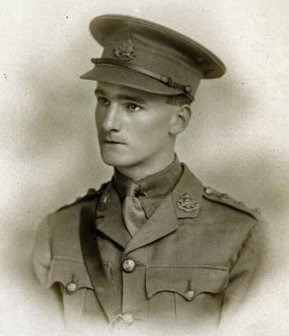
R. C. Sherriff
(1896-1975)

Robert Cedric Sherriff, the only child of Herbert Hankin Sherriff, insurance clerk, and his wife, Constance Winder, was born at Hampton Wick on 6th June 1896. He attended Kingston Grammar School and after leaving school in 1914 he joined the Sun Assurance Company in London.
A week after the outbreak of the First World War the British Army advertised in the national press inviting young men between the ages of 17 and 30 to serve as officers during the conflict.
Sherriff, who was 18 years old in 1914, decided to apply. Sherriff later recalled: "I was excited, enthusiastic. It would be far more interesting to be an officer than a man in the ranks. An officer, I realised, had to be a bit above the others, but I had had a sound education at the grammar school and could speak good English." However, the army was not impressed with his grammar school education and his application was rejected. Sherriff returned to his job with the Sun Assurance Company.
However, by the following year, the British Army had lost so many junior officers that it decided to lower its standards. In November 1915, Sherriff volunteered again and he was granted a commission in the East Surrey Regiment. He arrived on the front-line of the Western Front on 7th October 1916. Over the next four months he served at Vimy Ridgeand Messines Ridge.
On 27th January 1917 Sherriff was wounded during a bombardment at Bracquemont. After two weeks of being treated at the 73rd Field Ambulance's Main Dressing Station he returned to the front-line. In July he was sent on a sniping course at Mont des Cats.
General Sir Douglas Haig, the British Commander in Chief in France, was encouraged by the gains made at the offensive at Messines Ridge. Haig was convinced that the German Army was now close to collapse and once again made plans for a major offensive to obtain the necessary breakthrough at Passchendaele. Sherriff and the East Surrey Regiment took part in the opening sequences of the battle. In his autobiography, No Leading Lady (1968), Sherriff recalled: "The great preliminary bombardment had begun. We were surrounded by batteries of artillery, and for three nights it was bedlam."
Allied attacks on the German front-line continued despite very heavy rain that turned the Ypres lowlands into a swamp. The situation was made worse by the fact that the British heavy bombardment had destroyed the drainage system in the area. This heavy mud created terrible problems for the infantry and the use of tanks became impossible.
As William Beach Thomas, a journalist working for the Daily Mail, pointed out: "Floods of rain and a blanket of mist have doused and cloaked the whole of the Flanders plain. The newest shell-holes, already half-filled with soakage, are now flooded to the brim. The rain has so fouled this low, stoneless ground, spoiled of all natural drainage by shell-fire, that we experienced the double value of the early work, for today moving heavy material was extremely difficult and the men could scarcely walk in full equipment, much less dig. Every man was soaked through and was standing or sleeping in a marsh. It was a work of energy to keep a rifle in a state fit to use."
Sherriff argued in No Leading Lady (1968): “The living conditions in our camp were sordid beyond belief. The cookhouse was flooded, and most of the food was uneatable. There was nothing but sodden biscuits and cold stew. The cooks tried to supply bacon for breakfast, but the men complained that it smelled like dead men."
On 31st July 1917, Sherriff and his men were called forward to attack the German positions. "At dawn on the morning of the attack, the battalion assembled in the mud outside the huts. I lined up my platoon and went through the necessary inspection. Some of the men looked terribly ill: grey, worn faces in the dawn, unshaved and dirty because there was no clean water. I saw the characteristic shrugging of their shoulders that I knew so well. They hadn't had their clothes off for weeks, and their shirts were full of lice."
Sherriff later recalled: "All of us, I knew, had one despairing hope in mind: that we should be lucky enough to be wounded, not fatally, but severely enough to take us out of this loathsome ordeal and get us home. But when we looked across that awful slough ahead of us, even the thought of a wound was best forgotten. If you were badly hit, unable to move, what hope was there of being carried out of it? The stretcher bearers were valiant men, but there were far too few of them."
As the battalion advanced towards the German front-line a shell exploded close-by: "The crash was deafening... I remember putting my hand to the right side of my face and feeling nothing; to my horror I thought that the whole side had been blown away." In fact, the shell had landed on the top of a pillbox and he had been hit by the shattered concrete.
Sherriff was taken to the Casualty Clearing Station at Abeele. He was one of the 2,015 men treated in the opening two days of the offensive. He was later moved to the 14th Base Hospital at Wimereux. He later recalled that "with the aid of probes and tweezers, a doctor took fifty-two pieces of concrete out of me."
Sherriff was sent back to England and remained at Royal Victoria Hospital at Netley until November 1917. He then joined the Home Service battation of the regiment until being demobbed in March 1919. He returned to working as an insurance adjuster. In his spare-time he wrote plays for the annual fund-raising event at his Kingston Rowing Club. His first play was The Adventurers.
Sherriff's next play was Journey's End. It had been turned down by most of the theatres in London and only appeared after the intervention of George Bernard Shaw. As his biographer, John Courtenay Trewin, points out: “Journey's End, a play based upon his letters home from the trenches, in the new year of 1929 he became one of the most discussed English dramatists of the day…. The play is set entirely in a claustrophobic dugout before St Quentin on the eve of the March offensive of 1918. Sherriff, who always favoured naturalism in theatre, had sought to give no more than a straight, simple impression of the terrors of the western front in a play written with so much honesty - no heroics, no pretence - that its characters stamped themselves upon the English theatre of their time.” The play, with Laurence Oliver, playing the lead role of Captain Dennis Stanhope, was a great success and there were 594 performances in London and 485 in New York City. It was also translated and performed in every European language.
The success of Sherriff's play opened up the way for other soldiers to write about their experiences in the First World War. Publishers now became interested in publishing books on the subject of trench life.

‘Who can control his fate? ’tis not so now.
Be not afraid, though you do see me weaponed.
Here is my journey’s end, here is my butt,
And very sea-mark of my utmost sail.’
Othello, William Shakespeare

Did you know…?
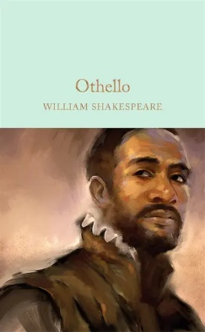
R.C. Sherriff named the play after a line from William Shakespeare’s play Othello?
It was written in 1603 and is about a black military hero who is betrayed and brought down by those closest to him. The lines above are from a famous speech of surrender.
Why do you think Sherriff chose to name the play after this?

This is the transcript of a letter Sherriff wrote to his parents whilst at war.
9th East Surreys
24th Division
British Expeditionary Force
4.10.16

France
Dear Pips,
I have now spent close on a week in France and it seems months since I sailed.
I have seen plenty to interest me and enough of war to disgust me without having been into the Front Line yet.
At present I am on what is termed a “quiet part” of the front although at certain intervals during the day there is enough banging away off in the front line (half a mile or so away) to let you know there is a war – and at night you here the machine guns going “tap tap tap” like some impatient person knocking at the door.
Yesterday I made a journey up the line to find my away about – the ground is just as it appears in photos – absolutely honeycombed with shell holes which are now covered up in some places by rank looking weeds.
All the way up the trenches you here a bang behind and then a fearful screeching as the shell flies by and a second later a dull crash as it comes down behind the German lines.
The support line where I am has been free from bombardment up till now – and I hope it will remain so until we leave – I expect the first time under shell fire will be far from pleasant. Tomorrow I am in charge of a working party of 50 men going up near the front line to do some repairs – they were shelled today so I may get a dose tomorrow – but the “baptism of fire” has got to come and it may be as well to get it over.
I have told you, I believe, how we are living here – in a shed which is quite comfortable if it were not for the Rats and Mice – one (with maybe an accomplice) got into the haversack which I was using as a pillow last night and bit through the liner of my emergency ration, marvellous feat considering the thickness of the clot – I heard them busy scratching about inthe night.
We have quite a comfortable Mess – it is a dugout with a table down the middle and little sleeping bunks down the sides – we have quite good Meals too – bacon or sausages for breakfast and porridge cold tongue or salmon and bread and butter for lunch, and tea at 4 o’clock with dinner at 8 o’clock – there are 8 of us to the Company – 2 Captains and 6Lieutenants all very nice.
The rain is very unpleasant as regards making everything very sticky – I have to inspect my men’s rifles in their dugouts when it is wet – the men are wonderfully cheerful when considering the hardships they have to put up with – they get wet through and then set about getting dry before the little cokes fires under the most trying circumstances treating it almostas a joke.
We all wear steel helmets which are rather heavy until you get used to them – but now I am touching on military matter and must get off them quickly or will be letting out secrets.
My chief worry is the impossibility of buying anything here – of course it is quite out of the question in the lines, but even in the rest billets it is almost out of the question to buy anything except what you don’t want – chicory and coloured glass vases seem to be the chief articles which French people specialise in.
So if you could arrange with Mother to send me out parcels periodically – deducting the Cost from my account book I shall be very glad – it seems the custom here to get parcels and share some of the contents at Mess.
Chocolate, peppermints or anything of that nature which are difficult to get here would be very acceptable.
By the way – I expect my private account has run rather dry – so will let me know what I owe and I can send you a cheque so that you will money to get these things. As I write I can hear trench mortars firing which make a noise like rolling a big square tank along.
We do not have very much to do here unless detailed for a working party – so I occupy most of my time in reading and writing.
Washing is rather an awkward procedure when up the line here as water is rather deficient to procure but on the whole we are living here in reserve almost the same we did in rest. Things have moved so quickly since I left home that I expect I have only given you a pretty hazy idea of what has happened, so as it is all bound stand well in my memory I will not recount anything of my journey bringing me here reserving that for another time when I hope I will be able to tell you all about it on a walk down Cromwell Road at some time I hope not far distant.
I will write to you again as soon as I can, so goodbye for the present and I hope shall hear from you or mother soon – I know it will take quite a week to get any letters at first on account of my changes of address, so will not expect any till I get them.
From your loving son,
Bob

Characters

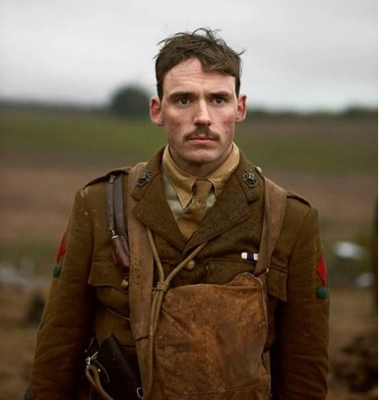
Stanhope
The Captain of an infantry company stationed in the trenches of St. Quentin, France during World War I. Stanhope is a young man, but he has already seen three years of combat and has gained the respect of his men, who see him as a brave leader. But they also see him as something of an alcoholic. Indeed, the war has changed him greatly, turning him from a rugby captain and school hero into a hard-drinking man with shot nerves who can drink an entire bottle of whiskey, stumble to bed, and wake up and command an infantry the next morning.

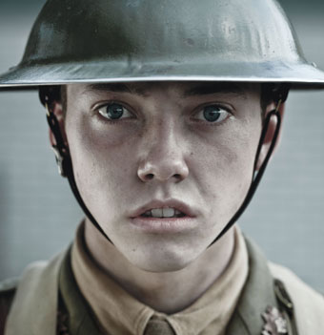
Raleigh
A young officer fresh out of school. Raleigh went to the same school as Stanhope, who is several years older than him. As such, he has always admired Stanhope—so much so that he asked a high-ranking relation of his to help him get placed in Stanhope’s infantry. When he arrives in the trenches and sees Stanhope once more, though, he’s surprised to find his role model significantly changed. Nonetheless, Raleigh remains eager and good-natured as he becomes accustomed to life in the trenches.

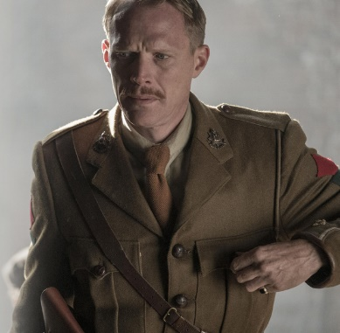
Osbourne
The second-in-command to Stanhope. Osborne is a bit older than the other soldiers, but he is well-liked. In fact, he actually helps keep Stanhope—his superior—psychologically grounded, making sure to take care of his friend when he’s gotten too drunk. In many ways, Osborne serves as a fatherly figure to a number of the officers in Stanhope’s infantry, talking to them about the nature of war and giving them advice about how to make the best out of trying circumstances.

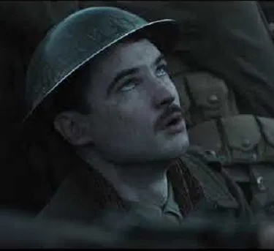
Hibbert
An officer in Stanhope’s infantry. Hibbert is so afraid of dying in the trenches that he pretends to suffer from an acute case of neuralgia (intense nerve pain). He seizes every opportunity to talk about his physical pain in front of Stanhope, finally approaching the captain and claiming that he will have to go home on account of this overbearing condition.

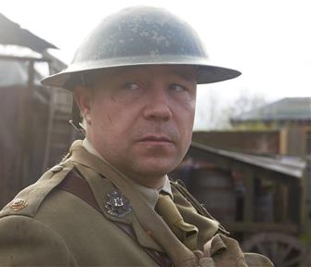
Trotter
An officer in Stanhope’s infantry. Trotter is cheerful, mocking, and gluttonous, frequently giving Mason—the cook—a hard time about the food served in the dugout. Trotter provides primarily comedic relief in Journey’s End.

Mason
The officers’ cook. Mason is very obedient, constantly trying to accommodate the often ridiculous requests of people like Trotter, who have unrealistic expectations. Still, Mason strives to provide the officers with the best possible service, experimenting with his cooking techniques in order to produce the best quality food. Unfortunately, his efforts often go unnoticed, and the officers talk behind his back about the problems with his food.

What is the story of Journey’s End?

Detailed Plot Summary

In the first scene of Journey’s End, Osborne arrives in the British trenches of St. Quentin, France in the last year of World War I. He is the second-in-command of an infantry stationed only 70 yards from the trenches of their Germany enemies. The nature of this kind of military service is quite intense, so the infantries rotate working this location, each group taking six-day shifts. When Osborne arrives, he has a brief conversation with Hardy, the second-in-command who has just finished his six days. Hardy tells Osborne there is a German attack expected to come soon, and the two soldiers talk about Stanhope, the captain of the infantry. Stanhope is a hard-drinking young man who has been in the war already for three years. Hardy exalts Stanhope as both a sound leader and a prolific drinker. Hardy also tells Osborne about an officer who recently left, and he hopes that the replacement will be a better, braver soldier.

When Hardy leaves, Osborne sits down to a dinner made by Mason, the officers’ cook. At this point, Raleigh, the new officer, enters. As Osborne and Raleigh talk, Raleigh reveals that he knows Stanhope from before the war. He and Stanhope went to the same high school, and Stanhope was a respected rugby captain whose father was friends with Raleigh’s father. The boys spent summers together, and Stanhope started dating Raleigh’s sister. When Stanhope went off to war, Raleigh thought constantly of him as brave captain. When Raleigh enlisted, he even ­­asked a relative to help him get assigned to Stanhope’s infantry. Hearing this, Osborne realizes he should warn Raleigh that Stanhope has changed. Next the two men talk about Raleigh’s journey through the trenches to the front lines, which he says was an unnervingly quiet experience. Osborne confirms that it is “often quiet” there, despite it being one of the most dangerous places to be stationed. Osborne says they are just “waiting for something” to happen.
When Stanhope enters the dugout, he’s stunned to see Raleigh. Rather than embracing him, he simply asks how he got here. He then turns his attention to Osborne and Trotter, another officer, and the group sits down to eat together. Eventually, the fourth officer of Stanhope’s infantry, Hibbert, enters and claims that he doesn’t know if he can eat because of his neuralgia. This obviously annoys Stanhope, who urges Hibbert to eat, but Hibbert goes to bed. “Another little worm trying to wriggle home,” Stanhope says.
During dinner, Trotter decides to make a chart representing the remaining hours until he and his fellow officers can leave the trenches. On a paper he draws 144 circles, intending to fill them in as the hours pass. By the end of dinner, only Stanhope and Osborne remain in the dugout, and Stanhope is exceedingly drunk. He admits that he’s afraid Raleigh will write to his sister—who’s waiting for Stanhope to return—and tell her about his drinking. Stanhope declares that he’s going to censor Raleigh’s letters, and Osborne puts his drunken friend to bed.
The following day, the Colonel informs Stanhope that the long-awaited German attack is set to take place on March 21st, in two days. Stanhope relays this information to Osborne, who says he’s glad something is happening at last. Stanhope then muses on his experience in the trenches and worries that he’s going crazy. Osborne assures him he’s merely experiencing “nerve strain.”
Raleigh enters the dugout with a letter, and Stanhope tells him to leave it open so it can be censored. Raleigh says that he hasn’t said anything confidential, but Stanhope angrily insists that he follow orders and allow his letter to be censored. When Raleigh leaves, Stanhope asks Osborne to read the letter, only to discover that the boy has said only positive things about him.

Later that afternoon, the Colonel tells Stanhope that the higher-ups have decided to stage a raid on the German trenches before the attack on the 21st. To Stanhope, this sounds like a suicide mission, but the Colonel insists that it must be done, and the two men determine that Osborne and Raleigh should be the ones to lead the effort. After the Colonel departs, Hibbert enters the dugout and tells Stanhope that his neuralgia has progressed so badly that he believes he must go home. This enrages Stanhope, who pressures him to stay and even pulls a gun on him, though he doesn’t shoot. Finally Hibbert makes it clear that he doesn’t truly have neuralgia. Rather, he can’t stand the war. Stanhope becomes more sympathetic, telling Hibbert that he too feels this way. He reveals that the only thing keeping him from faking sick and going home is drinking.

The next day, the Colonel and Stanhope go through the plan for the raid: Osborne and his men will launch a smoke bomb at a section of German fence. Raleigh and his men will slip through the fence, grab the first German soldier they can find, and take him hostage so they can gather info about the attack. Stanhope and the Colonel then visit Osborne and Raleigh, who are preparing for the mission. When they leave, Osborne and Raleigh wait to begin, sitting together at a table and trying to pass the time. Eventually, they talk about where Raleigh grew up. In the minutes before they leave, they continue to bond.

The raid goes successfully, and they kidnap a young German soldier. This pleases the Colonel, but Stanhope soon learns Osborne has been killed. Like Stanhope, Raleigh is stunned by the loss, but the Colonel has to strain to show his emotion, as he’s primarily excited to pass on news of the successful mission. When the Colonel finally leaves, Stanhope and Raleigh look at one another as gunfire sounds overhead.

That night, Stanhope, Trotter, and Hibbert get drunk on champagne, which the Colonel and other officials provided as a reward. Hibbert drinks more than he normally does, and tells Stanhope that Raleigh isn’t celebrating with them because he’s with the soldiers on watch. This enrages Stanhope, and when Raleigh comes into the dugout, he asks why he would eat with the sergeants rather than the officers. Raleigh admits he couldn’t imagine feasting and partying on the day of Osborne’s death. He asks how Stanhope can do so, and Stanhope yells, “To forget! You think there’s no limit to what a man can bear?”
The next morning, the officers are hungover when the German attack begins. Stanhope and Hibbert are in the dugout, and Hibbert tries to delay leaving. Eventually, Stanhope gets him into the trenches, but he himself remains. Soon Raleigh is injured and brought into the dugout. At first, he’s in such shock that he doesn’t register how badly he’s been hurt. Shortly thereafter, though, he realizes he can’t move his legs, and he starts calling Stanhope “Dennis.” In turn, Stanhope calls him “Jimmy” and tells him he’ll stay by his side. Stanhope goes to get a candle, and when he returns Raleigh has stopped talking. A soldier enters and tells Stanhope that Trotter wants him to join them in the trenches. Stanhope stares at Raleigh’s lifeless body, and then climbs the steps of the dugout. Moments later, a shell explodes nearby, snuffing out the candle by Raleigh’s side.

What is Raleigh’s attitude towards joining the army?

This extract is taken from Act One. Raleigh has just joined the battalion and is speaking with Osbourne about their experiences so far.

(Osborne rouses himself and speaks briskly).
Osborne: Now, let’s see. We’ve got five beds here — one each. Two in here and three in that dug-out there. I’m afraid you’ll have to wait until the others come and pick the beds they want.
Raleigh: Righto!
Osborne: Have you got a blanket?
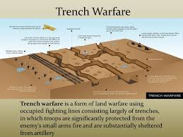
Raleigh: Yes, in my pack. (He rises to get it.)
Osborne: Better wait and unpack when you know where you are sleeping.
Raleigh: Righto! (He sits down again.)
Osborne: We never undress when we’re in the line. You can take your boots off now and then in the daytime, but it’s better to keep pretty well dressed always.
Raleigh: I see. Thanks.
Osborne: I expect we shall each do about three hours on duty at a time and then six off. We all go on duty at stand-to. That’s at dawn and dusk.
Raleigh: Yes.
Osborne: I expect Stanhope’ll send you on duty with one of us at first — till you get used to it.
(There is a pause. Raleigh turns, and looks curiously up the steps into the night.)
Raleigh: Are we in the front line here?
Osborne: No. That’s the support line outside. The front line’s about fifty yards farther on.
Raleigh: How frightfully quiet it is!
Osborne: It’s often quiet — like this.
Raleigh: I thought there would be an awful row here — all the time.
Osborne: Most people think that.
(Pause.)
Raleigh: I’ve never known anything so quiet as those trenches we came by; just now and then I heard rifle firing, like the range at Bisley, and a sort of rumble in the distance.
Osborne: Those are the guns up north — up Wipers way. The guns are always going up there; it’s never quiet like this. (Pause.) I expect it’s all very strange to you?

Raleigh: It’s — it’s not exactly what I thought. It’s just this — this quiet that seems so funny.
Osborne: A hundred yards from here the Germans are sitting in their dug-outs, thinking how quiet it is.
Raleigh: Are they as near as that ?
Osborne: About a hundred yards.
Raleigh: It seems — uncanny. It makes me feel we’re — we’re all just waiting for something.
Osborne: We are, generally, just waiting for something. When anything happens, it happens quickly. Then we just start waiting again.
Raleigh: I never thought it was like that.
Osborne: You thought it was fighting all the time?
Raleigh [laughing]: Well, yes, in a way.
Osborne [after puffing at his pipe in silence for a While]: Did you come up by trench to-night —
or over the top?
Raleigh: By trench. An amazing trench — turning and twisting for miles, over a sort of plain.
Osborne: Lancer’s Alley it’s called.
Raleigh: Is it? It’s funny the way it begins — in that ruined village, a few steps down into the cellar of a house — then right under the house and through a little garden — and then under the garden wall — then alongside an enormous ruined factory place — then miles and miles of plains, with those green lights bobbing up and down ahead — all along the front as far as you can see.
Osborne: Those are the Very lights. Both sides fire them over No Man’s Land — to watch for raids and patrols.
Raleigh: I knew they fired lights. [Pause]. I didn’t expect so many — and to see them so far away.
Osborne: I know. [He puffs at his pipe]. There’s something rather romantic about it all.
Raleigh [eagerly]: Yes. I thought that, too.
Osborne: You must always think of it like that if you can. Think of it all as — as romantic. It helps.

Who's for the Game? by Jessie Pope

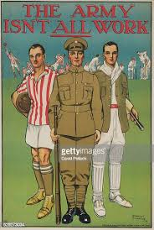
Who’s for the game, the biggest that’s played,
The red crashing game of a fight?
Who’ll grip and tackle the job unafraid?
And who thinks he’d rather sit tight?
Who’ll toe the line for the signal to ‘Go!’?
Who’ll give his country a hand?
Who wants a turn to himself in the show?
And who wants a seat in the stand?
Who knows it won’t be a picnic – not much-
Yet eagerly shoulders a gun?
Who would much rather come back with a crutch
Than lie low and be out of the fun?
Come along, lads –
But you’ll come on all right –
For there’s only one course to pursue,
Your country is up to her neck in a fight,
And she’s looking and calling for you.

Recruitment by E. Alan Mackintosh

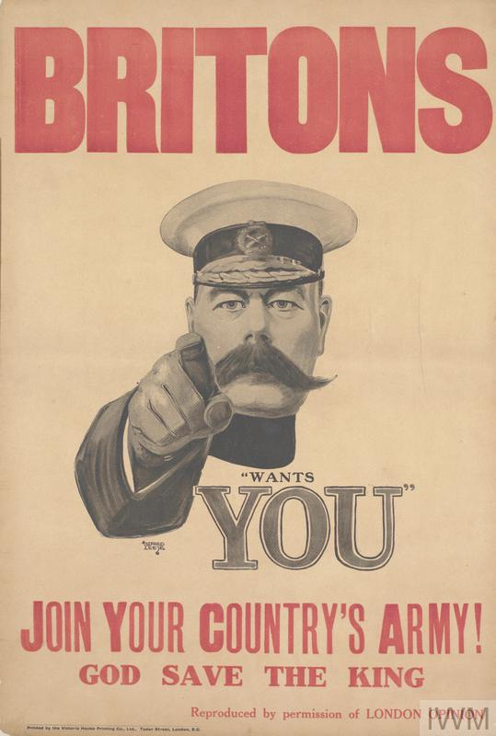
‘Lads, you’re wanted, go and help,’
On the railway carriage wall
Stuck the poster and I thought
Of the hands that penned the call.
Fat civilians wishing they
‘Could go out and fight the Hun.’
Can’t you see them thanking God
That they’re over forty-one?
Girls with feathers, vulgar songs –
Washy verse on England’s need –
God – and don’t we damned well know
How the message ought to read.
‘Lads, you’re wanted! over there,’
Shiver in the morning dew,
More poor devils like yourselves
Waiting to be killed by you.
What different attitudes do these two poems show about young men joining the army to fight in WWI?
Go and help to swell the names
In the casualty lists.
Help to make a column’s stuff
For the blasted journalists.
Help to keep them nice and safe
From the wicked German foe,
Don’t let him come over here!
‘Lads, you’re wanted-out you go.’
There’s a better world than that,
Lads, and can’t you hear it come,
From a million men that call
You to share their martyrdom.
Leave the harlots still to sing
Comic songs about the Hun,
Leave the fat old men to say
Now we’ve got them on the run.
Better twenty honest years
Than their dull three score and ten.
Lads you’re wanted. Come and learn
To live and die with honest men.
You shall learn what men can do
If you will but pay the price,
Learn the gaiety and strength
In the gallant sacrifice.
Take your risk of life and death
Underneath the open sky.
Live clean or go out quick –
Lads you’re wanted. Come and die.

Lionel Ferguson, joined the British Army in Liverpool, interview (1978)
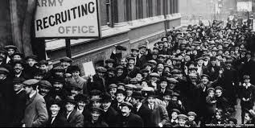

That afternoon I decided to join the Liverpool Scottish. What sights I saw on my way up to Frazer Street: a queue of men over two miles long in the Haymarket; the recruiting office took over a week to pass in all those thousands. At the Liverpool Scottish HQ things seemed hopeless; in fact I was giving up hopes of ever getting in, when I saw Rennison, an officer of the battalion, and he invited me into the mess, getting me in front of hundreds of others. I counted myself in luck to secure the last kilt, which although very old and dirty, I carried away to tog myself in.

George Coppard was sixteen when he joined the Royal West Surrey Regiment in August, 1914.

Although I seldom saw a newspaper, I knew about the assassination of Archduke Ferdinand at Sarajevo. News placards screamed out at every street corner, and military bands blared out their martial music in the main streets of Croydon. This was too much for me to resist, and as if drawn by a magnet, I knew I had to enlist straight away.
I presented myself to the recruiting sergeant at Mitcham Road Barracks, Croydon. There was a steady stream of men, mostly working types, queuing to enlist. The sergeant asked me my age, and when told, replied, "Clear off son. Come back tomorrow and see if you're nineteen, eh?" So I turned up again the next day and gave my age as nineteen. I attested in a batch of a dozen others and, holding up my right hand, swore to fight for King and Country. The sergeant winked as he gave me the King's shilling, plus one shilling and ninepence ration money for that day.

Does Sherriff effectively portray conditions in the trenches?
Stage directions are important and should be paid as much attention to as the dialogue itself. Stage directions are responsible for telling the director and actors how the scene should look and feel to the audience.
Many members of the audience would have been in the war and experienced trench life for themselves. What do the stage directions in this extract tell us about life in the trenches?

THE SCENE

A dug-out in the British trenches before St. Quentin .

A few rough steps lead into the trench above , through a low doorway . A table occupies a good space of the dug-out floor. A wooden frame , covered with wire netting , stands against the left wall and serves the double purpose of a bed and a seat for the table. A wooden bench against the back wall make another seat , and two boxes serve for the other sides.
Another wire-covered bed is fixed in the right corner beyond the doorway.
Gloomy tunnels lead out of the dug-out to left and right .
Except for the table , beds , and seats , there is no furniture save the bottles holding the candles, and a few tattered magazine pictures pinned to the wall of girls in flimsy costumes. The earth walls deaden the sounds of war, making them faint and far away , although the front line is only fifty yards ahead. The flames of the candles that burn day and night are steady in the still, damp air.
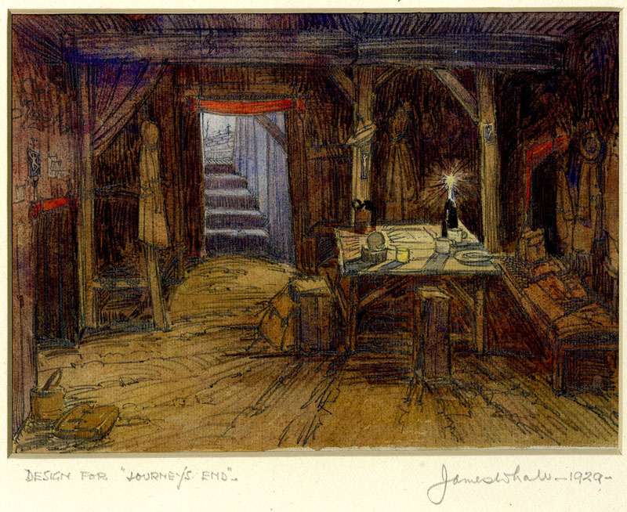

This extract is taken from the opening of the play. Osborne and Hardy are discussing life in the trenches.
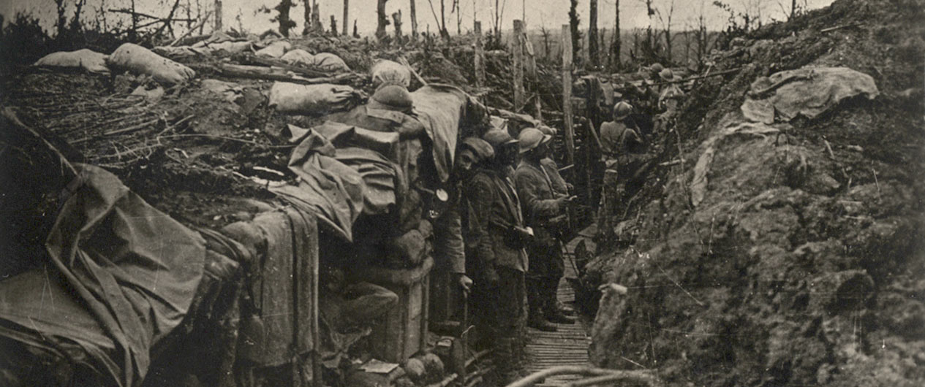

The evening of a March day. A pale glimmer of moon- light shines down the narrow steps into one corner of the dug-out. Warm yellow candle-flames light the other corner from the necks of two bottles on the table. Through the doorway can be seen the misty grey parapet of a trench and a narrow strip of starlit sky. A bottle of whiskey, a jug of water, and a mug stand on the table amongst a litter of papers and magazines. An officer's equipment hangs in a jumbled mass from a nail in the wall. Captain Hardy, a red-faced, cheerful-looking man, is sitting on a box by the table, intently drying a sock over a candle flame. He wears a heavy trench-boot on his left leg, and his right foot, which is naked, is held above the damp floor by resting it on his left knee. His right boot stands on the floor beside him. As he carefully turns the sock this way and that— feeling it against his face to see if it is dry — he half sings, half hums a song — humming when he is not quite sure of the words, and marking time with the toes of his right foot.
Hardy: One and Two it’s with Maud and Lou;
Three and Four, two girls more ;
Five and Six it’s with — hm — hra — hm —
Seven, Eight, Clara and Caroline
[He lapses into an indefinite humming, and finishes with a lively burst]
Tick ! — Tock ! — wind up the clock.
And we start the day over again.
[A man's legs appear in the moonlit trench above, and a tall, thin man comes slowly down the dug-out steps, stooping low to avoid the roof. He takes his helmet off and reveals a fine head, with close-cropped, iron-grey hair. He looks about forty-five — physically as hard as nails].
Hardy [looking round]: Hullo, Osborne! Your fellows arriving?
Osborne [hitching off his pack and dropping it in a corner]: Yes. They’re just coming in.
Hardy: Splendid! Have a drink.
Osborne: Thanks. [He crosses and sits on the left- hand bed].
Hardy [passing the whiskey and a mug]: Don’t have too much water. It’s rather strong today.
Osborne [slowly mixing a drink]: I wonder what it is they put in the water.
Hardy: Some sort of disinfectant, I suppose.
Osborne: I’d rather have the microbes, wouldn’t you?
Hardy: I would — yes.
Osborne: Well, cheero.
Hardy: Cheero. Excuse my sock, won’t you?
Osborne: Certainly. It’s a nice-looking sock.
Hardy: It is rather, isn’t it? Guaranteed to keep the feet dry. Trouble is, it gets so wet doing it.
Osborne: Stanhope asked me to come and take over. He’s looking after the men coming in.
Hardy: Splendid! You know, I’m awfully glad you’ve come.
Osborne: I heard it was a quiet bit of line up here.
Hardy: Well, yes — in a way. But you never know. Sometimes nothing happens for hours on end; then — all of a sudden — over she comes! — rifle grenades — Minnies — and those horrid little things like pineapples — you know.
Osborne: I know.
Hardy: Swish — swish — swish — swish — bang!
Osborne: All right-all right— I know.
Hardy: They simply blew us to bits yesterday. Minnies — enormous ones; about twenty. Three bang in the trench. I really am glad you’ve come; I’m not simply being polite.
Osborne: Do much damage?
Hardy: Awful. A dug-out got blown up and came down in the men’s tea. They were frightfully annoyed.
Osborne: I know. There’s nothing worse than dirt in your tea.
Hardy: By the way, you know the big German attack’s expected any day now?
Osborne: It’s been expected for the last month.
Hardy: Yes, but it’s very near now; there’s funny things happening over in the Boche country. I’ve been out listening at night when it’s quiet. There’s more transport than usual coming up — you can hear it rattling over the pavé all night; more trains in the distance — puffing up and going away again, one after another, bringing up loads and loads of men.
Osborne: Yes. It’s coming — pretty soon now.
Hardy: Are you here for six days?
Osborne: Yes.
Hardy: Then I should think you’ll get it — right in the neck.
Osborne: Well, you won’t be far away. Come along, let’s do this handing over. Where’s the map?
Hardy: Here we are. [He gropes among the papers on the table and finds a tattered map]. We hold about two hundred yards of front line. We’ve got a Lewis gun just here — and one here, in this little sap. Sentry posts where the crosses are.
Osborne: Where do the men sleep?
Hardy: I don’t know. The sergeant-major sees to that. [He points off to the right] The servants and signallers sleep in there. Two officers in here, and three in there. [He points to the left-hand tunnel]. That is, if you’ve got five officers.
Osborne: We’ve only got four at present, but a new man’s coming up to-night. He arrived at transport lines a day or two ago.
Hardy: I hope you get better luck than I did with my last officer. He got lumbago the first night and went home. Now he’s got a job lecturing young officers on life in the front line.
Osborne: Yes. They do send some funny people over here nowadays. I hope we’re lucky and get a youngster straight from school. They’re the kind that do best.
Hardy: I suppose they are, really.
Osborne: Five beds, you say? [He examines the one he is sitting on]. Is this the best one?
Hardy: Oh, no. (He points to the bed in the right corner.) That’s mine. The ones in the other dug-out haven’t got any bottoms to them. You keep yourself in by hanging your arms and legs over the sides. Mustn’t hang your legs too low, or the rats gnaw your boots.
Osborne: You got many rats here?
Hardy: I should say — roughly — about two million; but then, of course, I don’t see them all. [He begins to put on his sock and draw on his boot]. Well, there’s nothing else you want to know, is there?

Life in the trenches of the First World War

The Long, Long Trail

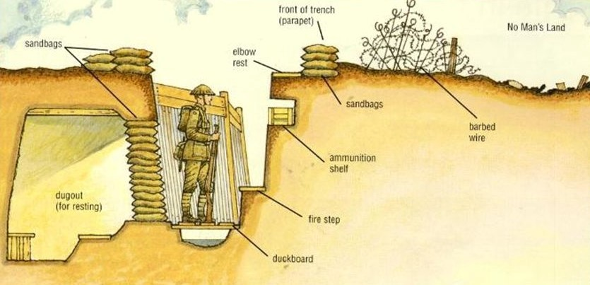
Researching soldiers of the British Army in the Great War of 1914-1919

What were the trenches?
Although most of us think primarily of the Great War in terms of life and death in the trenches, only a relatively small proportion of the army actually served there. The trenches were the front lines: the most dangerous places. But behind them was a mass of supply lines, training establishments, stores, workshops, headquarters and all the other elements of the 1914-1918 system of war, in which the majority of troops were employed. The trenches were the domain of the infantry, with the supporting arms of the mortars and machine-guns, the engineers, the medics and the forward positions of the artillery observers.

What were the trenches like?
The type and nature of the trench positions varied a lot, depending on the local conditions. For example, in the area of the River Somme in France the ground is chalky and is easily dug. The trench sides will crumble easily after rain, so would be built up (‘revetted’) with wood, sandbags or any other suitable material. At Ypres in Belgium the ground is naturally boggy and the water table very high, so trenches were not really dug, but more built up using sandbags and wood (these were called ‘breastworks’). In parts of Italy, trenches were dug in rock; in Palestine in desert. In France the trenches ran through towns and villages, through industrial works, coalmines, brickyards, across railway tracks, through farms, fields and woods, across rivers, canals and streams. Each feature presented its own set of challenges for the men who had to dig in and defend. In the major offensives of 1915, 1916 and 1917 many trench positions were only held for a few days at a time before the next advance moved them on into what had been no man’s land or the enemy position. These trenches were scratch affairs, created as the advancing troops dug in, and were sometimes little more than 18 inches deep.

Living conditions
Trench conditions varied widely between different theatres of war, different sectors within a theatre, and with the time of year and weather. Trench life was however always one of considerable squalor, with so many men living in a very constrained space. Scraps of discarded food, empty tins and other waste, the nearby presence of the latrine, the general dirt of living half underground and being unable to wash or change for days or weeks at a time created conditions of severe health risk (and that is not counting the military risks). Vermin including rats and lice were very numerous; disease was spread both by them, and by the maggots and flies that thrived on the nearby remains of decomposing human and animal corpses. Troops in the trenches were also subjected to the weather: the winter of 1916-1917 in France and Flanders was the coldest in living memory; the trenches flooded in the wet, sometimes to waist height, whenever it rained. Men suffered from exposure, frostbite, trench foot (a wasting disease of the flesh caused by the foot being wet and cold, constrained into boots and puttees, for days on end, that would cripple a man), and many diseases brought on or made worse by living in such a way.
Where possible, the floor of the trench was made by using wooden duckboards. One of the features the diagrams above do not show is the latrine, which had to be dug somewhere close to hand. This was generally as deep a hole in the ground as possible, over which was mounted a plank to sit on. Men would, with permission, leave their post to use the latrine. This rough form of sanitation was often a target for enemy snipers and shellfire and was also a considerable smell and health hazard for the men in the trenches.

DISEASE IN THE TRENCHES
The Biomedical Scientist
26 March 2018

To mark 100 years since the First World War came to a close, we look at the conditions in the trenches and hear from the diaries and letters of those who endured the horrific conflict.
The First World War is estimated to have claimed 20 million lives and to have left 21 million wounded. The total number of deaths included 9.7 million military personnel and about 10 million civilians. Of these deaths, an estimated 5.7m were soldiers fighting for the Allies.
Many died in combat, through accidents, or perished as prisoners of war. But the majority of loss of life can be attributed to famine and disease – horrific conditions meant fevers, parasites and infections were rife on the frontline and ripped through the troops in the trenches.
Among the diseases and viruses that were most prevalent were influenza, typhoid, trench foot and trench fever.

The biggest risk
Ceri Gage, Curator of Collections at the Army Medical Services Museum in Aldershot, says that infection posed one of the greatest medical risks.
“A simple cut to a finger from cleaning your gun or digging a trench could quite quickly become infected and develop into pneumonia,” she says.
“The men were knee-deep in mud nine out of 12 months of the year, surrounded by bacteria from the bodies of men and animals in no-man’s-land.
“Their bodies were weaker anyway from a lack of sleep, wet and dirty clothes and a restricted diet in which a piece of fruit or vegetable was a treat.”
Field ambulance records show how the pattern of offensives and attacks dominated work for the doctors at times. On a single day, up to 300 men could be admitted with gas poisoning and on days where there was no fighting, medics were able to treat non-urgent cases, such as tooth decay.
But despite the threat of fighting, documents show that the top five conditions treated by 51st Field Ambulance were pyrexia (a catch-all term for fevers)(8.7%), inflammation of connective tissue (7.9%), trench foot (6.8%), influenza (6.6%) and scabies (6.1%). Shrapnel comes in sixth place, causing 4.9% of conditions treated. The figures come from the Western Front and were compiled from the records of 30,000 men treated in field hospitals (see box, opposite, for the top 20 conditions treated by the 51st Field Ambulance).

Trench fever
Trench fever, often classed as “pyrexia”, is a condition that was first reported from troops in Flanders in 1915, when individuals suffered from a febrile illness that relapsed in five-day cycles. At the time, the cause of the disease was unknown.
It is estimated to have affected 380,000 to 520,000 members of the British army and had a debilitating effect, leaving a large numbers of men incapacitated.
A lot of research was carried out by the British and US to identify the cause and mechanism of transmission.
Due to its similarity to Malaria, many thought that lice were the cause, but attempts to find a treatment were not successful, and efforts to prevention were mainly focussed in using insecticides to delouse clothing.
At the time, the causative agent was identified and grouped with the Rickettsia and named Rickettsia Quintana. After the war, R. quintana would subsequently join the genus Bartonella.

Trench foot
Another common and serious issue was trench foot, especially during the winter of 1914-15, when over 20,000 of the Allied are thought to have been affected. By the end of the war, a total of 74,000 Allied troops are believed to have suffered from the condition.
The issue was prominent in trenches that were dug in land that was at, or near, sea level, where the water table was just beneath the surface.
The soldiers would hit water after a couple of feet and the trenches would flood. After long periods standing in soaking wet socks and boots, trench foot would start to set in. The men’s feet would swell and go numb and then the skin would start to turn red or blue. Untreated feet often became gangrenous and the condition could lead to nerve damage, tissue loss and ultimately the need for amputation.
To minimize the chances of contacting trench foot, men were ordered to change into dry socks as often as possible. And around 1916, John Logie Baird started to sell socks prepared with borax to help alleviate the problems of wet feet.
Rats
The trenches were home to millions of rats, which could produce up to 900 young a year, meaning attempts to kill and curb the rat population proved futile.
Private Harold Saunders enlisted in the 14th London (London Scottish) in November 1915, and went to France with the 2nd Battalion in June 1916.
When the 6oth Division left France for Salonika, he was left behind with a septic heel. He was then transferred to the 1st Battalion and was finally discharged April 1918.
In an account of his experiences, published in the 1930 anthology Everyman at War, he wrote: “One got used to many things, but I never overcame my horror of the rats. They abounded in some parts, great loathsome beasts gorged with flesh. I shall never forget a dug-out at the back of the line near Anzin. It was at the foot of rising ground, at the top of which was a French war cemetery.
“About the same time every night the dug-out was invaded by swarms of rats. They gnawed holes in our haversacks and devoured our iron rations. We hung haversacks and rations to the roof, but they went just the same. Once we drenched the place with creosote. It almost suffocated us, but did not keep the rats away. They pattered down the steps at the usual time, paused a moment and sneezed, and then got to work on our belongings. A battalion of Jerrys would have terrified me less than the rats did sometimes.”

Flies
Harold William Cronin, Lieutenant in 5th Bedfordshire Regiment, described the conditions in which diseases thrived in a letter home.
“In the trenches it was fairly bad, they are so narrow and smelly and one is being potted at and shelled all the time.”
He continued: “Although it is so gloriously sunny something is wrong with the place and it really isn’t as healthy as it looks. I think the flies have something to do with it as well as the heat and the still unburied dead bodies about.
“There are millions and millions of flies here and they are all over everything. Put a cup of tea down without a cover and it is immediately covered with dead ones, they are all round your mouth and directly you open it to speak or to eat in they pop. It is a game. We have all got nets of course, we should have been worried, no medicine by now if we hadn’t.”

This extract is taken from Act Three. Osborne and Raleigh are preparing for the raid.
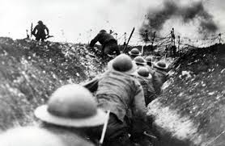

Raleigh: Is it time yet?
Osborne: Two minutes. Then we must go up. I wish we had a good hot bath waiting for us when we get back.
Raleigh: So do I. [Pause]. We’re having something special for dinner, aren’t we?
Osborne: How did you know? It’s supposed to be a secret.
Raleigh: Mason dropped a hint.
Osborne: Well, we’ve had a fresh chicken sent up from Noyelle Farm.
Raleigh: I say!
Osborne: And a most awful luxury — two bottles of champagne and half a dozen cigars! One each, and one spare one in case one explodes.
Raleigh: I’ve never smoked a cigar.
Osborne: It’s bound to make you sick.
[Raleigh notices Osborne’s ring on the table; he picks it up].
Raleigh: I say, here’s your ring.
Osborne: Yes. I’m — I’m leaving it here. I don’t want the risk of losing it.
Raleigh: Oh! [There is silence. He puts the ring slowly down].
Osborne [rising]: Well, I think perhaps we ought to get ready.
Raleigh: Yes. Righto. [He also rises].
Osborne: I’m not going to wear a belt — -just my revolver, with the lanyard round my neck.
Raleigh: I see. [He puts his lanyard round his neck and grips his revolver]. I feel better with this in my hand, don’t you?
Osborne: Yes. Something to hold. Loaded all right?
Raleigh: Yes.

[They put on their helmets. Osborne takes his pipe from his mouth and lays it carefully on the table].
Osborne: I do hate leaving a pipe when it’s got a nice glow on the top like that.
Raleigh [with a short laugh]: What a pity!
[There is another pause. Osborne glances at his watch as it lies on the table.]
Osborne: Three minutes to. I think we’d better go.
Raleigh: Righto.
[Their eyes meet as Osborne turns from the table.]
Osborne: I’m glad it’s you and I — together Raleigh.
Raleigh [eagerly]: Are you — really?
Osborne: Yes.
Raleigh: So am I — awfully.
Osborne: We must put up a good show.
Raleigh: Yes. Rather!
[There is a short pause.]
Osborne: Let’s go along, shall we?
Raleigh: Righto. [They go towards the steps.]
Mason comes to the entrance of his dug-out as they pass.
Mason: Good luck, sir.
Osborne: Thanks, Mason.
Mason: It’s a lovely chicken for dinner, sir.
Osborne [slowly going up the steps]: Splendid!
Mason: Good luck, Mr. Raleigh.
Raleigh: Thanks.
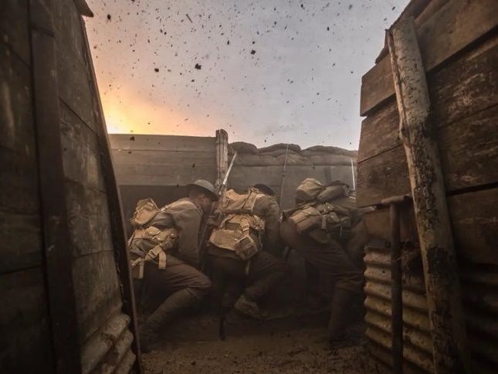
[Osborne and Raleigh go up together into the pale evening sun. Mason tidies the papers on the table; picks up the two coffee mugs and goes away.
There is silence in the trenches above the deserted dug-out. Then, suddenly, there comes the dull “crush” of bursting smoke bombs, followed in a second by the vicious rattle of machine-guns. The red and green glow of German alarm rockets comes faintly through the dug-out door. Then comes the thin whistle and crash of falling shells; first one by itself, then two, almost together. Quicker and quicker they come, till the noise mingles together in confused turmoil. Yet the noise is deadened by the earth walls of the tiny dug-out, and comes quite softly till the whine of one shell rises above the others to a shriek and a crash. A dark funnel of earth leaps up beyond the parapet of the trench outside; earth falls and rattles down the steps and a black cloud of smoke rises slowly out of sight. Gradually the noise dies away — there is a longer pause between the crash of each bursting shell. The machine-guns stop — rattle again and stop — rattle for the last time — and stop.
Voices are calling in the trench outside; Stanhope’s voice is heard].
Stanhope: All right, sir. Gone down quickly!
Colonel: How many?
Stanhope: Only one.
[Another shell whines and shrieks and crashes nearby. There is silence for a moment, then Stanhope speaks again.] Hurt, sir?
Colonel: No. It’s all right.
[Stanhope, pale and haggard, comes down the steps followed by the Colonel].
Stanhope [calling up the steps]: Bring him down, Sergeant-Major.
S.-M. [above]: Coming, sir.
Stanhope [to the Colonel]: You won’t want me, will you?
Colonel: Well — er
Stanhope: I want to go and see those men.
Colonel: Oh, all right.
[Stanhope goes to the door, making way for the Sergeant-Major to come down, followed by a bareheaded German Boy, in field grey, sobbing bitterly. Behind come two Soldiers with fixed bayonets.
Stanhope goes up the steps.
The Sergeant-Major takes the German Boy by the arm and draws him into the centre of the dug-out to face the Colonel, who has seated himself at the table. The two Soldiers stand behind].
S.-M. [soothingly to the German Boy]: All right, sonny, we ain’t going to ’urt you.
[Suddenly the Boy falls on his knees and sobs out some words in broken English.]
German: Mercy — mister — mercy!
S.-M.: Come on, lad, get up. [With a huge fist he takes the Boy by the collar and draws him to his feet.
The Boy sobs hysterically. The Colonel clears his throat and begins in somewhat poor German].
Colonel: Was ist sein Regiment?
German: Wurtembergs.
Colonel: Was ist der nummer von sein Regiment?
German: Die Zwanzig.
Colonel [making a note]: Twentieth Wurtembergers. [He looks up again]. Wann kommen sie hier?
German: Gestem abend.
Colonel [making a note and looking up again]: Wo kommen sie her?
German [after a moment’s thought]: Mein Geburtsort?
Colonel [forgetting himself for a moment]: What’s that?
German [in halting English]: You — wish — to know — where I was — born?
Colonel: No! What town did you come up to the line from?
German [after a little hesitation]: I — do not tell you.
Colonel: Oh, well, that’s all right. [To the Sergeant Major.] Search him.
[The Sergeant-Major’s big fists grope over the Boy’s pockets. He produces a small book.]
S.-M. [giving it to the Colonel]: Looks like ’is pay-book, sir.
Colonel [looking eagerly into the book]: Good.
[The Sergeant-Major has found a pocket-book; the German Boy clutches at it impulsively.]
S.-M.: ’Ere, stop that!
German: Lass mich! [He pauses]. Let — me — please — keep — that.
S.-M. [very embarrassed]: You let go! [He wrenches the case away and gives it to the Colonel].
Colonel [glancing at the papers in the case]: Look like letters. May be useful. Is that all, sergeant-major?
S.-M. [looking at a few articles in his hands]: ’Ere’s a few oddments, sir — bit o’ string, sir; little box o’ fruit drops; pocket-knife, sir; bit o’ cedar pencil — and a stick o’ chocolate, sir.
Colonel: Let him have those back, except the pocket-knife.
S.-M.: Very good, sir. [He turns to the German Boy with a smile] ’Ere you are, sonny.
[The German Boy takes back the oddments.]
Colonel: All right, sergeant-major. Send him straight back to my headquarters. I’ll question him again there.
S.-M.: Very good, sir. [He turns to the German.] Come on, sonny, up you go. [He points up the steps.]
[The German Boy, calm now, bows stiffly to the Colonel and goes away, followed by the two Soldiers and the Sergeant-Major. The Colonel is deeply absorbed in the German's pay-book. He mutters “Splendid” to himself then looks at his watch and rises quickly.
Stanhope comes slowly down the steps.]
Colonel [excitedly]: Splendid, Stanhope! We’ve got all we wanted — 20th Wurtembergers! His regiment came into the line last night. I must go right away and ’phone the brigadier. He’ll be very pleased about it. It’s a feather in our cap, Stanhope.
[Stanhope has given one look of astonishment at the Colonel and strolled past him. He turns at the table and speaks in a dead voice.]
Stanhope: How awfully nice — if the brigadier’s pleased.
[The Colonel stares at Stanhope and suddenly collects himself.]
Colonel: Oh — er — what about the raiding- party — are they all safely back.
Stanhope: Did you expect them to be all safely back, sir?
Colonel: Oh — er — what — er
Stanhope: Four men and Raleigh came safely back, sir.
Colonel: Oh, I say, I’m sorry that’s — er — six men and — er — Osborne?
Stanhope: Yes, sir.
Colonel: I’m very sorry. Poor Osborne!
Stanhope: Still it’ll be awfully nice if the brigadier’s pleased.

Colonel: Don’t be silly, Stanhope. Do you know — er — what happened to Osborne?
Stanhope: A hand grenade — while he was waiting for Raleigh.
Colonel: I’m very sorry. And the six men?
Stanhope: Machine-gun bullets, I suppose.
Colonel: Yes. I was afraid — er
[His words trail away; he fidgets uneasily as Stanhope looks at him with a pale, expressionless face. Raleigh comes slowly down the steps, walking as though he were asleep; his hands are bleeding. The Colonel turns to the boy with enthusiasm.] Very well done, Raleigh. Well done, my boy. I’ll get you a Military Cross for this! Splendid! [Raleigh looks at the Colonel and tries to speak. He raises his hand to his forehead and sways. The Colonel takes him by the arm.] Sit down here, my boy. [Raleigh sits on the edge of Osborne’s bed.] Have a good rest. Well, I must be off. [He moves towards the steps, and, turning once more to Raleigh as he leaves] Very well done. [With a quick glance at Stanhope, the Colonel goes away.]
There is a silence now in the trenches outside; the last shell has whistled over and crashed. Dusk is beginning to fall over the German lines. The glow of Very lights begins to rise and fade against the evening sky. Stanhope is staring dumbly at the table — at Osborne’s watch and ring. Presently he turns his haggard face towards Raleigh, who sits with lowered head, looking at the palms of his hands. Stanhope moves slowly across towards the doorway, and pauses to look down at Raleigh. Raleigh looks up into Stanhope’s face, and their eyes meet. When Stanhope speaks, his voice is still expressionless and dead.]
Stanhope: Must you sit on Osborne’s bed?
Raleigh: I’m sorry. [He rises].
[Stanhope turns and goes slowly up the steps. Raleigh stands with lowered head. Heavy guns are booming miles away].
The Curtain Falls
How does Sherriff use Stanhope to show the impact of war on a person?

In this extract from Act I, Raleigh joins as a new officer. He is talking to Osborne about his excitement of knowing that a boy a few years older than him from school, Stanhope, is also in this Battalion.

Raleigh : You don’t think Dennis’ll mind my — sort of — forcing myself into his company? I never thought of that ; I was so keen.
Osborne : No, of course he won’t. (Pause.) You say it’s — it’s a good time since you last saw him ?
Raleigh : Let’s see. It was in the summer last year — nearly a year ago.
Osborne : You know, Raleigh, you mustn’t expect to find him — quite the same.
Raleigh : Oh ?
Osborne : You see, he’s been out here a long time. It — it tells on a man — rather badly.
Raleigh (thinking) : Yes, of course, I suppose it does.
Osborne : You may find he’s — he’s a little bit quick-tempered.
Raleigh (laughing) : Oh, I know old Dennis’s temper ! I remember once at school he caught some daps in a study with a bottle of whiskey. Lord ! the roof nearly blew off. He gave them a dozen each with a cricket stump. (Osborne laughs) He was so keen on the fellows in the house keeping fit. He was frightfully down on smoking — and that sort of thing.
Osborne : You must remember he’s commanded this company for a long time — through all sorts of rotten times. It’s — it’s a big strain on a man.
Raleigh : Oh, it must be.
Osborne : If you notice a — difference in Stanhope — you’ll know it’s only the strain.
Raleigh : Oh, yes.

In this extract from Act I, Stanhope feels concerned that Raleigh will post a letter to his sister telling her how Stanhope has changed. He considers censoring Raleigh’s letters to prevent this from happening.

Osborne : I believe Raleigh will go on liking you — and looking up to you — through everything. There’s something very deep, and rather fine, about hero-worship.
Stanhope : Hero-worship be damned ! (He pauses , then goes on, in a strange , high-pitched voice) You know, Uncle, I’m an awful fool. I’m captain of this company. What’s that bloody little prig of a boy matter? D’you see? He’s a little prig. Wants to write home and tell Madge all about me. Well, he won’t ; d’you see, Uncle ? He won't write. Censorship ! I censor his letters — cross out all he says about me.
Osborne : You can’t read his letters.
Stanhope ( dreamily ) : Cross out all he says about me. Then we all go west in the big attack — and she goes on thinking I’m a fine fellow for ever — and ever — and ever. (He pours out a drink , murmuring “ Ever — and ever — and ever .”)
Osborne (rising from his bed) : It’s not as bad as all that. Turn in and have a sleep.
Stanhope : Sleep ! Catch me wasting my time with sleep.
Osborne (picking up Stanhope’s pack and pulling out the blanket) : Come along, old chap. You come and lie down here. (He puts the pack as a pillow on Stanhope’s bed , and spreads out the blanket .)
Stanhope (with his chin in his hands) : Little prig — that’s what he is. Did I ask him to force his way into my company ? No ! I didn’t. Very well, he’ll pay for his damn cheek. (Osborne lays his hand gently on Stanhope’s shoulder to persuade him to lie down.) Go away ! (He shakes Osborne’s hand off.) What the hell are you trying to do ?
Osborne : Come and lie down and go to sleep.
Stanhope : Go sleep y’self. I censor his letters, d’you see. Uncle ? You watch and see he doesn’t smuggle any letters away.
Osborne : Righto. Now come and lie down. You’ve had a hard day of it.
Stanhope ( looking up suddenly) : Where’s Hardy ? D’you say he’s gone ?
Osborne : Yes. He’s gone.
Stanhope : Gone, has he ? Y’know, I had a word to say to Master Hardy. He would go, the swine ! Dirty trenches — everything dirty — I wanner tell him to keep his trenches clean.
Osborne (standing beside Stanhope and putting his hand gently on his shoulder again) : We’ll clean them up to-morrow. [Stanhope looks up at Osborne and laughs gaily.]
Stanhope : Dear old Uncle ! Clean trenches up — with little dustpan and brush (He laughs .) Make you little apron — with lace on it.
Osborne : That’ll be fine. Now then, come along, old chap. I’ll see you get called at two o’clock. (He firmly takes Stanhope by the arm and draws him over to the bed.) You must be tired.
Stanhope (in a dull voice) : God, I’m bloody tired ; ache — all over — feel sick — damn sick. (Osborne helps him on to the bed , takes the blanket and puts it over him.)
Osborne : You’ll feel all right in a minute. How’s that ? Comfortable ?
Stanhope : Yes. Comfortable. (He looks up into Osborne’s face and laughs again.) Dear old Uncle. Tuck me up. (Osborne fumbles the blankets round Stanhope.)
Osborne : There we are.
How does this version of Stanhope differ from the version Raleigh remembers from school?
What point is Sheriff making about the impact of war?
Stanhope : Kiss me, Uncle.
Osborne : Kiss you be damned ! You go to sleep.
Stanhope (closing his eyes) : Yes — I go sleep. (He turns slowly on to his side with his face to the earth wall.)

In this extract from Act III, Raleigh challenges Stanhope on his decision to celebrate the success of the raid by drinking champagne and smoking cigars shortly after Osbourne’s death.

Raleigh : You resent my being here.
Stanhope : Resent you being here ?
Raleigh : Ever since I came.
Stanhope : I don’t know what you mean. I resent you being a damn fool, that’s all. (There is a pause.) Better eat your dinner before it’s cold.
Raleigh : I’m not hungry, thanks.
Stanhope : Oh, for God’s sake, sit down and eat it like a man !
Raleigh : I can’t eat it, thanks.
Stanhope (shouting) : Are you going to eat your dinner ?
Raleigh : Oh ! Good heavens ! Don’t you understand ? How can I sit down and eat that — when — (his voice is nearly breaking) — when Osborne’s — lying — out there. (Stanhope rises slowly. His eyes are wide and staring ; he is fighting for breath and his words come brokenly.)
Stanhope : My God ! You bloody little swine ! You think I don’t care — you think you’re the only soul that cares !
Raleigh : And yet you can sit there and drink champagne — and smoke cigars.
Stanhope : The one man I could trust — my best friend — the one man I could talk to as man to man — who understood everything — and you think I don’t care?
Raleigh : But how can you when ?
Stanhope : To forget, you little fool— to forget ! D’you understand ? To forget ! You think there’s no limit to what a man can bear ?
(He turns quickly from Raleigh and goes to the dark corner by Osborne’s bed. He stands with his face towards the wall , his shoulders heaving as he fights for breath .)
Raleigh : I’m awfully sorry, Dennis. I — I didn’t understand. (Stanhope makes no reply .) You don’t know how — I
Stanhope : Go away, please — leave me alone.
Raleigh : Can’t I –
(Stanhope turns wildly upon Raleigh)
Stanhope : Oh, get out ! For God’s sake, get out !
(Raleigh goes away into his dug-out , and Stanhope is alone . The Very lights rise and fall outside , softly breaking the darkness with their glow — sometimes steel-blue , sometimes grey. Through the night there comes the impatient grumble of gunfire that never dies away.)

This article is taken from a review of the play in 1929. How do the views of the writer emphasise how difficult it was for men such as Stanhope to discuss what they witnessed whilst at war?
‘Journey’s End. Another Point of View’ (October 1929)
H.T.W. Bousefield

After many months of unvarying success the public that has seen Journey’s End has grown to considerable dimensions. Great numbers of ordinary men and women, young and old, have seen it and gone quietly away, and ‘everybody who is anybody’ has seen it too, and gone away to proclaim its wonders, its truth, its force, its – every approving epithet that is fashionable at the moment.
Journey’s End is the worst exhibition of bad taste that this century has seen, and it is tasteless in the way that murder is tasteless.
Does anyone believe that such a sustained insult to our armies would have been tolerated by the nation even five years ago? In 191, what theatre presenting Journey’s End could have escaped the just fury of its audience? In those days the show would have been pelted, smashed, abolished. It survives today because we have mislaid our self-respect; because it provides a kick for sensationalists who have lost their palate…
Twelve countries, one is informed, are staging Journey’s End. Have twelve nations lost their wits? Or are twelve nations enjoying the spectacle of a demoralised Britain? Twelve countries, anyway; but one that has lately established manhood as a popular ideal, rejects it.
No one in these days desires to see war glorified; it has no glory. No one desires to hear that the sacrifice of manhood to war is unnecessary or, from any point of view, desirable… But Journey’s End is not only untrue…its success as a maker of profits at the expense of memories, that hitherto our nation has held sacred, is a circumstance of shame that would astound a pessimist.
How many fathers, mothers, wives and even sweethearts still cherish their love for someone who went out to that hell of war and did not return? Surely a great multitude. How many believed – until the appearance of Journey’s End – in the sheer courage and nobility of spirit of the man or boy who had made the sunshine warm for them? And how many who have seen it can keep their ideal?
There are two outstanding characters in the play. One is a coward whose fear has dominated his whole existence, the other a hero whose heroism is mere drunken despair…Journey’s End is, however, supposed to be a starkly true and realistic picture of our own men who won the greatest war of all time.
There was a time when national honour and personal honour were hotly defended, and man who did not hold his honour sacred, and his country’s honour as his own, was thought unworthy of citizenship in any human society. Surely the honour of the million dead who died in the war for the rest of us, is still a thing beyond profits.

However, the play wasn’t criticised by everyone. In fact, the play’s realism apparently struck a strong personal chord with many theatre goers, including the Norwegian-born Helga Stang, who wrote the following letter to Sherriff:
19 Queensberry Place South Kensington SW7 10th March 1929
Dear Mr Sherriff,
I’ve just returned from seeing Journey’s End, and although it’s dreadfully late I feel I really must write and tell you how absolutely wonderful and true to life it was. I have a brother whom I adore and who went out to France when he was barely eighteen – he came back in 1918 unhurt – without a scratch – but with his nerves shattered completely. For weeks he was nothing but a nervous wreck, even now he will never again be completely normal, and I know – from the little that he has told me of things – that what he faced was just what those men were facing tonight. For one felt they really were facing death – never for one moment did I realise that I was in a theatre, rather I felt as if I were in another dugout, watching a real and living drama unfold itself. How could you do it? How could you create such types? – no, not create them, for they have really lived, but breathe new life into them, make them live again – which is a far greater thing to do. I didn’t cry at all tonight, the whole thing was too tense for me to think of doing so, but when I was home again, musing over it all, I suddenly thought of Osborne sitting with that little brave grin and saying that he liked cocoa for breakfast and then – quite suddenly – I couldn’t help crying. Oh, don’t you see what you have done? You have brought back, so clearly, the memory of the War to so many people who were in danger of forgetting it – you have shown them the horror and wonder of those awful years.

Many ex-servicemen also had praise for the play, such as Captain J H Bray of Lodsworth, West Sussex. In the letter below he remarks how he was struck by its authenticity when he listened to a radio version broadcast by the BBC on Armistice Day 1929:

11/11/29
Dear Sirs
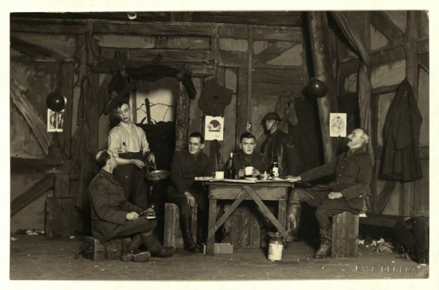
It is doubtful if I shall see Journey’s End on the stage, and so must thank the BBC for the splendid transmission tonight. It was all so vivid and true. The emotions natural to human nature so faithfully portrayed. The animal instinct of fear and self-preservation, the sense of right and wrong striving to overcome for the sake of the cause, and the good fellowship of those who saw the best in their fellows, and tried to help them in their weakness. Only those who have had war experiences can fully appreciate the tense moments before a raid or attack: just waiting, trying to keep your end up and be ready when the moment for action should come, talking of anything but the job, and what may be.
An Ex-Officer J H Bray,
Capt Lodsworth

Photo taken from the touring production of Journey’s End

How are soldiers in WWI presented as struggling to cope with the realities of war?

In this extract from Act II, Hibbert tells Stanhope that he can no longer fight due to his illness and wants to see a doctor to be sent home.

Hibbert : This neuralgia of mine. I’m awfully sorry. I’m afraid I can’t stick it any longer.
Stanhope : I know. It’s rotten, isn’t it ? I’ve got it like hell.
Hibbert ( taken aback) : You have ?
Stanhope : Had it for weeks.
Hibbert : Well, I’m sorry, Stanhope. It’s no good. I’ve tried damned hard ; but I must go down.
Stanhope : Go down — where ?
Hibbert : Why, go sick — go down the line. I must go into hospital and have some kind of treatment. ( There is a silence for a moment .) Stanhope is looking at Hibbert — till Hibbert turns away and walks towards his dug-out . I’ll go right along now, I think.
Stanhope ( quietly ) : You’re going to stay here.
Hibbert : I’m going down to see the doctor. He’ll send me to hospital when he understands —
Stanhope : I’ve seen the doctor. I saw him this morning. He won’t send you to hospital, Hibbert ; he’ll send you back here. He promised me he would. ( There is silence.) So you can save yourself a walk.
Hibbert ( fiercely ) : What the hell !
Stanhope : Stop that !
Hibbert : I’ve a perfect right to go sick if I want to. The men can — why can’t an officer ?
Stanhope : No man’s sent down unless he’s very ill. There’s nothing wrong with you, Hibbert. The German attack’s on Thursday ; almost for certain. You’re going to stay here and see it through with the rest of us.
Hibbert ( hysterically ) : I tell you, I can't — the pain’s nearly sending me mad. I’m going ! I’ve got all my stuff packed. I’m going now— -you can’t stop me! (He goes excitedly into the dug-out . Stanhope walks slowly towards the steps , turns , and undoes the flap of his revolver holster . He takes out his revolver , and stands casually examining it. Hibbert returns with his pack slung on his back and a walking-stick in his hand. He pauses at the sight of Stanhope by the steps . )
Hibbert : Let’s get by, Stanhope.
Stanhope : You’re going to stay here and do your job.
Hibbert : Haven’t I told you ? I can't ! Don’t you understand ? Let — let me get by.
Stanhope : Now look here, Hibbert. I’ve got a lot of work to do and no time to waste. Once and for all, you’re going to stay here and see it through with the rest of us.
Hibbert : I shall die of this pain if I don’t go !
Stanhope : Better die of the pain than be shot for deserting.
Hibbert (in a low voice ) : What do you mean ?
Stanhope : You know what I mean.
Hibbert : I’ve a right to see the doctor !
Stanhope : Good God ! Don’t you understand ! — he’ll send you back here. Dr. Preston’s never let a shirker pass him yet — and he’s not going to start now — two days before the attack.
Hibbert ( pleadingly ) : Stanhope — if you only knew how awful I feel Please do let me go by — [He walks slowly round behind Stanhope. Stanhope turns and thrusts him roughly back . With a lightning movement Hibbert raises his stick and strikes blindly at Stanhope, who catches the stick , tears it from Hibbert’s hands , smashes it across his knee , and throws it on the ground.)
Stanhope : God ! — you little swine. You know what that means — don’t you ? Striking a superior officer !
(There is silence . Stanhope takes hold of his revolver as it swings from its lanyard. Hibbert stands quivering in front of Stanhope.) Never mind, though. I won’t have you shot for that.
Hibbert : Let me go.
Stanhope : If you went, I’d have you shot — for deserting. It’s a hell of a disgrace — to die like that. I’d rather spare you the disgrace. I give you half a minute to think. You either stay here and try and be a man — or you try to get out of that door — to desert. If you do that, there’s going to be an accident. D’you understand ? I’m fiddling with my revolver, d’you see ? — cleaning it — and it’s going off by accident. It often happens out here. It’s going off, and it’s going to shoot you between the eyes.
Hibbert ( in a whisper) : You daren’t.
Stanhope : You don’t deserve to be shot by accident — but I’d save you the disgrace of the other way — I’ll give you half a minute to decide. (He holds up his wrist to look at his watch .) Half a minute from now — (There is silence ; a few seconds go by . Suddenly Hibbert bursts into a high-pitched laugh.)
Hibbert : Go on, then, shoot ! You won’t let me go to hospital. I swear I’ll never go into those trenches again. Shoot ! — and thank God.

Did you know…?
During WW1, any man deserting the battlefield would be tried for cowardice and, if found guilty, they could be shot. Medical evidence was meant to be heard if there was any possibility that desertion could be due to shellshock, but in reality it was often not even called for.
In total, 346 British soldiers were court-martialled and shot for cowardice during the First World War.

Lest we forget: the 306 'cowards' we executed in the first world war
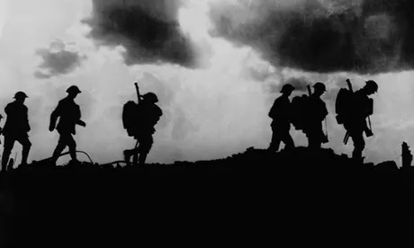
This is a newspaper article from the Guardian written in 1999. The writer is shocked to learn that the government won’t pardon the 306 deserters of the First World War that were shot. It wasn’t until 2006 that these soldiers finally received a pardon.

Eight decades on from the end of the First World War, the 306 British soldiers shot for desertion are still dishonoured, still shamed, still the subject of the official disapproval of Her Majesty's Government.
The microphone at the Cenotaph had been turned off, and the traffic kept at bay for only a brief moment by the police. The homage of Labour MP Andrew MacKinlay - 'We shall remember them' - was all but sabotaged as a silver Saab revved up and the exhaust of a souped-up superbike echoed across Whitehall.
We shall not remember them. We shall not remember Herbert Morrison, who was the youngest soldier in the West India Regiment when he was led in front of the firing squad and gunned down for desertion. A 'coward' at just 17.
We shall not remember the moment when Gertrude Farr went to the local post office in 1916 and was told: 'We don't give pensions to the widows of cowards.' She was left destitute, with a three-year-old and a four-month-old to feed.
To this day, the Ministry of Defence refuses to give a pardon to the 306, convicted of cowardice, though even in 1914 people knew all about 'shell shock' - what the modern world calls Post Traumatic Stress Disorder.
The daughter of Harry and Gertrude Farr was at the Cenotaph yesterday to hear the piper. Still fit and spry at 86 years, Gertrude Harris told of the agony of her father. He went over the top countless times from the day he joined up with the British Expeditionary Force in 1914. He was shelled repeatedly, collapsed with the shakes in May 1915 and was sent to hospital. 'He shook all the time. He couldn't stand the noise of the guns. We got a letter from him, but it was in a stranger's handwriting. He could write perfectly well, but couldn't hold the pen because his hand was shaking.'
It is possible that Farr was suffering from hypacusis, when the ear drums are so damaged that the auditory nerve is exposed and the victim cannot physically bear loud noises. This is a condition familiar to people in Northern Ireland caught up in bomb explosions. Whatever his precise ailment, Farr was sent back to the front line.
And that is not the worst. There was no war pension, only shame. Gertrude said yesterday: 'I only knew the truth about what happened to my father when I was 40. My mother never, ever spoke about it. She was destitute, and we both went into service.'
The historic shaming of men - and, consequentially, their women and children - happened in other countries too. In France and Germany men were shot for cowardice and desertion. But in the case of Germany, only 25, not 306. And in both countries that shame was lifted within a decade of the end of the war when official memorials were built.
Only in Britain do we continue to dishonour the victims of shell shock. The Government's argument echoes the one first set out by John Major. He told the Commons that pardoning the 'deserters' would be an insult to those who died honourably on the battlefield and that everyone was tried fairly.
Some of the executed were clearly under age. The Ministry of Defence defended this last barbarity in a letter dated 24 March 1999 to Shot At Dawn campaigner John Hipkin from MoD historian A. J. Ward. She wrote: 'You also state that a number of soldiers who were under-age were illegally tried and executed. This is not the case. Anyone over the age of 14 was deemed legally responsible for his actions and Army regulations provided no immunity from Military Law for an under-age soldier.'
That may have washed in 1918. For the Government to continue that defence of bureaucratic inertia in 1999 is as plain a disgrace as the silent microphone.

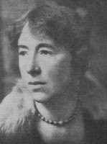
Scars Upon My Heart – War Poetry
Winifred M. Letts was a volunteer nurse based in Manchester during WWI. Like many women at the time, she wrote poetry based on her own experiences and the impact of war on soldiers and their families.

The Deserter

There was a man, - don't mind his name,
Whom Fear had dogged by night and day.
He could not face the German guns
And so he turned and ran away.
Just that - he turned and ran away,
But who can judge him, you or I ?
God makes a man of flesh and blood
Who yearns to live and not to die.
And this man when he feared to die
Was scared as any frightened child,
His knees were shaking under him,
His breath came fast, his eyes were wild.
I've seen a hare with eyes as wild,
With throbbing heart and sobbing breath.
But oh ! it shames one's soul to see
A man in abject fear of death,
But fear had gripped him, so had death;
His number had gone up that day,
They might not heed his frightened eyes,
They shot him when the dawn was grey.
Did you know…?

Blindfolded, when the dawn was grey,
War poetry is mostly associated with male soldiers that fought on the front line and in the trenches.
However, women had been writing anti-war poetry before many of the most famous male poets.
‘Scars Upon My Heart’ is a collection of First World War poems written entirely by women, challenging the idea that they were sat at home ignorant of the realities of war.
These two poems are from this collection.
He stood there in a place apart,
The shots rang out and down he fell,
An English bullet in his heart.
An English bullet in his heart !
But here's the irony of life, -
His mother thinks he fought and fell
A hero, foremost in the strife.
So she goes proudly; to the strife
Her best, her hero son she gave.
O well for her she does not know
He lies in a deserter's grave.

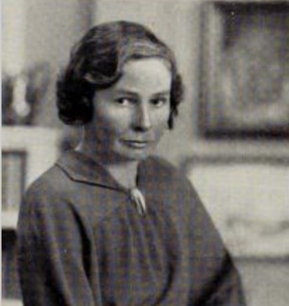
Margaret Postgate Cole was a politician, writer and poet. During the First World War, her brother applied for exemption from military service, on the grounds that he was a conscientious objector. His application was turned down and he was sent to prison. Margaret’s support for her brother led to a belief in pacifism and she began a campaign against conscription.

The Veteran
May 1916

We came upon him sitting in the sun
Blinded by war, and left. And past the fence
There came young soldiers from the Hand and Flower,
Asking advice of his experience.

And he said this, and that, and told them tales,
Thinking Point
What is the writer suggesting about the impact war has on young men in this poem?
And all the nightmares of each empty head
Blew into air; then, hearing us beside,
‘Poor chaps, how’d they know what it’s like?’ he said.

And we stood there, and watched him as he sat,
Turning his sockets where they went away,
Until it came to one of us to ask ‘And you’re – how old?’
‘Nineteen, the third of May.’

Regeneration Extract

This extract is taken from Regeneration by Pat Barker, first published in 1991, which explores the treatment of shell-shocked war victims. In this extract, Sarah, a munitions worker, visits the hospital with the girlfriend of one of the shell-shocked soldiers. At this point Sarah finds herself alone and tries to find her friend again.

Obviously she ought to stop and ask somebody, but then everybody seemed to be in such a hurry, and so grim-faced. At last she found a door that led out to the grounds at the back of the hospital, where the tall chimney of an incinerator dribbled brownish-yellow smoke. Here, a huge tent had been erected and this served as another ward. She glanced into the interior, which was golden in the sunlight filtered through the roof, but the atmosphere was close, stifling, a humming darkness in which the clumsiness of bandages and the itch of healing skin must be almost intolerable. A constant traffic of nurses and orderlies passed between the tent and the main building, and, feeling herself to be in the way, Sarah looked around for somewhere she could find temporary refuge and not bother anybody. There was a conservatory along the side of the hospital, facing east so that at that moment it caught the full warmth of the sun. Shadowy figures sat inside, and the door was open so she thought she might perhaps sit there.
Once across the threshold she became aware of a silence, a silence caused, she suspected, by her entrance. She was still dazzled by the brightness of the light outside and the relative dimness of the interior, and so she had to blink several times before she saw them, a row of figures in wheelchairs, but figures that were no longer the size and shape of adult men. Trouser legs sewn short; empty sleeves pinned to jackets. One man had lost all his limbs, and his face was so drained, so pale, he seemed to have left his blood in France as well. The blue of the hospital uniform looked garish against the skin. They’d been pushed out here to get the sun, but not right outside, and not at the front of the hospital where their mutilations might have been seen by passers-by. They stared at her, but not as the men had stared on the other ward, smiling, trying to catch her eye.
This was a totally blank stare. If it contained anything at all, it was fear. Fear of her looking at the empty trouser legs. Fear of her not looking at them. She stood there, unable to go forward, and unable, for a few crucial moments, to turn back, until a nurse bustled up to her and said, ‘Who is it you want to see?’
‘I’m just waiting for a friend. If it’s alright, I’ll wait outside.’
She backed out, walking away in the sunlight, feeling their eyes on her, thinking that perhaps if she’d been prepared, if she’d managed to smile, to look normal, it might have been better. But no, she thought, there was nothing she could have done that would have made it better. Simply by being there, by being that inconsequential, infinitely powerful creature: a pretty girl, she had made everything worse. Her sense of her own helplessness, her being forced to play the role of Medusa when she meant no harm, merged with the anger she was beginning to feel at their being hidden away like that. If the country demanded that price, then it should bloody well be prepared to look at the result. She strode on through the heat, not caring where she was going, furious with herself, the war…Everything.

Can good people survive a war?

This extract is taken from Act II. The German raid is expected to happen very soon and Stanhope and the Sergeant Major must make difficult decisions that will impact their soldiers.

S.-M. : Well, here’s your very good health, sir. (He raises his glass and drinks .)
Stanhope : Cheero. [He puts down his glass and abruptly changes his tone,) Now, look here, sergeant-major. We must expect this attack on Thursday morning, at dawn. That’s the second dawn from now. The Sergeant-Major takes a very dirty little note-book from his pocket and jots down notes with a very small stub of pencil.]
S.-M. : Thursday morning. Very good, sir.
Stanhope : We’re to hold these trenches, and no man’s to move from here.
S.-M. : Very good, sir.
Stanhope : It may happen that companies on our sides will give way, leaving our flanks exposed ; so I want a screen of wire put down both flanks till it meets the wire in the support line.
S.-M. ( writing hurriedly) : Both flanks — yes, sir.
Stanhope : When the attack begins, I shall take charge of the left, and Mr. Osborne the right. You will be with Mr. Osborne, and Sergeant Baker with me ; 9 and 10 Platoons will move over here [he points out the position on the trench map] ; 1 1 and 12 Platoons to the left.
S.-M. : I see, sir.
Stanhope : Is there anything you’re not clear about ?
S.-M. ( looking at his notes) : Seems all clear, sir.
Stanhope : Anything you want to know ?
S.-M. : Well, sir [clears his throat] — when the attack comes, of course, we beat ’em off— but what if they keep on attacking ?
Stanhope : Then we keep on beating them off.
S.-M. : Yes, sir. But what I mean is — they’re bound to make a big thing of it.
Stanhope [cheerily] : Oh, I think they will !
S.-M. : Well, then, sir. If they don’t get through the first day, they’ll attack the next day and the next.
Stanhope : They’re bound to.
S.-M. : Then oughtn’t we to fix up something about, well [he gropes for the right words] — er — falling back?
Stanhope : There’s no need to — you see, this company’s a lot better than “ A ” and “B ” Companies on either side of us.
S.-M. : Quite, sir.
Stanhope : Well, then, if anyone breaks, “ A ” and “ B ” will break before we do. As long as we stick here when the other companies have given way, we can fire into the Boche as they try and get through the gaps on our sides — we’ll make a hell of a mess of them. We might delay the advance a whole day.
S.-M. ( diffidently ) : Yes, sir, but what ’appens when the Boche ’as all got round the back of us ?
Stanhope : Then we advance and win the war.
S.-M. (chuckling) : I see, sir.
Stanhope : But you understand exactly what I mean, sergeant-major. Our orders are to stick here. If you’re told to stick where you are you don’t make plans to retire.
S.-M. : Quite, sir.
[Osborne’s voice is calling down the steps . Sergeant-Major rises. ]
Osborne : Are you there, Stanhope ?
Stanhope (rising quickly) : Yes. What’s the matter ?
Osborne : The colonel’s up here. Wants to see you.
Stanhope : Oh, right, I’ll come up.
Colonel ( from above) : All right, Stanhope — I’ll come down.
S.-M. ( who has risen ) : Anything more, sir ?
Stanhope : I don’t think so. I’ll see you at stand-to this evening.
S.-M. : Very good, sir.
[He stands back a pace and salutes Stanhope smartly . Stanhope’s eye falls on the Sergeant- Major’s nearly finished drink on the table . He points to it.]
Stanhope : Hoy ! What about that ?
S.-M. : Thank you, sir. (He finishes the drink. The Colonel comes down the steps.)
Colonel : Good morning, sergeant-major.
S.-M. : Good morning, sir.
[The Sergeant-Major goes up the steps.]
Stanhope : Hullo, sir !
Colonel : Hullo, Stanhope ! (He sniffs.) Strong smell of bacon.
Stanhope : Yes, sir. We had some bacon for breakfast.
Colonel : Hangs about, doesn’t it ?
Stanhope : Yes, sir. Clings to the walls.
Colonel : Lovely day.
Stanhope : Splendid, sir.
Colonel : Spring’s coming. (There is a pause.) I’m glad you’re alone. I’ve got some rather serious news.
Stanhope : I’m sorry to hear that, sir. Will you have a drink ?
Colonel : Well, thanks— just a spot.

[Stanhope mixes a drink for the Colonel and himself.] Here’s luck.
Stanhope : Cheero, sir. (. Bringing forward a box .) Sit down, sir.
Colonel : Thanks.
Stanhope : What’s the news, sir ?
Colonel : The brigadier came to see me this morning. (He pauses.) It seems almost certain the attack’s to come on Thursday morning. They’ve got information from more than one source — but they don’t know where it’s going to fall the hardest. The Boche began relieving his frontline troops yesterday. They’re bound to put in certain regiments where they intend to make the hardest push.
Stanhope : Naturally
Colonel : And the general wants us to make a raid to find out who’s come into the line opposite here. [There is a pause .]
Stanhope : I see. When ?
Colonel : As soon as possible. He said tonight.
Stanhope : Oh, but that’s absurd !
Colonel : I told him so. I said the earliest would be tomorrow afternoon. A surprise daylight raid under a smoke screen from the trench-mortar people. I think daylight best. There’s not much moon now, and it’s vitally important to get hold of a Boche or two.
Stanhope : Quite.
Colonel : I suggest sending two officers and ten men. Quite enough for the purpose. Just opposite here there’s only seventy yards of No Man’s Land. To-night the trench-mortars can blow a hole in the Boche wire and you can cut a hole in yours. Harrison of the trench-mortars is coming in to dinner with me this evening to discuss everything. I’d like you to come too. Eight o’clock suit you ?
Stanhope : Very good, sir.
Colonel : I’ll leave you to select the men.
Stanhope : You want me to go with them, sir ?
Colonel : Oh, no, Stanhope. I — I can’t let you go. No. I want one officer to direct the raid and one to make the dash in and collar some Boche.
Stanhope : Who do you suggest, sir ?
Colonel : Well, I suggest Osborne, for one. He’s a very level-headed chap. He can direct it.
Stanhope : And who else ?
Colonel : Well, there’s Trotter — but he’s a bit fat, isn’t he ? Not much good at dashing in ?
Stanhope : No. D’you suggest Hibbert ?
Colonel : Well, what do you think of Hibbert ?
Stanhope : I don’t think so.
Colonel : No.
[ There is a pause . ]

Stanhope : Why not send a good sergeant, sir ?
Colonel : No. I don’t think a sergeant. The men expect officers to lead a raid.
Stanhope : Yes. There is that.
Colonel : As a matter of fact, Stanhope, I’m thinking of that youngster I sent up to you last night.
Stanhope : Raleigh ?
Colonel : Yes. Just the type. Plenty of guts.
Stanhope : He’s awfully new to it all.
Colonel : All to the good. His nerves are sound.
Stanhope : It’s rotten to send a fellow who’s only just arrived.
Colonel : Well, who else is there ? I could send an officer from another company.
Stanhope ( quickly ) : Oh, Lord, no. We’ll do it.
Colonel : Then I suggest Osborne to direct the raid and Raleigh to make the dash — with ten good men. We’ll meet Harrison at supper and arrange the smoke bombs — and blowing a hole in the wire. You select the men and talk to Osborne and Raleigh about it in the meantime.
Stanhope : Very well, sir.
Colonel : Better send Osborne and Raleigh down to me in the morning to talk things over. Or, better still ! — I’ll come up here first thing to-morrow morning.
Stanhope : Right, sir.
Colonel : It’s all a damn nuisance ; but, after all — it’s necessary.
Stanhope : I suppose it is.

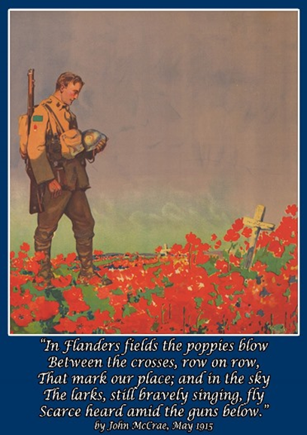
For the Fallen
BY LAURENCE BINYON

With proud thanksgiving, a mother for her children,
England mourns for her dead across the sea.
Flesh of her flesh they were, spirit of her spirit,
Fallen in the cause of the free.

Solemn the drums thrill; Death august and royal
Sings sorrow up into immortal spheres,
There is music in the midst of desolation
And a glory that shines upon our tears.

They went with songs to the battle, they were young,
Straight of limb, true of eye, steady and aglow.
They were staunch to the end against odds uncounted;
They fell with their faces to the foe.

They shall grow not old, as we that are left grow old:
Age shall not weary them, nor the years condemn.
At the going down of the sun and in the morning
We will remember them.

They mingle not with their laughing comrades again;
They sit no more at familiar tables of home;
They have no lot in our labour of the day-time;
They sleep beyond England's foam.

But where our desires are and our hopes profound,
Felt as a well-spring that is hidden from sight,
To the innermost heart of their own land they are known
As the stars are known to the Night;

As the stars that shall be bright when we are dust,
Moving in marches upon the heavenly plain;
As the stars that are starry in the time of our darkness,
To the end, to the end, they remain.

MCMXIV
By Philip Larkin

Those long uneven lines
Standing as patiently
As if they were stretched outside
The Oval or Villa Park,
The crowns of hats, the sun
On moustached archaic faces
Grinning as if it were all
An August Bank Holiday lark;

And the shut shops, the bleached
Established names on the sunblinds,
The farthings and sovereigns,
And dark-clothed children at play
Called after kings and queens,
The tin advertisements
For cocoa and twist, and the pubs
Wide open all day;

And the countryside not caring
The place-names all hazed over
With flowering grasses, and fields
Shadowing Domesday lines
Under wheat’s restless silence;
The differently-dressed servants
With tiny rooms in huge houses,
The dust behind limousines;

Never such innocence,
Never before or since,
As changed itself to past
Without a word—the men
Leaving the gardens tidy,
The thousands of marriages
Lasting a little while longer:
Never such innocence again.

Extract from At Night All Blood is Black by David Diop
At Night All Blood is Black captures the tragedy of a young man's mind hurtling towards madness and tells the little-heard story of the Senegalese who fought for France on the Western Front during the First World War.

I know, I understand, I shouldn’t have. In the world before, I wouldn’t have dared, but in today’s world, God’s truth, I allow myself the unthinkable. No voice rises in my head to forbid me: my ancestors’ voices and my parents’ voices all extinguished themselves the minute I conceived of doing what, finally, I did. I know now, I swear to you that I understood it fully the moment I realized that I could think anything. It happened like that, all of a sudden without warning, it hit me brutally in the head, like a giant seed of war dropped from the metallic sky, the day Mademba Diop died.

Ah! Mademba Diop, my more-than-brother, took too long to die. It was very, very difficult, it wouldn’t end, from dawn into evening, his guts in the air, his insides outside, like a sheep that has been ritually dismembered after the sacrifice. Except Mademba was not yet dead, and already the insides of his body were outside. While the others hid in the gaping wounds in the earth we called trenches, I stayed close to Mademba, I lay pressed against him, my right hand in his left hand, staring at the cold blue sky crisscrossed with metal. Three times he asked me to finish him off, three times I refused. This was before, before I allowed myself to think anything I want. If I had been then what I’ve become today, I would have killed him the first time he asked, his head turned toward me, his left hand in my right.

God’s truth, if I’d already become then what I am now, I would have slaughtered him like a sacrificial sheep, out of friendship. But I thought of my old father, of my mother, of the inner voice that commands us all, and I couldn’t cut the barbed wire of his suffering. I was not humane with Mademba, my more-than-brother, my childhood friend. I let duty make my choice. I offered him only mistaken thoughts, thoughts commanded by duty, thoughts condoned by a respect for human law, and I was not human.

God’s truth, I let Mademba cry like a small child, the third time he begged me to finish him off, pissing himself, his right hand groping at the ground to gather his scattered guts, slimy as freshwater snakes. He said to me, “By the grace of God and of our marabout, if you are my brother, Alfa, if you are really who I think you are, slit my throat like a sacrificial sheep, don’t let the scavengers of death devour my body! Don’t abandon me to all that filth. Alfa Ndiaye … Alfa … I’m begging you … slit my throat!”
But precisely because he spoke to me of our great marabout, precisely so as not to disobey the laws of humanity, the laws of our ancestors, I was not humane and I let Mademba, my more-than-brother, my childhood friend, die with his eyes full of tears, his hand trembling, groping the muddy battlefield for his guts so he could stuff them back into his open belly.

Ah, Mademba Diop! Only after you were gone did I finally begin to think. Only with your death, at dusk, did I know, did I understand that I would no longer listen to the voice of duty, the voice that commands, the voice that leads the way. But it was too late.

Once you were dead, your hands finally immobile, finally at rest, finally released from their shameful suffering by your last breath, I thought only that I should not have waited. I understood, one breath too late, that I should have slit your throat as soon as you asked me to, while your eyes were still dry, your left hand clasped in mine. I shouldn’t have let you suffer like an old solitary lion, eaten alive by hyenas, its insides turned out. I let you plead with me for reasons that were corrupt, because of thoughts that arrived fully formed, too well dressed to be honest.

Ah, Mademba! How I’ve regretted not killing you on the morning of the battle, while you were still asking me nicely, as a friend, with a smile in your voice! To have slit your throat in that moment would have been the last good bit of fun I could have given you in your life, a way to stay friends for eternity. But instead of coming through for you, I let you die condemning me, bawling, drooling, screaming like a feral child. In the name of who knows what human laws, I abandoned you to your miserable lot. Maybe to save my own soul, maybe to remain the person those who raised me hoped for me to be, before God and before man. But before you, Mademba, I was incapable of being a man. I let you curse me, my friend, you, my more-than-brother, I let you scream, blaspheme, because I did not yet know how to think for myself.
But as soon as you were dead, with a final groan, your guts exposed, my friend, my more-than-brother, as soon as you were dead, I knew, I understood that I should not have abandoned you.

This extract is taken from All Quiet on the Western Front by Erich Maria Remarque, first published in 1929. In this extract, Bäumer and his comrades have just undergone a bombardment.

The shelling has stopped. I turn back to the crater and wave to the others. They scramble up and
tear off their masks. We pick up the wounded man, one of us holds the arm with the splint on it. And
in a group we stumble away as quickly as possible.
The cemetery has been blown to pieces. Coffins and corpses are scattered all around. They have
been killed for a second time; but every corpse that was shattered saved the life of one of us.
The fence has been wrecked, the rails of the field railway on the other side have been ripped out and
bent upwards, so that they point to the sky. Someone is lying on the ground in front of us. We stop.
Kropp goes on alone with the wounded man.
The man on the ground is a recruit. He has blood smeared all over one hip; he is so exhausted that I
reach for my flask, which has tea with rum in it. Kat holds back my hand and bends over him. ‘Where
did you cop it, mate?’
He moves his eyes, too weak to answer.
Carefully we cut away his trousers. He moans. ‘It’s OK, OK, it’ll soon be better…’
If he’s been hit in the stomach then he mustn’t drink anything. He has thrown up, and that is a good
sign. We expose the hip area. It is just a pulp of torn flesh and splintered bone. The joint has been
hit. This lad will never walk again.
I wet my fingers and run them across his forehead, then give him a drink. Some life comes into his
eyes. It’s only now that we realise that his right arm is bleeding as well.
Kat spreads out two field dressings as wide as he can, so that they cover the wound. I look around
for some cloth, so that I can tie it up loosely. We haven’t got anything. So I cut more of the wounded
man’s trousers away so that I can use a piece of his underpants as a bandage. But he isn’t wearing
any. I look at him more closely. It’s the blond lad from earlier on.
Meanwhile Kat has fetched a couple more field dressings from the pockets of dead soldiers, and we
place them carefully on the wound. The lad is looking at us with a fixed gaze.
‘We’ll go and get a stretcher now.’
But he opens his mouth and whispers, ‘Stay here –'
Kat says, ‘We’ll be back in a minute. We’re going to get a stretcher for you.’
It is impossible to say whether he understands or not; he whimpers like a child behind us as we go:
‘Stay here -'
Kat looks all round and then whispers, ‘Wouldn’t it be best just to take a revolver and put him out of
his misery?’
The lad is not likely to survive being moved, and at the very most he’ll last a couple of days. But
everything he’s been through so far will be nothing compared to those few days until he dies. At the
moment he is still in shock and can’t feel anything. Within an hour he’ll be a screaming mass of
unbearable agonies, and the few days he still has left to live will just be an incessant raging torture.
And what difference does it make to anyone whether he has to suffer them or not?
I nod. ‘You’re right Kat. The best thing would be a bullet.’
‘Give me a gun,’ he says, and stops walking. I can see that he is set on it. We look around – but we’re
not alone any more. A small group is gathering near us, and heads are appearing out of the shell
holes and trenches.
We bring a stretcher.
Kat shakes his head. ‘Such young lads –' He says it again: ‘Such young innocent lads -'
How does Journey’s End explore the futility of war?

The Sergeant-Major hurries up the steps . A shell screams and bursts very near . The Sergeant-Major shrinks back and throws his hand across his face , as though a human hand could ward off the hot flying pieces. He stumbles on again into the trench, and hurriedly away. Stanhope is by Osborne’s bed, fumbling a blanket over it. He takes a trench coat off the wall and rolls it for a pillow. He goes to his own bed, takes up his blanket, and turns as the Sergeant-Major comes carefully down the steps carrying Raleigh like a child in his huge arms.
Stanhope: (With blanket ready.) Lay him down there.
S.-M.: ’E’s fainted, sir. ’E was conscious when I picked ’im up.
The Sergeant-Major lays the boy gently on the bed; he draws away his hands, looks furtively at the palms, and wipes the blood on the sides of his trousers. Stanhope covers Raleigh with his blanket, looks intently at the boy, and turns to the Sergeant-Major.
Stanhope: Have they dressed the wound?
S -M.: They’ve just put a pad on it, sir. Can’t do no more.
Stanhope: Go at once and bring two men with a stretcher.
S.-M. : We’ll never get ’im down, sir, with them shells falling on Lancer’s Alley.
Stanhope : Did you hear what I said ? Go and get two men with a stretcher.
S.-M. (after a moment’s hesitation) : Very good, sir.
The Sergeant-Major goes slowly away. Stanhope turns to Raleigh once more , then goes to the table , pushes his handkerchief into the water-jug , and brings it , wringing wet , to Raleigh’s bed. He bathes the boy’s face. Presently Raleigh gives a little moan , opens his eyes , and turns his head.
Raleigh: Hullo — Dennis.
Stanhope: Well, Jimmy — (he smiles) — you got one quickly.
There is silence for a while. Stanhope is sitting on a box beside Raleigh. Presently Raleigh speaks again — in a wondering voice.
Raleigh : Why — how did I get down here ?
Stanhope : Sergeant-major brought you down.
(Raleigh speaks again , vaguely , trying to recollect)
Raleigh : Something — hit me in the back — knocked me clean over — sort of— winded me I’m all right now. (He tries to rise.)
Stanhope : Steady, old boy. Just lie there quietly for a bit.
Raleigh : I’ll be better if I get up and walk
about. It happened once before — I got kicked in just the same place at Rugger ; it — it soon wore off. It — it just numbs you for a bit.
(There is a pause.) What’s that rumbling noise ?
Stanhope : The guns are making a bit of a row.
Raleigh : Our guns ?
Stanhope : No. Mostly theirs.
(Again there is silence in the dug-out . A very faint rose light is beginning to glow in the dawn sky. Raleigh speaks again — uneasily.)
Raleigh : I say — Dennis.
Stanhope : Yes, old boy ?
Raleigh: It — it hasn’t gone through, has it? It only just hit me ? — and knocked me down ?
Stanhope : It’s just gone through a bit, Jimmy.
Raleigh : I won’t have to — go on lying here ?
Stanhope : I’m going to have you taken away.
Raleigh : Away ? Where ?
Stanhope : Down to the dressing-station — then hospital — then home. (He smiles .) You’ve got a Blighty one, Jimmy.
Raleigh : But I — I can’t go home just for — for a knock in the back. (He stirs restlessly.) I’m certain I’ll be better if— if I get up. (He tries to raise himself and gives a sudden cry.) Oh — God ! It does hurt !
Stanhope : It’s bound to hurt, Jimmy.
Raleigh : What’s — on my legs ? Something holding them down.
Stanhope : It’s all right, old chap ; it’s just the shock — numbed them.
(Again there is a pause . When Raleigh speaks, there is a different note in his voice.)
Raleigh : It’s awfully decent of you to bother, Dennis. I feel rotten lying here — everybody else — up there.
Stanhope : It’s not your fault, Jimmy.
Raleigh : So — damn — silly — getting hit. (Pause.) Is there — just a drop of water ?
Stanhope: (rising quickly) : Sure. I’ve got some here. (He pours some water into the mug and brings it to Raleigh. Cheerfully.) Got some tea-leaves in it. D’you mind ?
Raleigh : No. That’s all right — thanks. (Stanhope holds the mug to Raleigh’s lips, and the boy drinks.) I say, Dennis, don’t you wait — if — if you want to be getting on.
Stanhope : It’s quite all right, Jimmy.
Raleigh : Can you stay for a bit ?
Stanhope : Of course I can.
Raleigh (faintly) : Thanks awfully.
There is quiet in the dug-out for a long time. Stanhope sits with one hand on Raleigh’s arm, and Raleigh lies very still . Presently he speaks again — hardly above a whisper.
Raleigh: Dennis?
Stanhope : Yes, old boy ?
Raleigh : Could we have a light ? It’s — it’s so frightfully dark and cold.
Stanhope (rising) : Sure ! I’ll bring a candle and get another blanket.
(Stanhope goes to the left-hand dug-out , and Raleigh is alone , very still and quiet , on Osborne’s bed. The faint rosy glow of the dawn is deepening to an angry red. The grey night sky is dissolving, and the stars begin to go. A tiny sound comes from where Raleigh is lying — something between a sob and a moan. Stanhope comes back with a blanket . He takes a candle from the table and carries it to Raleigh’s bed . He puts it on the box beside Raleigh and speaks cheerfully.) Is that better, Jimmy ? (Raleigh makes no sign.) Jimmy -
(Still Raleigh is quiet . Stanhope gently takes his hand . There is a long silence . Stanhope lowers Raleigh’s hand to the bed, rises , and takes the candle back to the table . He sits on the bench behind the table with his back to the wall , and stares listlessly across at the boy on Osborne’s bed. The solitary candle-flame throws up the lines on his pale , drawn face , and the dark shadows under his tired eyes. The thudding of the shells rises and falls like an angry sea. A Private Soldier comes scrambling down the steps, his round, red face wet with perspiration, his chest heaving for breath.)
Soldier : Message from Mr. Trotter, sir — will you come at once. (Stanhope gazes round at the Soldier — and makes no other sign.) Mr. Trotter, sir — says will you come at once !
(Stanhope rises stiffly and takes his helmet from the table.)
Stanhope : All right, Broughton, I’m coming.
(The Soldier turns and goes away. Stanhope pauses for a moment by Osborne’s bed and lightly runs his fingers over Raleigh’s tousled hair. He goes stiffly up the steps, his tall figure black against the dawn sky. The shelling has risen to a great fury. The solitary candle burns with a steady flame, and Raleigh lies in the shadows. The whine of a shell rises to a shriek and bursts on the dug-out roof. The shock stabs out the candle-flame ; the timber props of the door cave slowly in , sandbags fall and block the passage to the open air . There is darkness in the dug-out. Here and there the red dawn glows through the jagged holes of the broken doorway . Very faintly there comes the dull rattle of machine- guns and the fevered spatter of rifle fire.)
THE PLAY ENDS

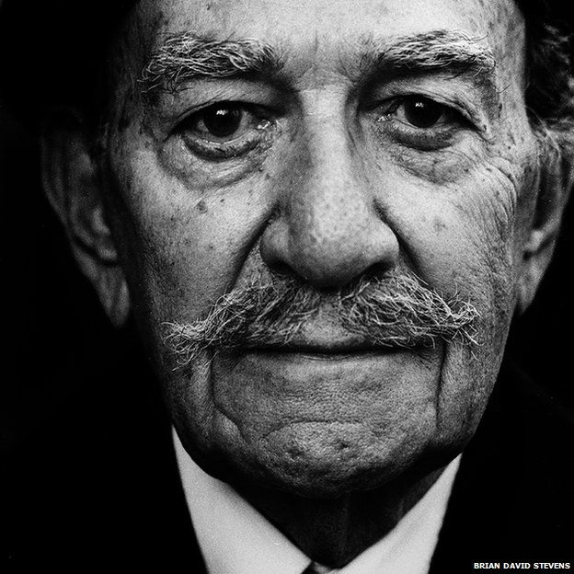

Write a story from the perspective of this man
OR
Write a description of this man

Example Student Response
I awake once again in a fit of panic. From that dream. The same dream I have each and every night. The one that fills me with blind fear. With its booms and crashes. With its screams and wails. Yet when the dream is over, that is when the worst part comes. The moment I open my eyes and there is silence. The moment when all I am surrounded by are dusty photographs of long forgotten memories. The moment when I am no longer my younger self, but am lumbered back into the broken fragments that I call my body. With its tuffs of hair that look like barbed wire running across a battlefield. With its trench-like wrinkles that run across my skin. Within it I can feel every moment of my life, every battle I have fought and everything I have lost. This body that is a shadow of the person I once was.
I should never have had to live like this. Most of those I knew back when I was young didn’t. They lie in fields in France, eternally young. They will never age, never know how life slowly grinds you down and eventually breaks you. It is with them that I should be. Not here, in this room, in this pitiful existence.
As I look around the room I realise I am surrounded by ghosts. The ghosts of my past staring out from photographs. All I see is eyes looking at me accusingly, asking why? Why are you still alive? Why do you sit and wither and age whilst we stay like this. From their endless watch these sentries stand in judgement, condemning me to my grief and guilt.
I attempt to get up, though in doing so I face yet another battle. Both of my knees have seen much better days and so for what many think of as an easy task becomes a monumental challenge. I stagger upwards, each movement taking an eternity that is filled with agony. Where once I would leap up ready to face the dawn chorus, I now might as well crawl across the room. Every step I take feels as if I am walking through mud and I suddenly feel a sense of déjà vu.

Example Student Response – Does Sherriff effectively portray conditions in the trenches?
Your assessment question is: How does Sherriff use Stanhope to show the impact of war on a person? However, look at this student example for a way in which to analyse stage directions.
One technique used by R C Sherriff so that the audience may learn about the realities of war in Journey’s end is his use of sound effects and light which are shown in the stage directions. An example of the use of sound effects is in Act 3 Scene 2, “There is silence except for the rumble of guns” this suggests to the audience that war is always present in the lives of the soldiers because even during “silence” the rumble of guns is still heard. This also highlight that war is inescapable as it fills every part of the lives of the soldiers even in silence. Another stage direction used by Sherriff is “Then comes the thin whistle and crash of falling shells; first one by itself, then two, almost together. Quicker and quicker they come, till the noise mingles together in a confused turmoil.” This implies to the audience that not only the raid itself but also the soldiers’ lives have been completely changed by war as they are now in “complete turmoil”; the word turmoil suggests that their lives have been turned upside-down and that all meaning and purpose has been lost in the chaos that is war. Personification is used in the word “whistle” which could suggest there is a connection between man and war as men tend to whistle; it could also imply that the war has become an uncontrollable being only satisfied by killing.

Retrieval Quiz

- List three things we are told in the opening stage directions about the conditions of the trenches.

- How do Hardy and Osbourne describe Stanhope in the opening of Act 1?

- How do Hardy and Osbourne describe the state of the trenches?

- Where does Raleigh know Stanhope from?

- What has Stanhope become addicted to and why has he become addicted to it?

- How do Raleigh and Osbourne view the Germans?

- Why does Stanhope feel ashamed about reading Raleigh’s letter home?

- What does the Colonel learn from an enemy soldier?

- At what time of day are the soldiers planning on carrying out a raid?

- What is Hibbert’s reason for wanting to leave the army?

- What does the Colonel tell Stanhope not to feel about the raid?

- What book do Raleigh and Osbourne quote from?

- Who is killed during the raid?

- Where does Raleigh sit after the battle?

- How would we describe Stanhope’s reaction to the news of who is killed during the raid?

- Who wakes up Stanhope before the enemy raid begins?

- What injuries does Raleigh suffer during the enemy raids?

- Why does Stanhope try to comfort Raleigh?

- How does the play end?

- Which characters are left alive at the end of the play?

Articles for wider reading and flipped learning

Extract from ‘A Brass Hat in No Man’s Land’, a memoir by Commander
Frank Percy Crozier
This extract is taken from A Brass Hat in No Man’s Land, a war memoir by Commander Frank Percy
Crozier (1879–1937) first published in 1930. More than three hundred men were shot at dawn by the
British Army during World War One. These men were executed for various offences considered by the
military authorities to be forms of cowardice, and Crozier was present at several of these executions.

Inside the little garden on the other side of the wall, not ten yards distant from the centre of the
line, the victim is carried to the stake. He is far too drunk to walk. He is out of view save from myself,
as I stand on a mound near the wall. As he is produced I see he is practically lifeless and quite
unconscious. He has already been bound with ropes. There are hooks on the post; we always do
things thoroughly in the Rifles. He is hooked on like dead meat in a butcher’s shop. His eyes are
bandaged – not that it really matters, for he is already blind. The men of the firing party pick up their
rifles, one of which is unloaded, on a given sign. On another sign they come to the Present and, on
the lowering of a handkerchief by the officer, they fire – a volley rings out – a nervous ragged volley
it is true, yet a volley. Before the fatal shots are fired I had called the battalion to attention. There is
a pause, I wait. I see the medical officer examining the victim. He makes a sign, the subaltern strides
forward, a single shot rings out. Life is now extinct. We march back to breakfast while the men of a
certain company pay the last tribute at the graveside of an unfortunate comrade. This is war.
To this sad story there was a sequel. Some months later one of my officers was on leave, and as he
had recently been awarded the D.S.O. was entertained to luncheon by his Club. At the function there
were present some young business men who had not volunteered for war service. One of these
asked my officer if it were true that ‘one of your men had been executed for desertion, and if so did
he not think it was a very discreditable affair for the battalion and a disgrace to the city?’ ‘Well,’ my
officer replied, ‘the unfortunate man volunteered to serve his country in the field; you have not
done even that yet. He went through the trials of a truly terrible winter in the trenches. He endured
bombardment, mud, exposure, cold, frost, trench-feet, sleepless nights and daily drudgery under
conditions in which man was never intended to play a part (he had to play a part the whole time to
keep going at all). This quite unnatural test broke his spirit. His brain was probably affected. In
despair he quitted the line. Why don’t you and your other slacking and profiteering friends join up
and have a shot at doing better than this unhappy comrade of ours? If you can’t stand the test and
are executed because you are not endowed with the steel-like qualities which make for war
efficiency, I shall think better of you than I do now. Our dead comrade, whom we had to kill with our
own hands and rifles pour encourager les autres1 , is a hero compared with you! He tried and failed.
He died for such as you! Isn’t it time you had a shot at dying for your country?’

Death of our best and brightest: Eton Rifles may have been 'built for' slaughter
By JOHN LEWIS-STEMPEL
CARICATURED as nice but dim and hiding miles from the front line, public school officers during the First World War have had a bad press. As John Lewis-Stempel reports however, their chances of surviving were scant and their bravery unquestionable
Eton will be to the last the same as my parents and dear friends are to me...To die for one’s school is an honour
Lionel Sotheby, in his last letter home
I am deadly serious. When war came in August 1914 the martial and patriotic “ethos” of Eton and the other 120 elite public schools of Britain was exactly what the country needed. Who could withstand the highly drilled militarism of the Kaiser’s army better than British boys who believed in courage, country and selfless service?
These values may stick in the craw of modern political sensitivities, especially after decades of classroom exposure to “pity of war” poetry, but as a Darwinian survival mechanism the public schools of Britain were unsurpassed. They trained a whole generation of boys to be waiting in the wings of history as military leaders.
The young gentlemen from Eton and the Edwardian public schools paid a terrible price for this duty. It was a funny old world war, the First World War, but there was one unassailable, and surprising, truth about it. The more exclusive your education, the more likely you were to die.
As a rule of thumb 20 per cent of public school boys who fought in the war died, against 13 per cent of those overall who served. There are 1,157 names on Eton’s memorial to its Great War dead, so many chiselled on the wall in the cloisters that it hurts the head to scan them.
Historians have a horrible phrase for this difference between the war’s general mortality rate and the public school rate: “surplus deaths”.
The reason for the “surplus deaths” of public school boys is simple: They were more likely to be junior officers, lieutenants and captains, in the bloody trenches. Forget the pernicious myth that officers sipped sherry in HQ while they carelessly sent the workers to the slaughter. By the rule of the British Army, junior officers were the first “over the top” and the last to retreat.
Some officers were very junior indeed when they climbed the side of the trench. They were just 17. The young officers died in their droves with a revolver in one hand a cigarette in the other; held for a desperate, affected nonchalance as they led their men into the hail of German or Turkish lead. In the worst places, and worst phases, of the war a second lieutenant could expect to survive a mere six weeks before becoming a casualty.
Of course, public school boys were easier for the Germans and Turks to hit. Due to their better diet and general physical fitness they were, on average, five inches taller than their working-class contemporaries in 1914.
One might almost say that public school boys had been physically built up for the slaughter. School sport, as the Duke of Wellington suggested, was a key part in their preparation as incipient warriors. The public schools of Britain had a fitness regime that a Spartan would blanch at: lashings of physical contact sport such as rugby or, Eton’s version of it, the wall game, plus lots of cross-country runs and cold showers. Sedbergh’s school song required its athletes to “laugh at pain”.
Besides toughening up the warriors in waiting, sport instilled military skills. After all, most sports contain some DNA of their military origins. What else is cricket but using a shield to protect oneself from a projectile? Of Eton’s first VIII rowing team of 1913 three died in action. So did their diminutive cox, Esmond Elliot, killed at wintry Passchendaele.
Above all, schools believed that team sports developed character, leadership skills and loyalty. A boy’s loyalty to his alma mater could equal his loyalty to his family. Lionel Sotheby wrote in his last letter before he was killed in battle in 1915: “Eton will be to the last the same as my parents and dear friends are to me... To die for one’s school is an honour.” Loyalty is an elastic concept. If a boy could be made loyal to his “house”, his school, he could be made loyal to his country.
The sport beloved of Wellington, however, was just one of the Holy Quartet of methods by which schools prepared young boys to become officers and gentlemen. There was also curriculum, chapel and unadulterated military training.
Off the playing fields and into the classroom, a boy at Eton in 1913 could expect to spend half his week studying Latin and Greek classics, not anything as airy-fairy as Plato’s philosophical Republic but action yarns celebrating sinewy subalterns. Homer’s Odyssey was a standard. These classics lessons forged an enduring mental template of aspirational heroism.
When 29-year-old Patrick Shaw-Stewart went into action at Gallipoli in 1915 his school days at Eton were long behind him. Even so he had just scrawled the only poem of his life, including a couplet calling on the greatest of Greek heroes for help:
Stand in the trench, Achilles Flame-capped, and shout for me.
Fellow Old Etonian and future prime minster Harold Macmillan was similarly hooked on classics. Injured by machine gun bullets at Ginchy on the Western Front, Macmillan lay in a shell-hole and read his pocket edition of Aeschylus’s play Prometheus, about the suffering the Titan endured when bound to a rock. A paean to fortitude, Prometheus was singularly appropriate reading. Macmillan perused the tragedy in Ancient Greek.
Not all public school boys were as intellectual as Macmillan, the scion of a publishing dynasty. Some were terrifically “hearty”, yet the dim-witted Lieutenant George (Hugh Laurie) in Blackadder Goes Forth is a whopping miss. Stupidity was a sin in school. An empire could hardly be run efficiently if the helmsmen were uneducated or inane.
Next in the education of the warrior-in-waiting was chapel. Boys could expect religious services every morning and in boarding schools thrice on Sunday. What they heard from the pulpit was Church of England lite, a religion that downplayed doctrine and ramped up ethics. Boys on the shivering pews were told over and over to live a life of service and sacrifice. Like the Lord Jesus himself.
There was one last corner of the school life in which boys were inculcated with their future martial duty. The Officers’ Training Corps was introduced in 1908 by Lord Haldane. Almost all public schools had this form of army cadets, which trained boys to lead a platoon of 50 men. Some schools took “the Corps” extremely seriously; at Uppingham School in Rutland no pupil could receive a school prize or hold a house position unless he had passed a rifle marksmanship exam.
Everything about public school trained a boy for war. Manliness, duty, love of Britain, stiff upper-lip self denial were the inescapable virtues. So when Lord Kitchener asked public school boys to step forward to officer the expanded British Army in 1914 they did so. Almost to the boy.
Researching Six Weeks, my book on junior officers in the trenches, I asked school archivists: “How many of your old boys served in the Great War?” The reply was always: “We think almost everybody.” One snapshot will serve as proof and illustration. Of the 51 boys who left Newick House, Cheltenham College, in 1910, 50 donned khaki. They went willingly, even when every issue of the school magazine announced more dead.
Something like a tsunami of death was visited on the public schools. The unenviable pole position in the league table of loss goes to King Edward VII School, Lytham, where 32.4 per cent of its boys who served were slain.
Their sacrifice was not in vain. The gallantry of all the young gentlemen helped turn the grinding battles at Ypres, the Somme and Passchendaele. With their chapel services still in mind the public school boys did more than die well. They looked after their men.
Long before the Beatles, these young men realised all you needed was love. As Bernard Adams of Malvern College explained to a fellow downy-lipped officer on the Somme: “The only way to run a company is by love.” By looking after their men in the trenches, by giving them cigarettes and smiles, the public school officers made the lives of the khaki multitude bearable and kept morale buoyant.
Of course, some public school boys were arrogant and selfish. They were not all kindly, brave Bernard Adamses. By and large, however, the young toffs delivered the goods splendidly.

John Lewis-Stempel is author of Six Weeks: The Short And Gallant Life Of The British Officer In The First World War.

