BTEC DIT
Component 3 Effective Digital practices

Learning Aim C1: Responsible Use
Knowledge and Assessment Organiser

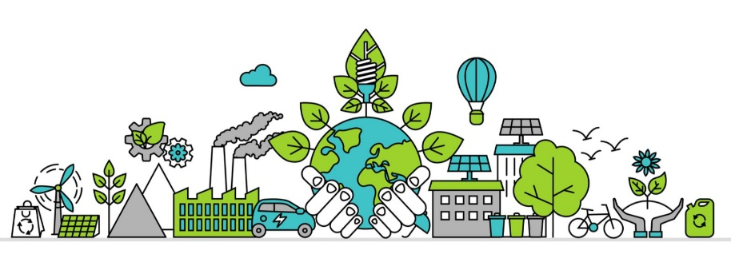
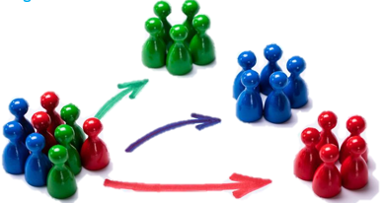

Student name: ………………………………….
How digital systems be used responsibly?
What should organisation do to be environmentally friendly?

Key Terms
Contents
Big Question and Small Question breakdown
Essential knowledge & tasks
BTEC Question stems
Articles for wider reading and flipped learning

Key terms
Exam question command words
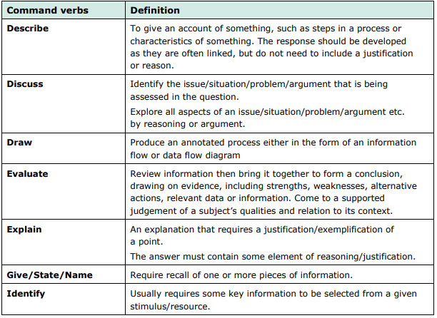
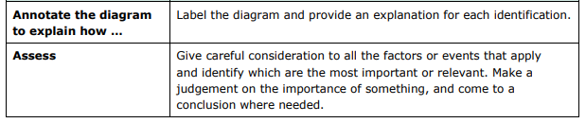
Thinking point?

Did you know…?
Most electronic waste is sent to landfills or incinerated, which releases materials such as lead, mercury, or cadmium into the soil, groundwater, and atmosphere, thus having a negative impact on the environment.

Key words
Key Vocabulary
GPS (Global Positioning System) | A navigational system that uses data transmitted by satellites to calculate the location of the GPS-enabled device.​
Data Subject | An individual whose personal data is being stored.
Consumables | Items such as ink cartridges, paper, toner, cleaning products, maintenance tools and cables.​
Motherboard | The main electronic circuit board that all the other computer components, such as memory, processor, graphics card etc., plug into

What is my big question?
How digital systems be used responsibly?
What should organisation do to be environmentally friendly?

How do organisations dispose of unwanted technology?
How do we mean by using digital systems responsibility?
What is shared data?
What are the benefits and drawbacks of shared data?
What is Shared Data?
In order for businesses to be successful they use data. Companies use the data they acquire to provide services, tailor products and personalise advertisements.
For a business to use this data they also must use it responsibility. We have an ethical responsibility to handle data carefully, as well as a legal one under the Data Protection Act 2018.
Organisations collect shared to them by their customers, and this data can then be used for a variety of purposes including advertising, planning, and providing services.
They use this data to target specific groups.
- Location-based-data – sharing location data is encouraged increasingly by websites and mobile apps. Especially with the growth of mobile devices with GPS that constantly logs our location. This is then used for all kinds of purposes. Some websites might show you country-specific deals, some to show you where to find restaurants local to you, some to help you plan a route on a map.
- Transactional data – Every time a purchase is made, a record of this is stored. This might include the time, date & cost of the transaction and the item purchased. This is used to customise advertising to you, analyse buying habits, track stock levels and identify trends in sales.

- Cookies – Most browsers collect cookies to carry data between the times you visit a website, such as leaving you logged in, or remembering settings like a language preference. It can also be used for analytics, like tracking how long you spend on a page. This can be used to improve the ease-of-use, customise advertisements & analyse website performance.
- Data exchange between services – data collected can sometimes be shared with another service. This might be one app sharing data with another. For example, your smartphone will gather data on your location, this can then be shared with Facebook, Google Maps and many others. Many apps and websites will exchange the data they gather (though they have to ask your permission).

Family tracker is an app that allows parents to monitor their children’s location
When used, a parent knows if their child lies to them about where they have been
How does this app know your location?

Benefits and Drawbacks of shared data.
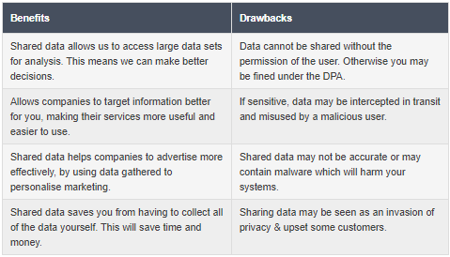

Responsible use of shared data
When using data, it is also important to consider the legal aspect of it, ethical consideration and privacy.
- Legal consideration - The Data Protection Act 2018
  - All companies now need to have a privacy policy if they deal with personal data
  - If they use cookies they will need to explain their use to customers
- If data is misused or lost then companies:
  - must inform customers or users
  - and face a fine of up to 20 million Euros
or 4% of company earnings

- Ethical use of data
- Product information needs to be clearly displayed
  - There have been cases of customers ordering furniture which, when it arrives, they find it is for a dolls house
- Personal data is often shared with many companies
  - They need to think carefully about whether the use of the data is ethical
  - The data needs to be kept private and confidential within the companies it has been
shared with

Task 1
A social network uses information about users so that advertisers can target their advertising.

For each of the data items in the first column below, tick the column to show where the data most likely came from and then explain how the data could be used by advertisers. The first row has been completed for you.
 | Where the data most likely comes from
Data item | Sign up form | The website produces the data | How the data could be used by advertisers
Name |  |  | To personalise information so you feel that the product is made for you
Email address
Age
Gender
Your friend’s interests
Your approximate location
Current place of employment
Name
Age
Address
Interests
Employed
Gender

Environmental Concerns
When dealing with technology, organisations also need to consider the environment, this including the impact of actually manufacturing the technology, when upgrading or replacing systems, and the usages and policies.

Environmental impact of systems
- Manufacturing – The biggest concerns of manufacturing technology are in the waste/cost generated during the creation process. These concerns can include:
  - Sourcing raw materials, some of which are non-renewable (such as copper used in chips and wires).
  - The electricity and gas required to power assembly lines, which produce harmful emissions.
  - The environmental impacts of fuel for the transport of IT systems for distribution.
  - The materials required for packaging, which may not be recyclable.
- Use – The operational costs of devices can be large as using devices will require electricity. This electricity will largely come from non-renewable sources and will contribute to air pollution. A particular issue is the amount of wasted electricity from leaving computers on when not in use. It’s estimated that £90m is wasted by UK companies each year by leaving computers turned on when not in use.
- Disposal – Huge quantities of old tech is being thrown out and not recycled. So-called “technotrash” makes up 5% of worldwide waste. Much of this technology is recyclable or could be donated and reused, but currently, this is not being done regularly enough. Much of this landfill waste will be left to rot or incinerated which will cause pollution.

Upgrading or Replacing
At some point businesses and individual will need to upgrade their IT systems, whether this is due to the need of new software upgrades and an individual just wants a better system. This is where we will need to think, can we upgrade the current system or will we need to replace. Both have their own pros and cons.
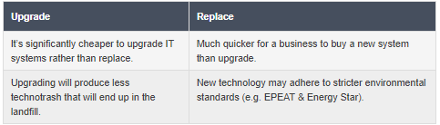

Usage and setting policies
We can reduce the impact that our computers have on the environment by changing how we use our computer systems and the settings we configure them with.
Some of these settings include the following:
- Auto Power-Off – Most devices have power-off settings that place your device into a standby state, or completely turn off, if it has not been used for a certain period of time. This will save on the wasted energy when we leave our computers on when not in use.
- Power-Saving Settings – Most devices also have settings for reducing the power consumption of a device. This might be by lowering screen brightness, turning off wireless connection methods like Bluetooth, certain features might be turned off & even reducing CPU speed. This will save on the amount of energy used while the device is in use.
- Electronic Distribution – Distributing electronic files rather than physical printed copies will save on wasting paper which will help reduce deforestation. We can also use digital downloads instead of purchasing physical software to reduce the environmental effect of distribution (pollution from planes and lorries).
What can you do on your mobile phone to save battery life?

Task 2

WebX is a small business, specialising in web development. They have decided to upgrade Ben, their front-end developer’s computer.
Over the last two weeks the computer has been slow to log on. When Ben logs in to access documents, it often says there is no disc space. He is also finding that when he opens images sent from the graphics department, the computer displays a ‘not responding’ message for a long period of time. He also noticed yesterday that the screen is starting to flicker in the bottom corner.

a) Give two reasons why upgrading the computer will be better for the environment than replacing it.

b) Give two reasons why the company will benefit from upgrading the computer rather than replacing it.

There are many ways to reduce the amount of energy that your phone uses so that the battery lasts longer.
How do the following settings help save battery life in your phone? The first row has been completed for you.

Setting | Why
Turn off background apps | By not having lots of apps running it will reduce the amount of work the CPU needs to do
Disable notifications
Turn off Location services
Software updates
Automatic Wi-Fi connection
Power saving mode
Don’t make phone calls

C1: Exam Questions
...........................................................................................................................................................................
2. In 2017 there were 39 million social media users in the UK with millions more expected to join in the coming years.
a) Social networks will typically need a username, password, email address and name. State two other items of personal data which users may give to a social network. [2]

b) Most social networks are free to use and funded by advertising. Explain two ways in which advertisers could use personal data held on social networks to increase sales [4]

State – to recall a piece of information.
Explain – identify a reason and then expand how.

Articles for Wider Reading and Flipped Learning
Subscribe and watch the YouTube clips to help you revise for BTEC Tech Award Component 3.
https://www.youtube.com/watch?v=HkzRvXdwcHs&list=PLmyUnKEeJk-6gijRiVKEfcvZhwcj6LWpo&index=7

Responsible Use - Know it all Ninja
Read through the topics on Responsible Use. Remember to complete the on-line quiz to gain house points!
https://www.knowitallninja.com/

