Colton Hills Community School medium term planning
Topic title:  ‘Fantastic Beasts’ | Year: 9  Term: Autumn |  | Why we teach this:  For students to produce creative work, explore and record their own ideas of ‘fantastic beasts’ inspired by a range of artists.  Students will gain an understanding of ‘surrealism’ in order to create drawings in a variety of different media. | Why we teach this here:  Students work through the art and design process, consolidating prior learning and selecting materials, processes, and techniques appropriate to their choice of theme and skills set.
Big questions:  What is surrealism?  Who is Salvador Dali?  What does ‘fantastic beasts’ mean to you?  How can I show an artist’s influence in my own work?  What am I good at and where/how can I improve my skills further?  How can I combine animals with everyday objects?  What is a dreamscape?  How can I develop my designs further to include a dreamscape? |  |  | Builds on previous topics:  The design process – analyse, create, review, develop, realise intentions. | Links to future topics:  Consolidate the formal elements of art & observation drawing. Analysing the work of artists and showing an understanding in applying to their own designs.
Key knowledge:

• A range of different drawing styles, materials and techniques.
• To gain an understanding of surrealism.
• To show an understanding of the work of a range of artists who were inspired by surrealism.
• To learn how to develop original ideas influenced by research material and observation studies.
• To review, modify and develop designs to create effective outcomes inspired by different artists.
• To evaluate work and progress in order to improve further and inform future work.

Skills developed:

We give the opportunity for students to analyse the work of artists, designers and craftspeople and create personal and meaningful practical outcomes in a range of media. In order to realise intentions, we teach students to be analytical, questioning and independent learners reviewing and refining their work to produce effective outcomes.

AO1 - Develop your ideas through investigations informed by contextual and other sources, demonstrating analytical and cultural understanding. |  | AO2 - Refine your ideas through experimenting and selecting appropriate resources, media, materials, techniques and processes. | Independent study tasks/resources:  - Tate Kids – What is surrealism?  - Salvador Dali  - Victor Nunes  - Jess Albert  - Maria Rivans  - Katie McCann | Key vocabulary:  Fantastic Beasts  Surrealism  Imagination  Experimental  Exquisite corpse  Colour  Animals  Everyday objects  Collage  Drawing  Painting  Record  Insects  Combine  Analyse  Monoprint  Hybrid  Develop  Evaluate
AO3 - Record ideas, observations and insights relevant to your intentions in visual and/or other forms. |  | AO4 - Present a personal, informed and meaningful response demonstrating analytical and critical understanding, realising intentions and making connections between visual or other elements.
Cultural capital opportunities:  Students to research meaning and purpose of artists work and consider their influences, including symbolism/tradition. |  |  | Whole school Curricular Concept links:  - Precious Planet  - Artistic Creativity

Learning objectives | Tasks
Summer - Weeks 1-2  - To be able to combine two or more insects together to create a hybrid drawing.  - To make informed choices in order to develop an interesting and imaginative design.  - To learn how to apply an appropriate colour scheme and anilinky paint effectively. | - Students to create their own hybrid insect drawings in the style of illustrator Jess Albert.  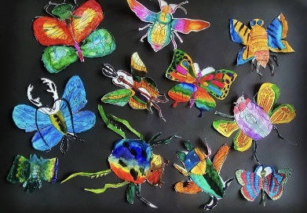  - Add an appropriate colour scheme and anilinky influenced by the artist. | - Small questions  How would you describe Jess Alberts artwork? What media does she use? How do you apply anilinky effectively?
- Retrieval focus
Artist analysis and how to apply anilinky
- Independent study
To complete any unfinished work
Autumn - Week 3  - To gain an understanding of Surrealism.  - To develop an understanding of Surrealist artists interest in the unconscious mind.  - To experiment creating your own Victor Nunes style drawings. | 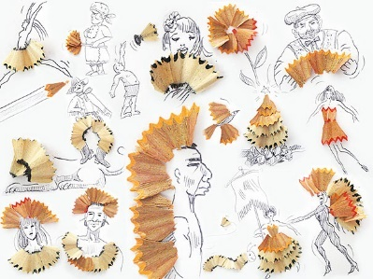  - Students to gain an understanding of surrealism. (Watch Tate Kids ‘What is surrealism?’ https://www.tate.org.uk/kids/explore/what-is/surrealism)  - Students to create their own drawings in the style of Victor Nunes using pen lids, popcorn, and pinecones etc. | - Small questions  What is surrealism? What unexpected things would you put together?
- Retrieval focus
Artist analysis
- Independent study
To complete any unfinished work
Weeks 4-5  - To learn what an exquisite corpse is.  - To work collaboratively in order to create your own unique fantasy creature. | 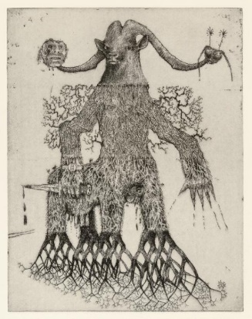  jj  - Students to work in pairs in order to create their own fantasy creature. | - Small questions  What does exquisite corpse mean?
- Retrieval focus
Design process and collaborative working
- Independent study
To complete any unfinished work

Weeks 6  - To learn and understand the process of monoprinting.  - To be able to develop and refine design in order to create an effective monoprint. | 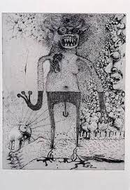  - Students to turn their exquisite corpse design into a monoprint. | - Small questions  What is monoprinting? How can you develop your exquisite corpse design?
- Retrieval focus
Printmaking
- Independent study
To complete any unfinished work

Weeks 7-9  - To learn how to combine an inanimate object with an animal.  - To learn how to analyse the style of artists work in order to create a your own imaginative design. | - Students to combine an inanimate object with an animal in the style of Redmer Hoekstra. Students to consider characteristics that are similar between both (like shapes, textures, etc.). Outcome can be either painted or completed in pencil crayon.  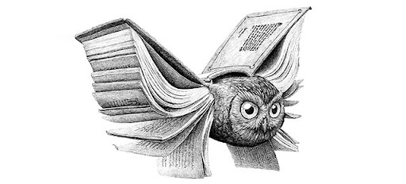 | - Small questions  What unexpected things would you put together with an animal? What animal would you combine with ___?
- Retrieval focus
Design process
- Independent study
To complete any unfinished work
Weeks 10-11  - To be able to use collage techniques to create your own hybrid animal in the style of Katie McCann.  - To make informed choices in order to develop an interesting and imaginative design.  - To learn and understand the process of collage. | 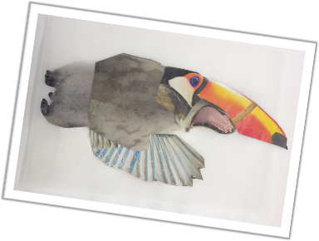  Using found images, students are to create their own hybrid animal inspired by Katie McCann. | - Small questions  Which are your preferred designs? How do you plan to do develop them?
- Retrieval focus
Design and development process
- Independent study
To complete any unfinished work

Weeks 12-14  - To learn the meeting of ‘dreamscape’.  - To learn how to develop your collage into painting in the style of Salvador Dali.  - To gain an understanding of Salvador Dali and the meaning behind his artwork. | 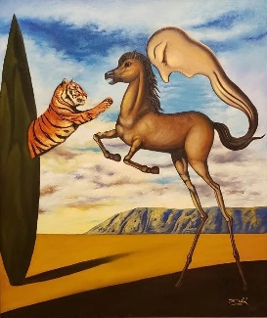  - Students to develop their collage into painting in the style of Salvador Dali using watercolour.  (Watch -https://www.tate.org.uk/kids/explore/who-is/who-salvador-dali) | - Small questions  How can my collage be developed into Dali inspired painting? Who is Salvador Dali? What is a dreamscape?
- Retrieval focus
Painting
- Independent study
To complete any unfished work
Weeks 15  - To be able to work independently in order to complete any outstanding work.  - To be able to improve your work by responding to teacher feedback. | - DIRT – Students to complete any outstanding work. | - Small questions  How can you improve your work further? What outstanding work do you need to complete? What have you learnt in this project?
- Retrieval focus
All tasks above
- Independent study
Complete any unfinished work

