BTEC DIT
Component 3 Effective Digital practices

Learning Aim D: Forms of notation
Knowledge and Assessment Organiser

Student name: ………………………………….
How can organisations communicate the flow of data and system function?

Key Terms
Contents
Big Question and Small Question breakdown
Essential knowledge
BTEC Question stems
Articles for wider reading and flipped learning

Key terms
‘Draw questions’

Information flow diagram symbols
Use squares for key parts of the system such as people or departments
Use arrows to show how the information flows around the system
Remember to label the arrow with what information is
being transferred

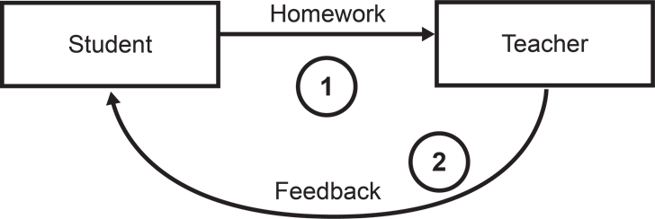

Data flow diagram symbols
A person, organisation or another system which sends or receives information.
A process or function, sometimes but not necessarily numbered

A file or database

Data or information flow shown by the direction of the arrow

Flow chart symbols
Yes
Decision

End
Input/Output
System diagram
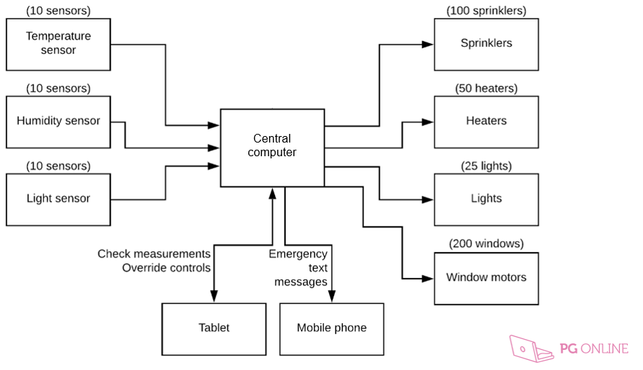

Key terms
Notation – means using symbols to represent something. In IT this means using diagrams to represent a range of ideas.

How can organisations communicate flow of data and system function?
What is the best way to present data?
What are the components of a system and how are they connected together?
How can we accurately record steps in a system process?
How can we illustrate how data is processed in an existing system?
Information flow diagram
- IFDs show how information flows through a system or organisation including:
- People / users of the system
- How information flows between organisations and also how information flows between different areas of an organisation
- IFD is similar to a DFD, except they only show information flows inside an organisation.
- Often has a single ‘actor’ and then looks at the flows that follow from that interaction.

How to create an information flow diagram.

Use squares for key parts of the system such as people or departments
Use arrows to show how the information flows around the system
Remember to label the arrow with what information is
being transferred
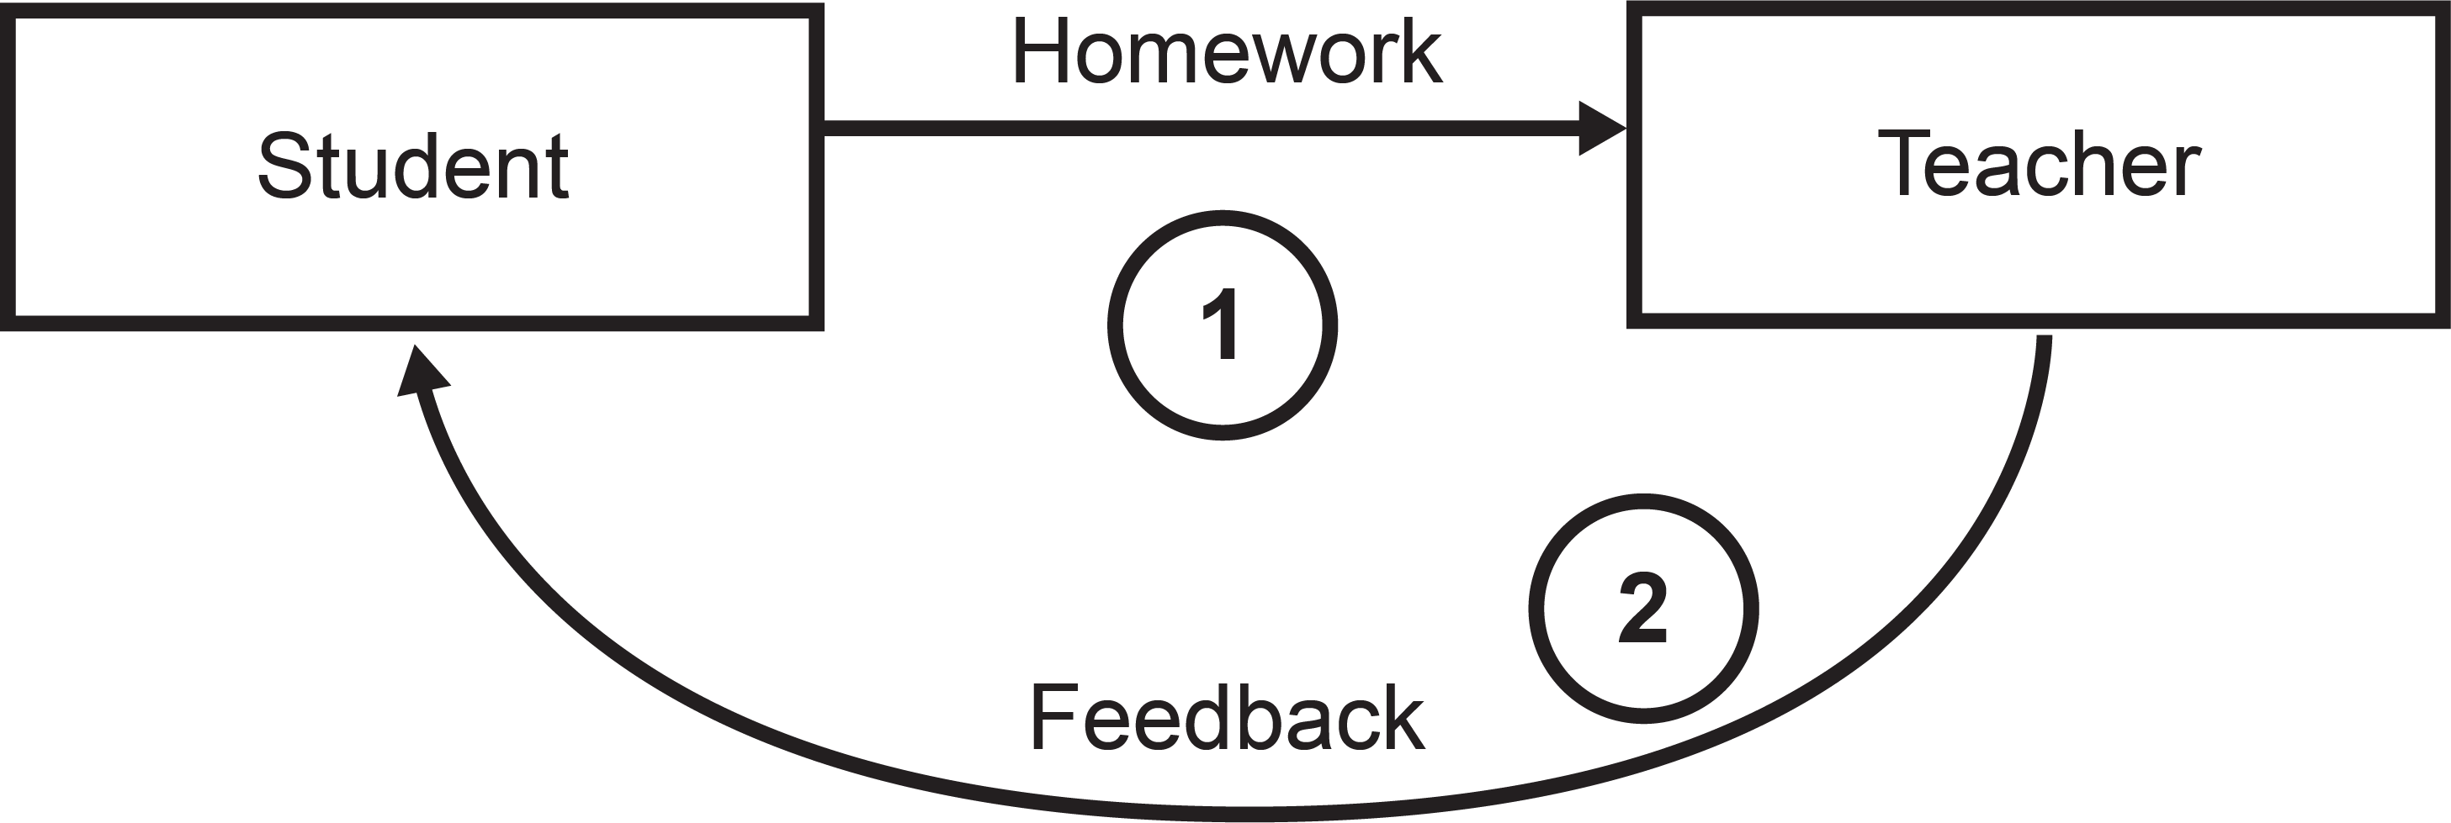

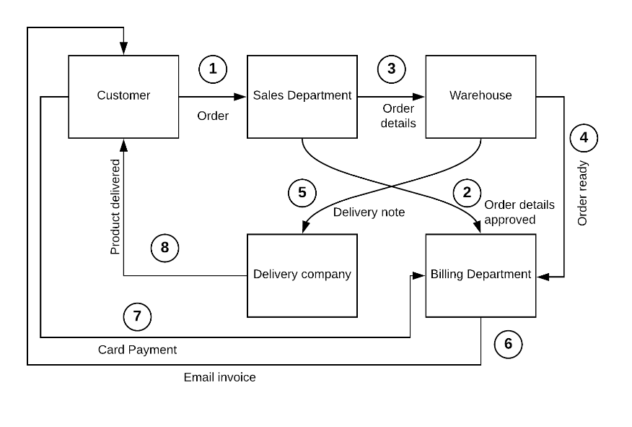
Information flow diagram for an online furniture shop

Planning space
Activity
Draw an information flow diagram which shows how the data flows in a system that allows users to register on a website for regular newsletters.
Use the steps below to draw the information flow diagram.
- Users input their details into the website.
- The site saves the user’s details on the registered users database.
- The email server picks up the user’s details from the registered users database and sends them the latest newsletter by email.

Thinking point!
From the list underline what you think might be the ‘actor’ (person) and the system or organisation.
The word database has been underlined for you as that will be a system that information will flow to.

Data flow diagram
A data flow diagram shows:
  - Who or where the input data comes from (entity)
  - How data flows around the system
  - How the data is processed
  - What data is stored (data store – file or database)
  - Who or where data from the system is output to

It is important to use the correct symbols when creating a DFD.
Example of a simple data flow diagram
Fast food ordering system
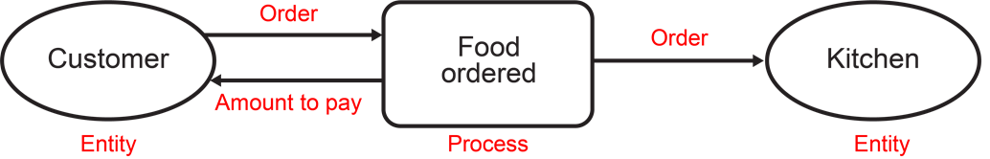

Always label a DFD
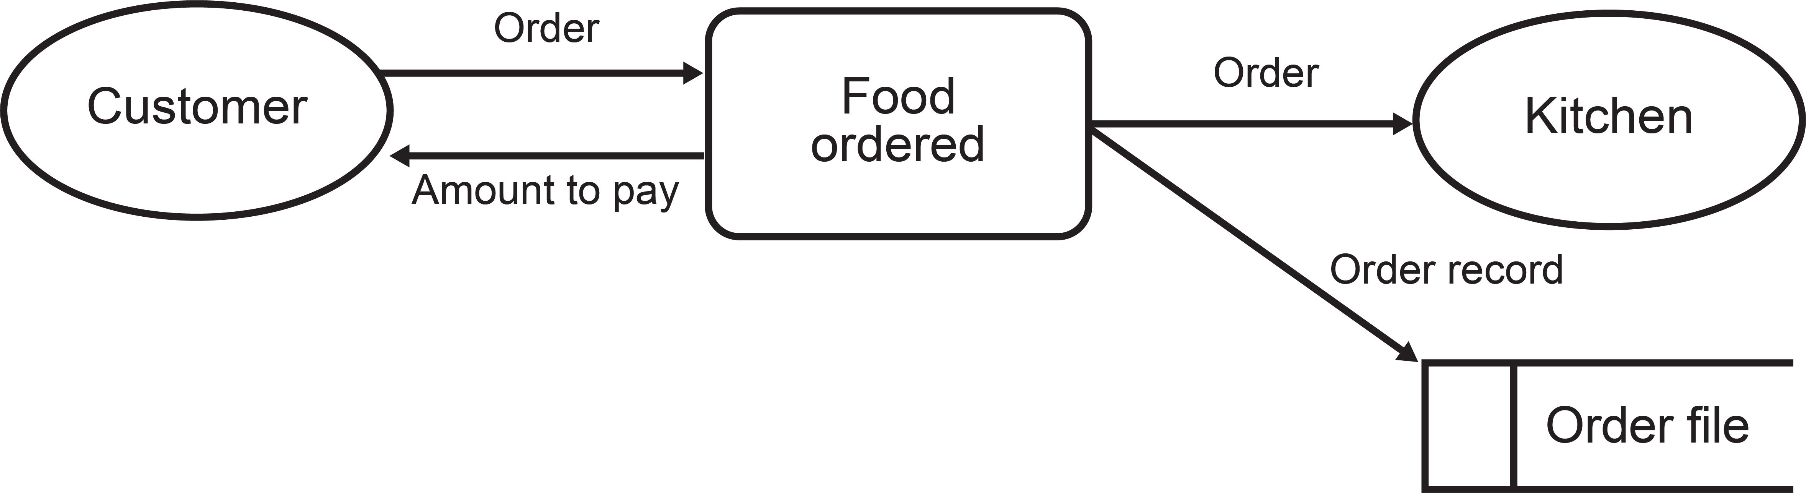

Most systems will store information gathered.
Developing the DFD
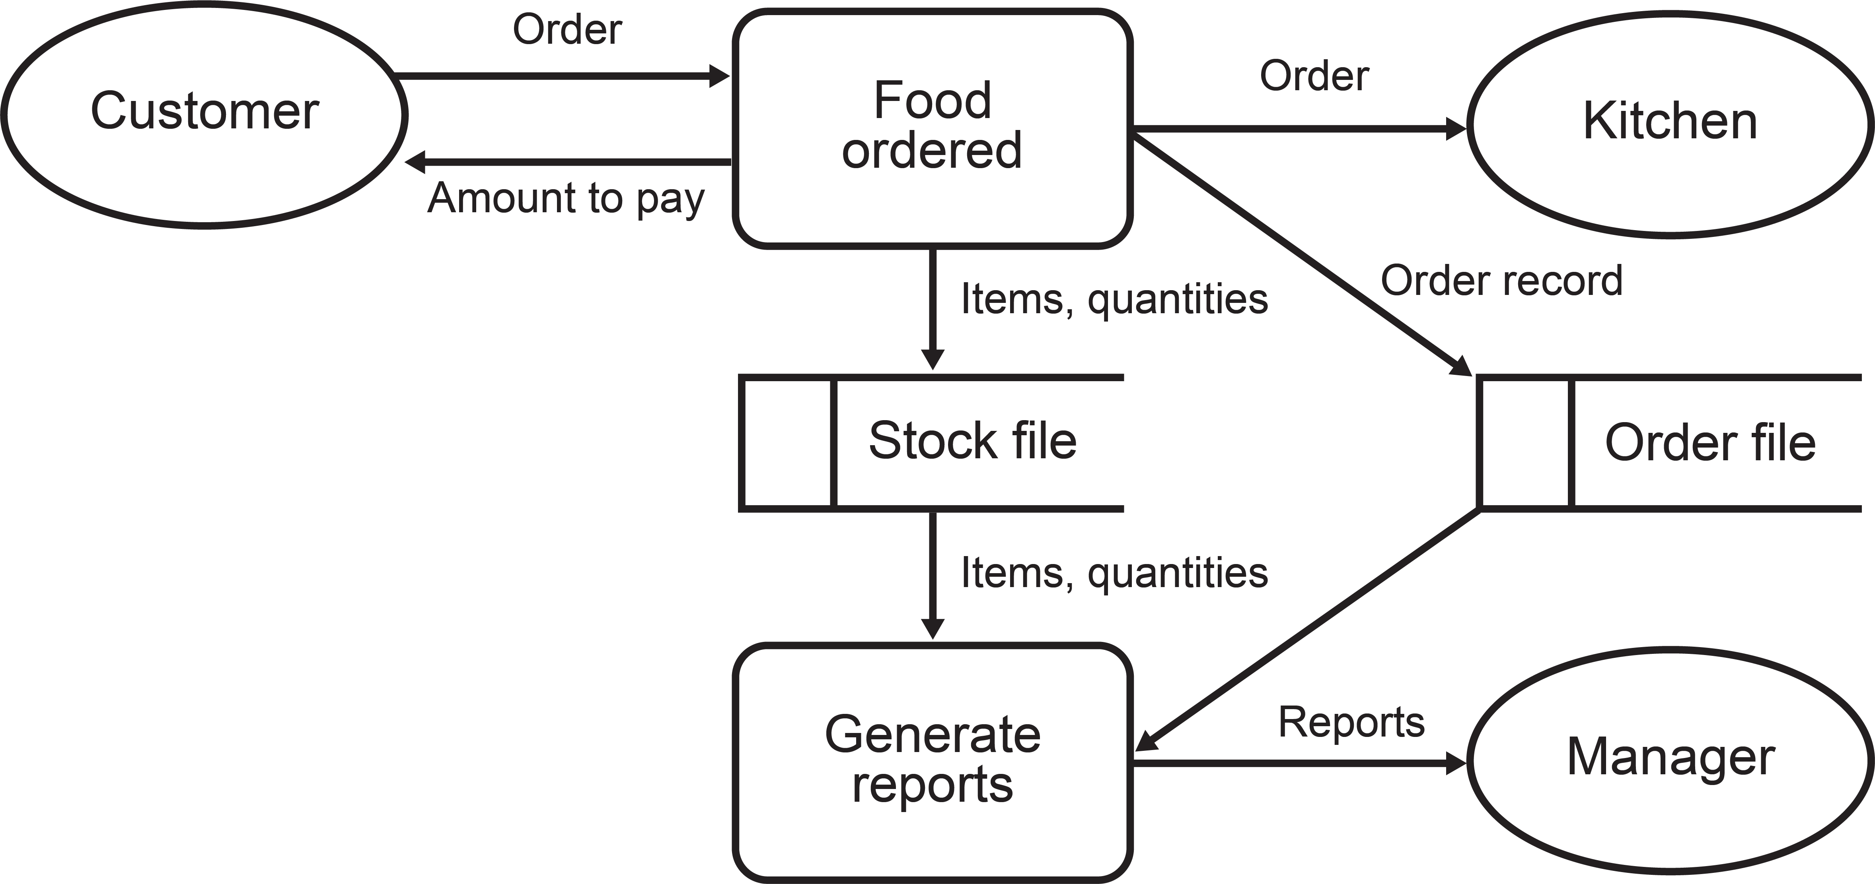
Reports will be generated from these two files and sent to the manager (process, two data stores, entity
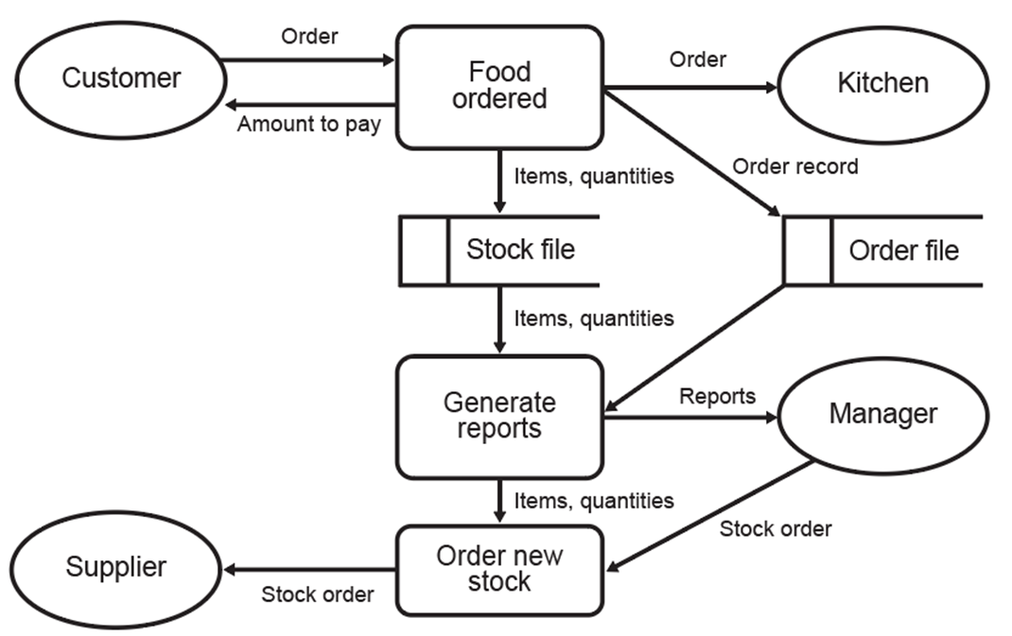
The manager orders new stock from the supplier (entity, process, entity)

Take note!
You should never draw a data flow line between two entities
Data flows always go to, or come from, a process
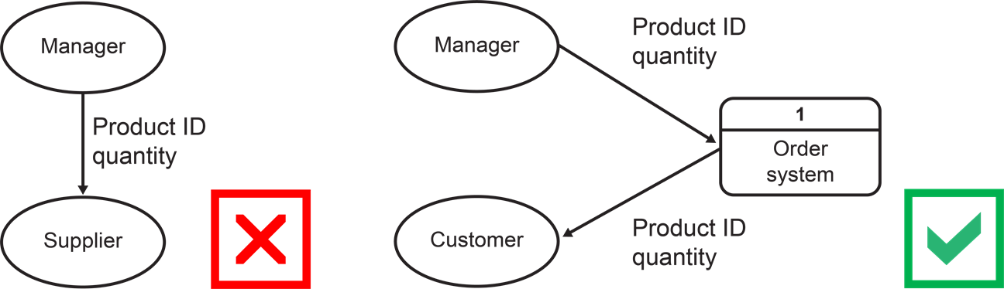

Planning space
Activity
A hotel booking app works like this:
- Customers input their search criteria into the app.
- The app searches in the ‘hotels availability’ database for available hotels.
- Matching the hotels are output to the customer.
- The customer selects the one they want and makes a booking.
- The app sends the booking confirmation to the hotel database.

Draw a level 0 DFD for this system.

Thinking point!
Always a good idea to underline the entities first.

Flow charts
Companies will often create flowcharts to show what to do when a problem occurs, such as:
  - Fire procedures
  - Customer complaints
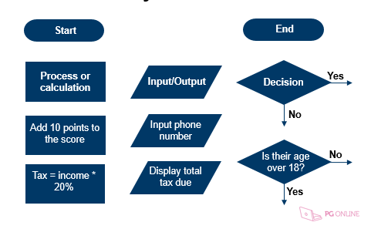
  - Manufacturing defects

Variables in a flowchart
Variables allow us to store a number or
text in a flowchart
  - Variables are often used in calculations
  - Calculations will always be in a process box
  - You can input or output what is stored
in the variable

Example of a flowchart with a variable
The flowchart finds how much a student
will spend on food and drink each week.
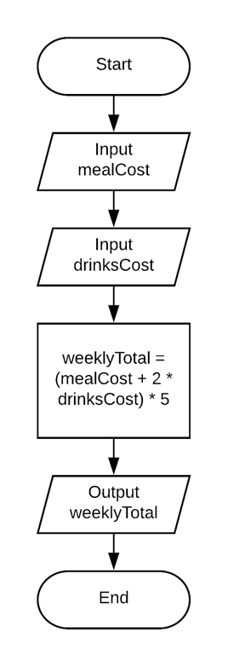

Counting
The statement count = count + 1 means “Add 1 to the variable called count”

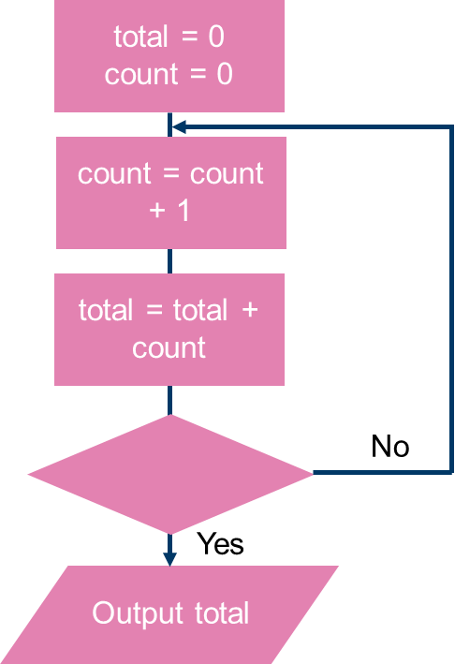
What will be output from this flowchart?

Is count = 1000?

Planning space
Activity
Draw a flow chart to show the steps that a spell checker needs to take.
- Input word to be checked.
- Look up word in a dictionary.
- If the word is in the dictionary, do nothing.
- If not, offer user alternatives.
- Input the choice the user has made for the correct word.
- Replace the word with selected alternative.

Thinking point!
Remember to use the correct shape for each step!

System diagram
System diagrams can be used to show the layout of computer equipment and how devices are connected. These diagrams can be useful for technicians who have to support the equipment.
Most IT system diagrams will include hardware:
  - Input / output devices
  - Storage devices / databases
  - Network equipment such as Wi-Fi access points
  - Computers / Smartphones / Tablets
People involved in the system can also be included
Processes or events are described

Example: a modern greenhouse
Many greenhouses are now automated for optimal growing conditions
What are the components of this automated
greenhouse system?

Step 1: identify key components
Key components of the system:
  - Input sensors – temperature,
humidity, light
  - Output devices – sprinklers,
heaters, lights, window motors
  - Main computer
  - Farmer – Tablet, mobile phone

Step 2: Draw the key parts
Put all the key components onto the diagram
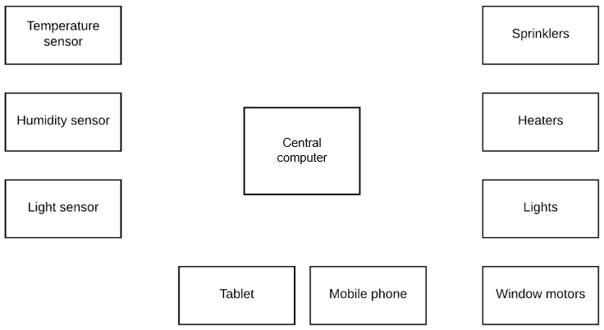

Step 3: connections
Connect the components to form a system.
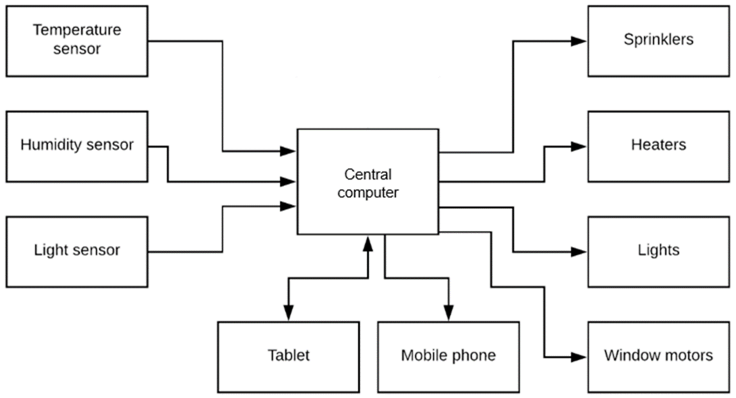
Step 4: label the diagram
Add appropriate labels to components/connections
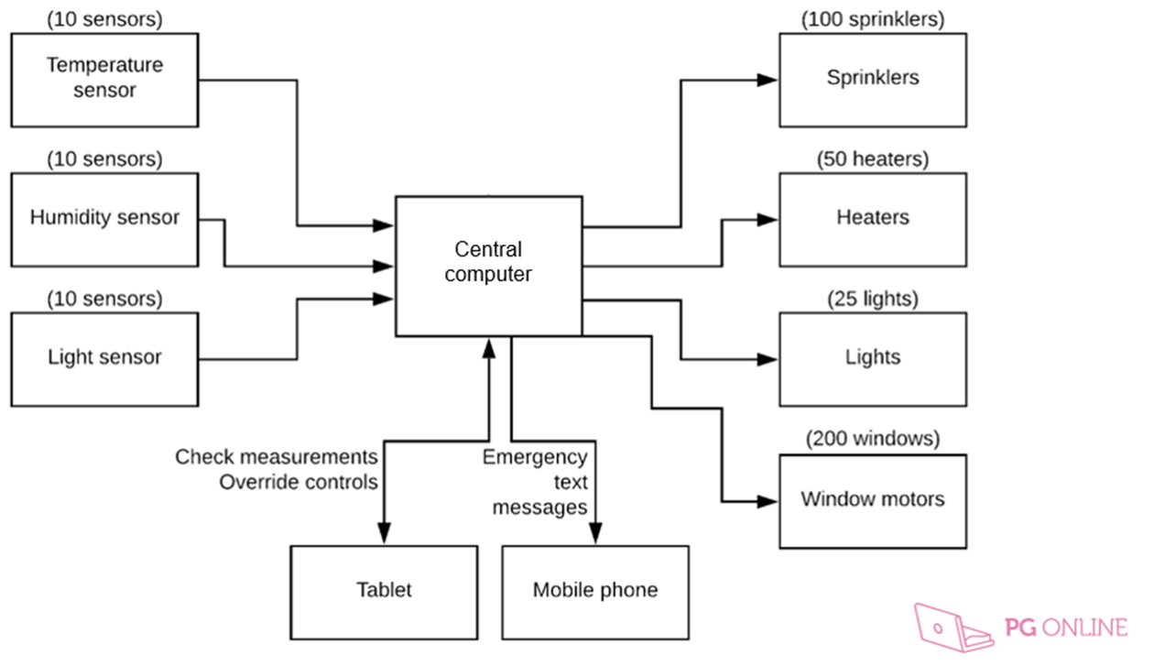
Why use system diagrams?
They can give a lot of information in a small space:
  - Input and output devices
  - Connections between components and data or signals
  - Computers / servers involved
  - Communication devices
  - Feedback loops
- They are a good way to communicate designs, infrastructure and processes about IT and an organisation’s systems
- They help in designing workable systems

Planning space
Activity
Create a system diagram for the computer equipment in your home.
Typical devices that can be found in the home:
- Computers/laptops
- I-pads/tablets
- Smartphones
- Internet router and firewall

Thinking point!
Think about the external connections to your devices at home.
What device has an external connection?
Presenting data
Tables are a useful way of presenting information
How the data is presented in a table makes a difference to how
easy it is to extract useful information.

Sometimes presenting information on a graph will help identify key information. However adding detail can be difficult. For instance there is no explanation as to why there has been a sake increase.

Where does Japan rank in this list of countries with the fastest Internet download speeds?
Improving the formatting of a table would make it easier to find key information.
Rank | Country | Download Speed (Mbps)
1 | Singapore | 60
2 | Sweden | 46
3 | Denmark | 44
4 | Norway | 40
5 | Romania | 39
6 | Belgium | 37
7 | Netherlands | 36
8 | Luxembourg | 35
9 | Hungary | 34
10 | Jersey | 31
11 | Switzerland | 30
12 | Japan | 29
13 | Latvia | 29
14 | Taiwan | 28
15 | Estonia | 28

Written information
Rules on writing:
- Write concisely
- Use appropriate language for your audience
- Check your writing for spelling, punctuation and grammar
- Include references and acknowledgements
For long documents or business reports:
- Include page numbers and a contents page
- Include a summary
Activity
For each of the following, explain whether you would use written information, a table or a bar chart to present the following information:
- Average broadband speeds in the ten countries with the fastest broadband.
- Exam results for a class of 25 students.
- The route between Birmingham and Calais giving times and distances for each leg of the journey.

D: Exam Questions
Level 0 data flow diagram
Piccalilli Shoes sells shoes through its nationwide shops and telephone orders.
Piccalilli Shoes has created a website to allow customers to buy online.
Figure 1 shows part of the process of purchasing shoes through the company's website:
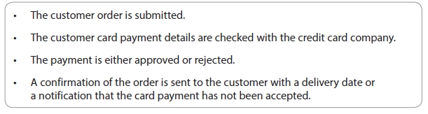
Figure 1
Draw a top level (Level 0) Data Flow Diagram showing the process Piccalilli Shoes uses for online orders.
(6)

Flow chart
Anna works for an online estate agency.
She travels to different places to meet with people who are selling their houses.
She uses a company laptop to record the property details.
She then uploads the property details to the company website using a mobile network.
Anna uses an incremental backup for her data.
An incremental backup will only backup a file if:
• it has changed since the last backup
or
• the file is new/has never been backed up.
The incremental backup must repeat this process for all the files on Anna's laptop.

Draw a flowchart to show the process for an incremental backup.
(6)

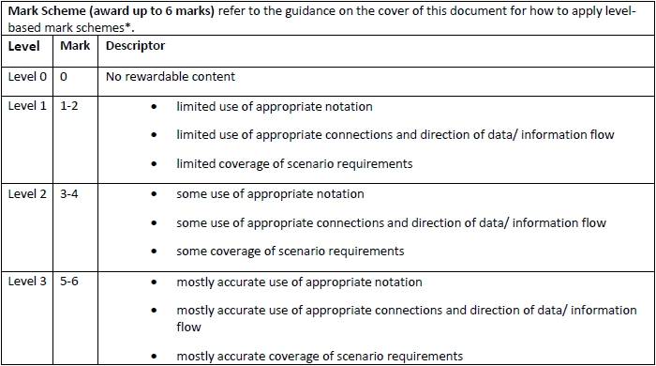
Articles for Wider Reading and Flipped Learning

Forms of notation - Know it all Ninja
Revise the different symbols and diagrams needed for this section
https://www.knowitallninja.com/modules/forms-of-notation/

