Colton Hills Community School medium term planning
Topic title:  ‘Sea Life’ SSm  OCR Art GCSE | Year: 10  Term: Autumn/Spring |  | Why we teach this:  For students to produce creative work, exploring their ideas and recording their experiences inspired by the theme ‘Sea Life’.  Students will create relief pieces of Poseidon and clay sculptures of coral reefs/underwater life in order to raise awareness of the environmental impact our actions are having on the oceans, in particular the issues surrounding plastic waste. | Why we teach this here:  Students work through the art and design process, consolidating prior learning and selecting materials, processes, and techniques appropriate to their choice of theme and skills set.
Big questions:  What are the requirements for GCSE Art and Design?  How has the ocean inspired artists/designers/craftspeople?  How can I show an artist’s influence in my own work?  What makes a good observation drawing?  Who is Poseidon?  What am I good at and where/how can I improve my skills further?  How can my drawings be developed/manipulated to create 3D designs in clay?  How can I present my work effectively? |  |  | Builds on previous topics:  The design process – analyse, create, review, develop, realise intentions. | Links to future topics:  Consolidate and improve skills in the formal elements of art, address the 4 GCSE assessment objectives in controlled assessment unit.
Key knowledge & skills:

• How to work in a range of different drawing styles, materials and techniques.
• To show an understanding of the work of different artists who were inspired by sea life.
• To learn how to develop original ideas influenced by research material and observation studies.
• To review, modify and adapt designs to create effective relief and 3D outcomes in clay.
• To evaluate work and progress in order to improve further and inform future work.

Skills developed:

We give the opportunity for students to analyse the work of artists, designers and craftspeople and create personal and meaningful practical outcomes in a range of media. In order to realise intentions, we teach students to be analytical, questioning and independent learners reviewing and refining their work to produce effective outcomes.

AO1 - Develop your ideas through investigations informed by contextual and other sources, demonstrating analytical and cultural understanding. |  | AO2 - Refine your ideas through experimenting and selecting appropriate resources, media, materials, techniques and processes. | Independent study tasks/resources:  Research into Poseidon and the work of:  - Yellena James – https://yellena.com/  - Courtney Mattison - https://courtneymattison.com/  - Alice R Ballard - http://aliceballard.com/  - Diane Lubinski  - Lisa Stevens  - Dale Chihuly | Key vocabulary:  Sea Life  Ceramics  Underwater  Poseidon  Neptune  Mythology  Observation  Experimental  3D  Colour  Ocean  Record  Original  Mark-making  Shells  Coral  Sea  Printmaking  Analyse  Design  Organic  Develop  Evaluate
AO3 - Record ideas, observations and insights relevant to your intentions in visual and/or other forms. |  | AO4 - Present a personal, informed and meaningful response demonstrating analytical and critical understanding, realising intentions and making connections between visual or other elements.
Cultural capital opportunities:  Students to research meaning and purpose of artists work and consider their influences, including symbolism/tradition.  Greek and Roman mythology – Poseidon and Neptune. |  |  | Whole school Curricular Concept links:  - Precious Planet  - Artistic Creativity

Learning objectives | Tasks
Week 1-  - To understand the requirements of the course and GCSE assessment objectives.  - To create observation drawings of shells, sea creatures etc with correct proportion, form , texture and tone  - To experiment with a range of materials and techniques | - Observational drawings of shells/sealife  - Biro cross-hatching  - Anilinky washes  - Oil pastel on tracing paper  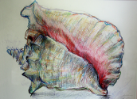  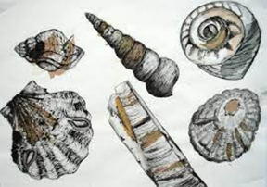  - Fine liner and water washes | - Small questions  What media should I use? What techniques am I best at? How do I use materials and techniques most effectively?
- Retrieval focus
Use of a range of media and techniques.
Formal drawing skills.
- Independent study
To complete any unfinished observational drawings

Week 2  - To complete, refine and improve observation studies  - To experiment with colour washes | - DIRT  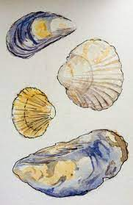  Review and improve drawings to date. Add colour washes to photocopies. | - Small questions  What do I need to finish? What can be improved? – how?
- Retrieval focus
Formal drawing elements
- Independent study
To research Posiedon/Neptune
Week 3  - To show  an understanding of the physical characteristics of Posiedon and the mythology surrounding him  - To learn how to present research material effectively and show a range of skills and knowledge to meet the assessment objectives. | jj 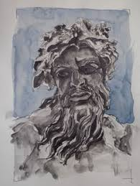  Create a research page on Poseidon/Neptune showing different modern and ancient depictions, own studies and contextual information | - Small questions  Who is Posiedon? What does he look like? What is an artist research page? What is the purpose of a research page? How do you present artist research successfully?
- Retrieval focus
Proportions of the face, effective presentation
- Independent study
To complete research page

Weeks 4-5  - To create a range of initial ideas for a relief ceramic mask of Posiedon  - To learn how to create visually interesting pages and demonstrating your skills with media | - Create an A2 initial ideas page  - Add colour using preferred media | - Small questions  How do I come up with my own ideas?  How should I present them?  How should I annotate them?
- Retrieval focus
Presentation skills and use of media
- Independent study
To complete colour and annotation

Weeks 6-7  - To learn how to develop and refine ideas, selecting artists influence, media and techniques.  - To learn how to critically analyse and review progress.  - To learn how to annotate effectively to explain ideas and justify choices.  - To learn how to finalise ideas by making informed decisions about scale, colour and materials. | - Development of designs  - Add colour using preferred media.  - Final design | - Small questions  What is your clay work going to look like? How are you going to include all the best elements of your designs?
- Retrieval focus
Design process
- Independent study
To complete any unfinished work
Weeks 8-10  - To learn how to make a relief ceramic mask  - To be aware of health and safety considerations when working with clay  - To create unique, personalised designs and effectively realise outcomes. | Model facial features  Add shells, seaweed, coral etc  Finalise detail. | - Small questions  How will you model the features accurately?  How will you adorn the face with sea life? How can you improve your design further whilst making?
- Retrieval focus
Design and development process whilst modelling
- Independent study
To complete any unfinished work

Week 11  To review work to date and improve in light of teacher feedback | - DIRT | - Small questions  What can I do to increase my marks?
- Retrieval focus
Techniques and processes on design sheets
- Independent study
To complete any unfished work
Weeks 12 - 13  - To show an understanding of the characteristics of a range of ceramic artists’ work  - To show an understanding of artists’ intentions, methods and techniques  - To learn how to present research material effectively and show a range of skills and knowledge to meet the assessment objectives. | Research pages 2-3 ceramic artists  - Courtney Mattison  - Alice Ballard  - Diane Lubinski  - Lisa Stevens  - Dale Chihuly  - Yellena James | - Small questions  Which artists’ work do I want to use as influences?  How do I present my research findings most effectively?
- Retrieval focus
Presentation and content of research pages
- Independent study
Complete all research pages
Week 14  - To understand health and safety rules when glazing  - To learn how to glaze effectively in order to realise intentions. | - Glaze relief ceramic pieces (Posiedon)  following a teacher demonstration. Students will use their designs to help inform their colour choices. | - Small questions  What colours are you going to apply? How do you apply glazes effectively?
- Retrieval focus
How to apply glazes effectively
- Independent study
To complete any unfinished work

Week 15  - To consolidate how to present the unit of work effectively and show a range of skills and knowledge to meet the assessment objectives.  - To be able to respond to teacher feedback to gain more marks to meet assessment objectives. | - DIRT - Complete any unfinished work and gain more marks to meet assessment objectives. | - Small questions  What work do you need to complete? What can you do to improve your work? What am I good at and where/how can I improve my skills further?
- Retrieval focus
- Review, modify, improve as part of the design process
- Independent study
To complete any unfinished work by responding to teacher feedback

Weeks 16-17-  - To create a range of initial ideas for a 3D ceramic piece influenced by artists’ work  - To learn how to create visually interesting pages and demonstrate your skills with media | 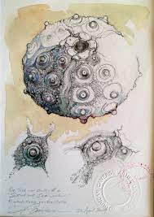  Create an A2 initial ideas page showing a range of ideas influenced by artists research | - Small questions  What media should I use? What techniques am I best at? How do I use materials and techniques most effectively?
- Retrieval focus
Use of a range of media and techniques.
Formal drawing skills.
- Independent study
To complete any unfinished observational drawings

Weeks 18-19  - To learn how to develop and refine ideas, selecting artists influence, media and techniques.  - To learn how to critically analyse and review progress.  - To learn how to annotate effectively to explain ideas and justify choices.  - To learn how to finalise ideas by making informed decisions about scale, colour and materials. | - Development of designs  - Add colour using preferred media.  - Final design  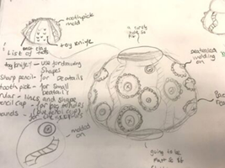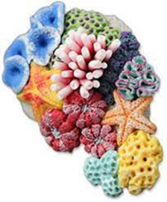 | - Small questions  How can I develop my work further?
- Retrieval focus
Development process and annotation
- Independent study
Complete design work
Weeks 20-22  - To effectively realise intentions in clay reviewing and modifying as the work progresses  - To apply glazes with accuracy after initial biscuit firing | jj  Making moulded/slabbed 3D ceramic pieces  Create preferred design(s) in clay using hand building techniques to suit designs.  Experiment with different tools to create a range of patterns and surface textures | - Small questions  What are the best methods to create this piece?
- Retrieval focus
Modelling with clay
- Independent study
To complete final pieces

