Mathematics

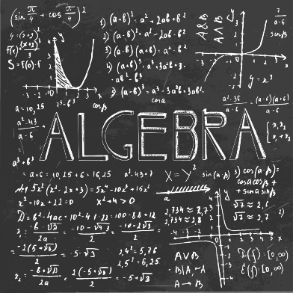
Year 7 – Autumn 1
Algebraic Thinking.
Knowledge and Assessment Organiser

Student name: ………………………………….
Why do we use algebra?

Contents

Key Terms | 3
What’s the story – Sequences | 5
Essential knowledge - Sequences | 6
Retrieval Questions - Sequences | 9
What’s the story – Algebraic Notation | 10
Essential knowledge – Algebraic Notation | 11
Retrieval Questions – Algebraic Notation | 13
What’s the story – Equality and Equivalence. | 14
Essential knowledge – Equality and Equivalence | 15
Retrieval Questions – Equality and Equivalence | 17
Big Question and Small Question breakdown | 18
Question stems | 19
Examples of students’ answers | 20
Articles for wider reading and flipped learning | 28
Did you know…?
The word algebra comes from a Latin variant of Arabic word al-jabr, it came from book’s title “Hidab al- jabrwal- muqubala” by mathematician from Arab-Mohammed ibn-Musa al-Khowarizmi in 825 A.D.
The roots of this subject dates back to 1900 BC when it was traced that it was Babylonians who came up with Algebra.

Key terms

Key Word | Definition/Tips | Example
Odd | Any integer (whole number) that cannot be divided exactly by 2. | 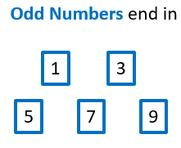.
Even | Any integer (whole) that can be divided exactly by 2. | 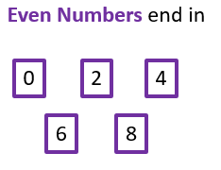
Operation | A mathematical process which acts which transforms the input. | The most common are add, subtract, multiply and divide.  (+, −, ×, ÷).
Inverse | The opposite. | The inverse of +3 is -3.
Sequence | A list of numbers or objects in a special order. | 2, 5, 8, 11
Ascending Sequence | A sequence where the terms increase in value | 2, 5, 8, 11, …
Descending sequence | A sequence where the terms decrease in value | 11, 8, 5, 2, -1, …
Term to term rule | A term to term rule allows you to find the next number in the sequence if you know the previous term (number.) | For 2, 5, 8, 11 the term to term rule is +3 as you +3 to each number to get the next one.
Arithmetic  sequence. | If the rule is to add or subtract a number each time | 2, 5, 8, 11
Geometric sequence | If the rule is to multiply or divide a number each time | 3, 6, 12, 24
Linear | Increases by the same amount – could be graphed as a straight line. | The sequence 2, 5, 8, 11 is linear because you add three each time.
Function Machine | It is like a machine that has an input and an output and the output is related somehow to the input. | 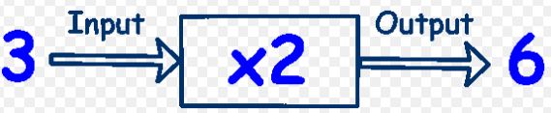
Input | What you start with. | 3 is the input of the function machine above.
Output | What you end up with. | 6 is the output of the function machine above.
Variable | A letter which is used to represent an unknown number | m, t, y, a, b, n,
Terms | In Algebra a term is either a single number or variable, or numbers and variables multiplied together. | y, 2b, 8a, 6bd, 8, 34
Coefficient | The number in front of a variable. | 6a, 86y, 3.4c
Like Terms | Terms which have the same variable (letter) | 2a and 4a  5n and 88n
Unlike Terms | Terms which have a different variable (letter) | 4c and 5d  4a and 4a²
Equivalent | Having the same value, or are equal | 1 pound is equivalent to 100 pence.  60 seconds is equivalent to 1 minute
Expression | A mathematical statement written using symbols, numbers or letters, | 3x + 2 or 5y²
Equation | A statement showing that two expressions are equal | 2y – 17 = 15
Identity | An equation that is true for all values of the variables | 2x ≡ x+x
Formula | Shows the relationship between two or more variables | Area of a rectangle = length x width or A= LxW
Simplifying Expressions | Collect ‘like terms’.  Be careful with negatives.  $x^{2}$ and $x$ are not like terms. | a + 3a = 4a  b + b + b = 3b
$x$times $x$ | The answer is $x^{2}$ not $2x$. | Squaring is multiplying by itself, not by 2.
$$p×p×p$$ | The answer is $p^{3}$ not $3p$ | If p=2, then $p^{3}$=2x2x2=8, not 2x3=6
Substitute | Putting values where the letters are. | 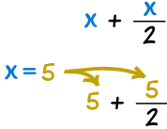
What’s the Story?
My name is Christopher Jones and I am stranded far from home. I’ve been travelling around the world, but the pandemic meant that all flights home have been cancelled. I’m running out of money and I really want to see my mum and have some of her homemade lentil pie.

I think the only option for me is to walk. It’s1024 miles and I don’t seem to be making much progress. I’ve spent weeks walking through dense forest and yet I’m only half-way home. I have blisters the size of golf balls and my shoes are starting to get holes in them. Oh well, only 512 miles to go.

At least I’ve passed the forest now. The last section has been much nicer, I’ve been walking by a small river recently, which means I can drink water whenever I want and even wash on occasions. Half-way there again now. Only 256 miles left.

I’m beginning to feel more and more frustrated. No matter how much I walk I still never make it, I only seem to get half-way there. 128 miles, then 64 miles, 32 miles, 16 miles, but I never make it more than half way. I’m beginning to think I’ll be stuck walking home forever. If that’s not bad enough I’ve run out of deodorant!

On the plus side I’m starting to recognise more and more about where I am walking. I can see the beautiful outskirts of my town and eventually I’m only 8 miles away. Maybe I was too quick to give up hope. With 4 miles to go I pass by a vegan café I used to frequent. With 2 miles to go I see my old school. Only 1 mile to go now as I start to walk onto my street. I can almost taste the lentil pie. Yum.

But wait! I’m still walking and I’m not making it home. I was only ½ mile from home, then ¼ mile, then an 1/8th of a mile, a 1/16th, 1/32 and it just keeps going and going. I can’t make it home without first going half-way, but when I get half-way there, I go another half, and another half, and another half and I keep walking. Please send help, I’m stuck in an eternal mathematical paradox!
Why does this matter?

- Many things around us follow a pattern. Knowing how these patterns works will allow us to better understanding the world.
- For example, how will the number of cases of a disease increase or decrease? Can we spot trends in a game that might help us to win? We can also use sequences to help us create music or even to fight in boxing or martial arts.
Sounds familiar?

You will have studied sequences in different points in your school life, starting at primary school. We start by looking at arithmetic sequences like 1, 4, 7, 10 that increase/decrease by the same number each time. We are now looking at other types of sequences which follow different rules and patterns that are sometimes harder to decipher.
Essential Knowledge
Notes:………………………………………………………………………………………………………………………………………………………………………………………………………………………………………………………………………………………………………………………………………………………………………………………………………………………………………………………………………………………………………………………………………………………………………………………………………………………………………………………………………………………………………………………………………………………………………………………………………………………………………………………………………………………………………………………………………………………………………………………………………………………………………………………………………………………………………………………………………………………………………………………………………………………………………………………………………………………………………………………………………………………………………………………………………………………………………………………………………………………………………………………………………………………………………………………………
Sequences.
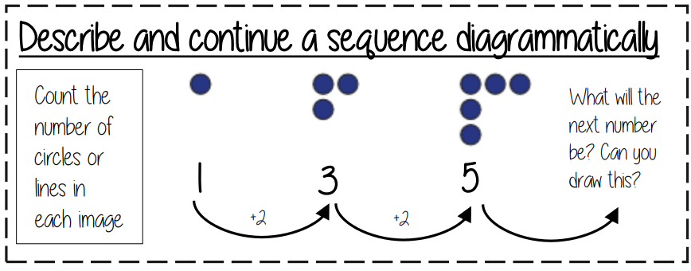
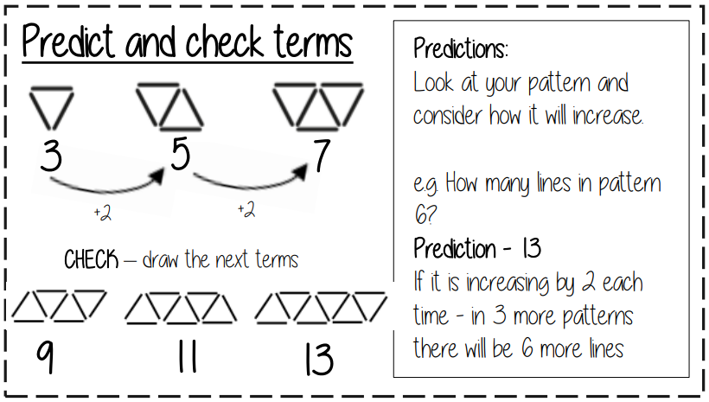
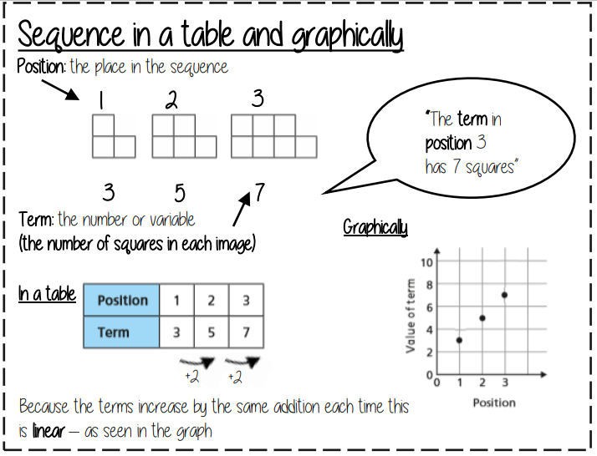

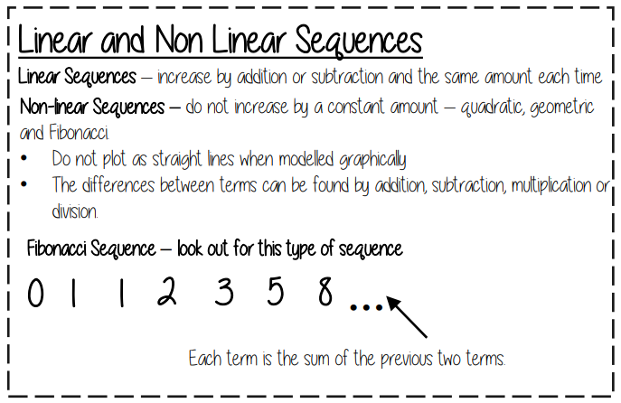
Did you know…?
The Fibonacci sequence is the numerical representation of the golden ratio which is used in many famous works of art.
One notable example is The Mona Lisa. Da Vinci utilized the sequence with the Golden Spiral.
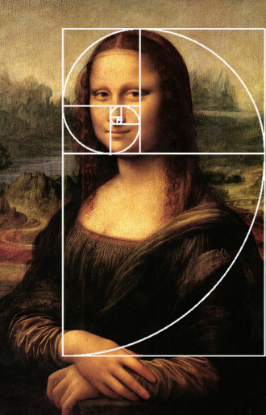

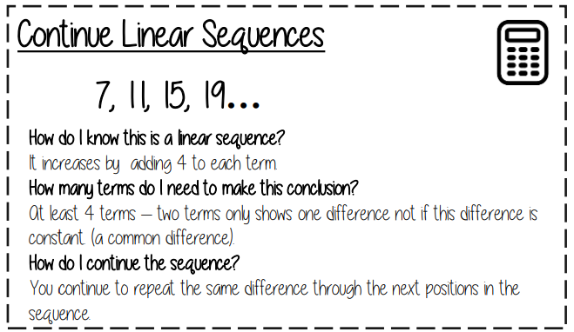
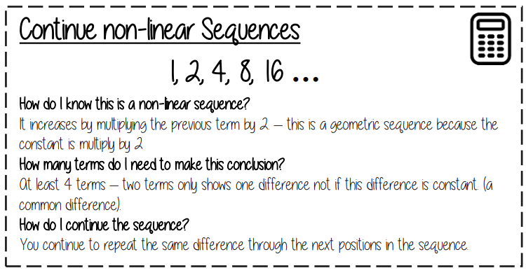
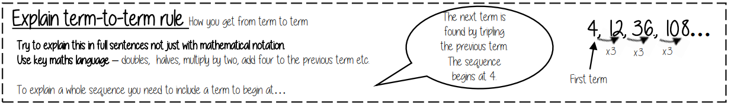

Retrieval Quiz – Sequences.
When you can answer all of the questions on this page without looking at your notes, you have mastered the basic skills.
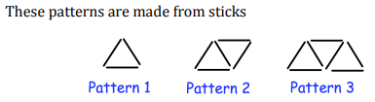
- How many sticks would the fourth term have?
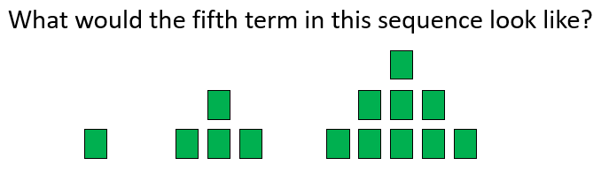
- Find the fourth term.
Position | 1 | 2 | 3 | 4 | 5
Term | 4 | 7 | 10 |  | 16
4. Find the next three terms in the following linear sequence.
90, 85, 80, …
5. Find the next two terms in the following sequence.
1, 1, 2, 3, 5, 8, …
6. Is this sequence linear? Why?
10, 20, 30, 40, 50, …
7. State the term-to-term rule of the sequence.
1, 5, 9, 13, …
8. What is the name of the sequence in question 5?
9. Find the missing term in the following sequence:
5, 9, ___, 17, …
10. State the term-to-term rule of the sequence and find the next term.
2, 2.5, 3, 3.5, …
What’s the Story?
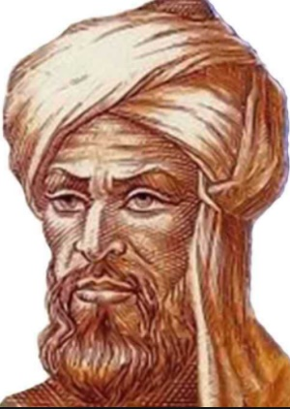
My name is Muhammad ibn Musa al-Khwarizmi. I am a mathematician from Persia and the year is is 830AD. I am currently working at the forefront in mathematical discovery and have been overseeing the translation of major Greek and Indian mathematical and astronomy works into Arabic. Through this work I have also advanced the understanding of mathematics in my time. In fact, I have made so many breakthroughs that my work will still be used almost 1200 years later in the year 2021AD.

I am credited with the conception of algebra and am sometimes called the father of the algebra. This comes from the Latinisation (translation) of ‘al-jabr’ which was the title of my most famous book – which I just published. It introduced the basic algebraic methods and suggested methods and techniques for solving problems – including equations. (Believe it or not they are a useful tool when trying to solve complex problems).

However, perhaps my most important contribution to the field of mathematics was my strong support of the Hindu numerals 1 – 9 and 0- which are known as Hindu-Arabic numerals. My support of their use helped get them adopted as the standard number system by the entire Islamic world. Later, following translations of my work, and the influence of my fellow mathematician Fibonacci, the number system was adopted throughout Europe as well. This meant that mathematics became a universal language across the globe.

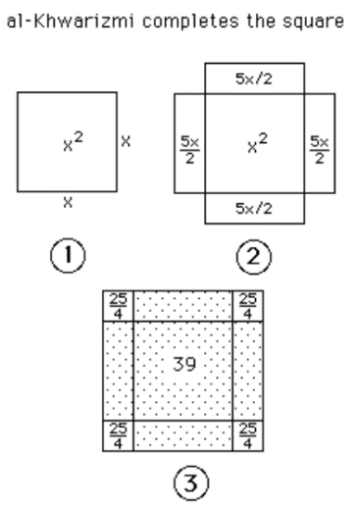
One of the most important things I am credited for discovering was the problem of completing the square. This is an algebraic skill which is widely used in problem solving and is taught to all secondary school aged pupils. It formed the basis for mathematical modelling – which is used in many things from rollercoaster design to space exploration.

By the end of this unit of work, you will understand how to represent problems using algebra. Could you help develop a new branch of mathematics?

Why does this matter?

- Algebra is one of the fundamental building blocks of Maths, crucial to understand.
- Most problems can be solved using algebra.
- More complicated mathematical problems require a more complicated mathematical representation.

Sounds familiar?

You will have come across missing number problems in primary school, as well as sequences and this is the foundation of algebra.
Algebraic Notation.
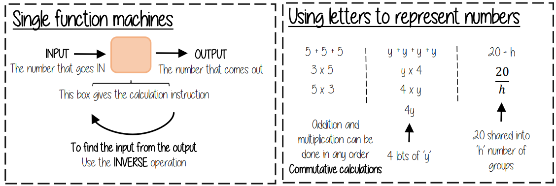
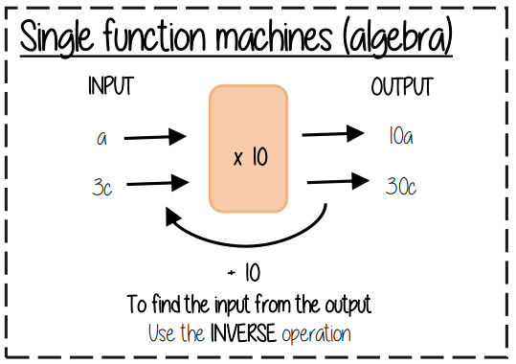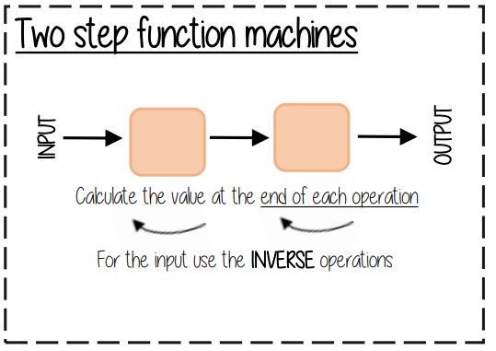
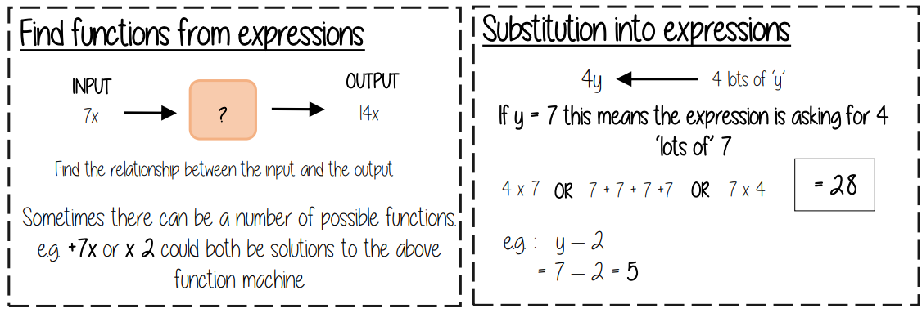
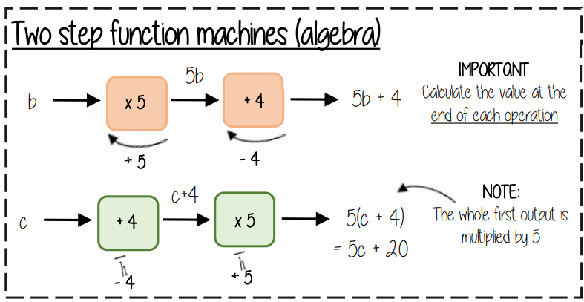
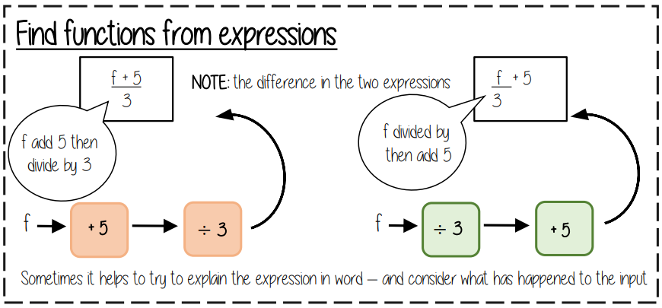
Notes:………………………………………………………………………………………………………………………………………………………………………………………………………………………………………………………………………………………………………………………………………………………………………………………………………………………………………………………………………………………………………………………………………………………………………………………………………………………………………………………………………………………………………………………………………………………………………………………………………………………………………………………………………………………………………………………………………………………………………………………………………………………………………………………………………………………………………………………………………………………………………………………………………………………………………………………………………………………………………………………………………………………………………………………………………………………………………………………………………………………………………………………………………………………………………………………………
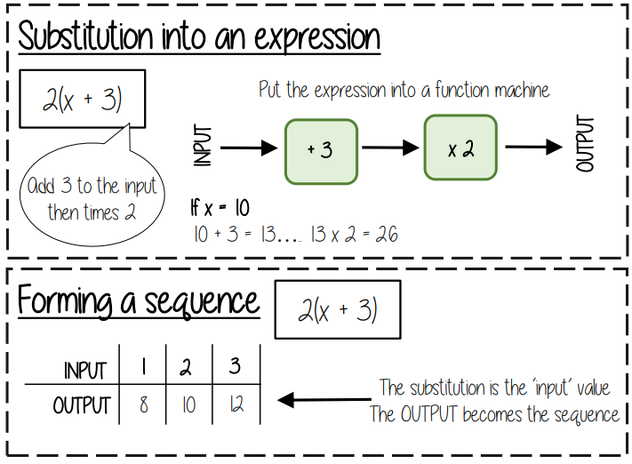
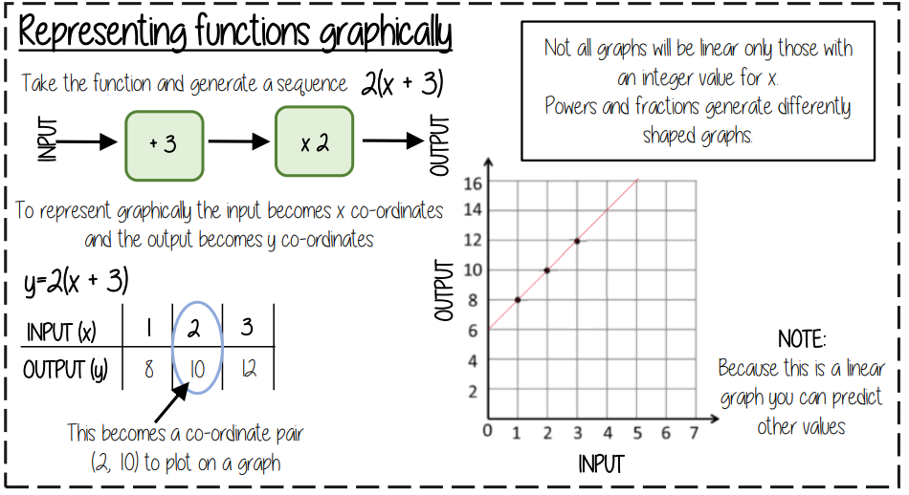
Did you know…?
To reach the moon, NASA scientists set up and solved a complex system of equations.

Retrieval Quiz – Algebraic Notation.
When you can answer all of the questions on this page without looking at your notes, you have mastered the basic skills.
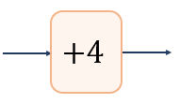
1. Find the output when you input 5 into this function machine.

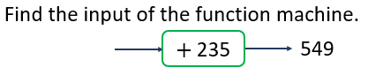
2.

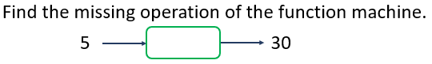
3.

4. Write this expression without mathematical operation signs.
f + f + f + f + f + f
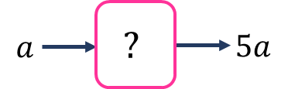
5. Find the function of this machine.
6. Substitute a=5 into the following expression.
7a
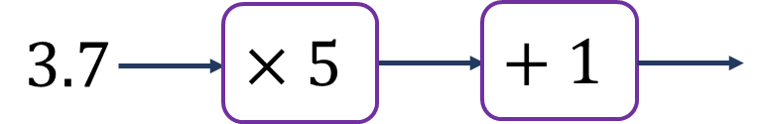
7. Find the output of this function machine.
8. Substitute e=150 into the expression $\frac{e}{3}$
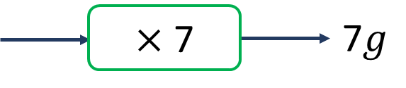
9. Find the input of the function machine.
10. Find the first three terms of this sequence. Is it a linear sequence?
$n^{2}-4$
What’s the Story?

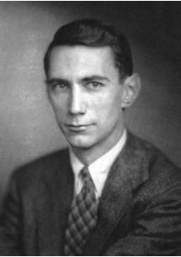
My name is Claude Shannon, and I am known as the father of information theory. I founded both digital computer and digital circuit design theory in 1937 and worked on cryptography for the United States government during World War II. I was concerned about the amount of data that could fit within signal processing operations, like storing data on a computer or facilitating telecommunications, so I created information theory in 1948. The mathematics that is used in computer programming is algebra. We use formulas and equations to find solutions to problems.

Information theory is quite complex, but I can describe it using a simple example. A computer can easily process the probability of a coin toss since there are only two outcomes: head or tails. However, the computer requires more data processing to consider the outcome of a six-sided dice being rolled. Therefore, information theory is the reduction of uncertainty so solutions can be made. So basically, algebra makes our lives a whole lot easier and helps us solve lots of problems!

You might be thinking what this has to do with computer coding. Coding is the language use to execute commands within a computer. If coding is a language of commands, then algebra can be thought of as the mathematical calculation of those commands.

A solid understanding of algebra includes defining relationships between objects, problem solving with limited variables, and analytic skill developments to help execute decision making. If you are interested in the field of computer programming and coding, then it is important for you to understand and manipulate mathematical logic.

Whenever life throws a maths problem at you algebra is usually the best way to attack it.

Why does this matter?

- Even the simplest of algebra is used in computer science in the development of algorithms and software. Without them we would not be able to play all the computer games that we have access to today!
- A student who enjoys computers and problem-solving will find a career in computer science very rewarding.
Sounds familiar?

It is found that as humans we are capable of problem solving as early as 10 months of age! So, although we may not realise it, we are introduced to algebra at a very early age and begin to use it in our daily lives to solve problems before we even know the word “algebra”.
Equality and Equivalence.
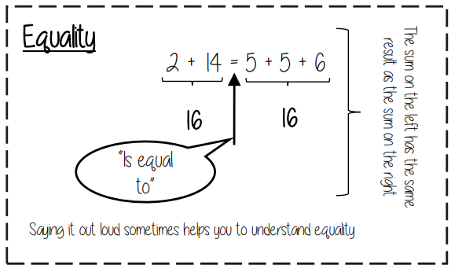
Notes:………………………………………………………………………………………………………………………………………………………………………………………………………………………………………………………………………………………………………………………………………………………………………………………………………………………………………………………………………………………………………………………………………………………………………………………………………………………………………………………………………………………………………………………………………………………………………………………………………………………………………………………………………………………………………………………………………………………………………………………………………………………………………………………………………………………………………………………………………………………………………………………………………………………………………………………………………………………………………………………………………………………………………………………………………………………………………………………………………………………………………………………………………………………………………………………………
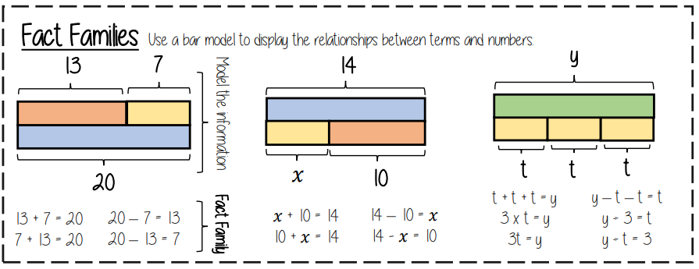
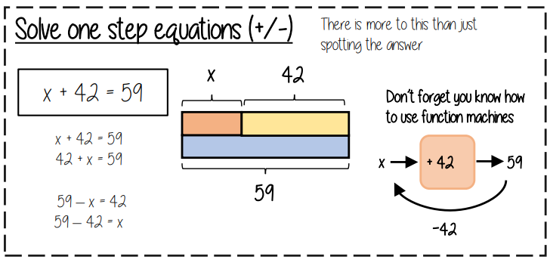
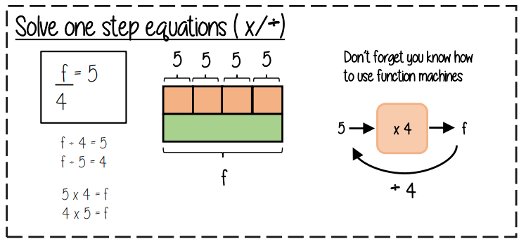

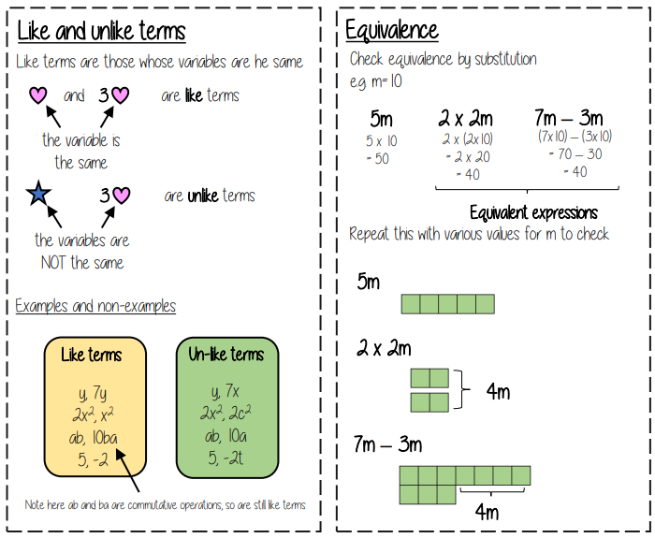
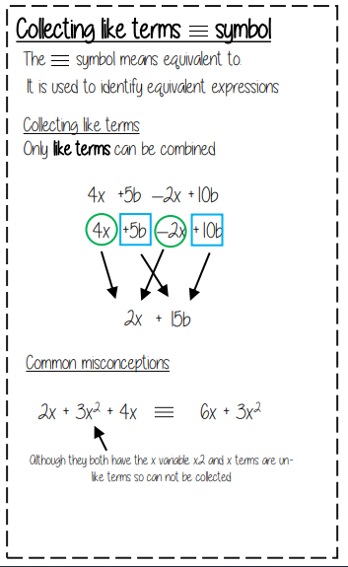
Did you know…?
Scientists use mathematical models to help predict the effects of, and create strategies to combat, global warming.
Thinking point
Why is x the most common letter used in algebra?
Retrieval Quiz – Equality and Equivalence.
When you can answer all of the questions on this page without looking at your notes, you have mastered the basic skills.
1. 19 + 3 = 18 + ?
2. 50 – 14 = 52 – ?
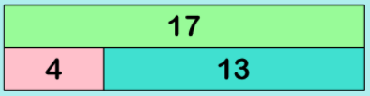
3. Write a fact family for the following bar model:

4. Solve: 34 – x = 16
5. Solve: 7x = 56
6. Solve: x/4 = 60
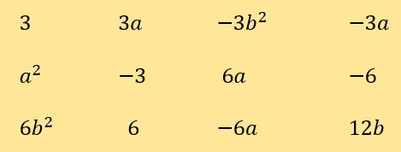
7. Match the like terms:

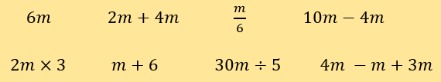
8. Which of the following expressions are equivalent?

9. Simplify: 3a + 2a + 4a
10. Simplify: 6b + 2c – 2b + 4c

What are the real-life applications of Algebra?
Why might it be useful to form an expression?
How can you tell if a sequence is arithmetic or geometric?

Is there a difference between 2x and 2y?
How can you generate a sequence from the rule?

Can you explain the difference between an expression and an equation?
How can bar models help you to solve a linear equation?
How can simplifying expressions help you to solve problems?

How can we identify ‘like terms’?
Can you describe the key characteristics of a sequence?
What is the purpose of a function machine?

How can simultaneous equations be used to solve real life problems?

How can you recognise the graph of a simple cubic function?

How can you prove that a number is even using algebraic methods?

Question Stems
Question Stem | Example | What to do.
Find the next term(s) | 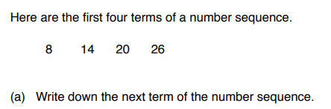 | Work out the term-to-term rule. Apply it and writ down the next term in the sequence.
Describe the rule. | 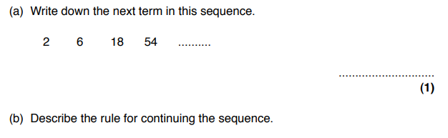 | Look at the sequence and write down the rule to get from on term to another.
Simplify  OR  Collect the like terms… | 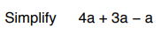 | Collect all the same terms together to form one term.
Expand | 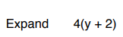 | Multiply out the brackets.
Factorise | 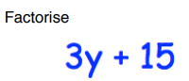 | Find the highest common multiply
Find an expression | 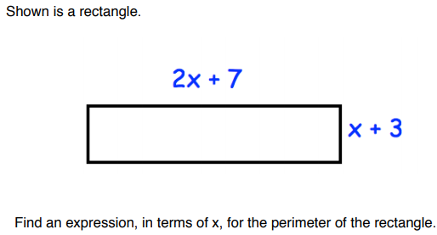 | Read the question at least twice.  Write down all of the expressions that you need to consider.  Simplify
Solve | 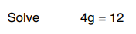 | Find the value of g which means 4 x g = 12.

Examples
Possible success criteria
Describe and continue number patterns.
Here are the first four terms of number sequence.
Notes:
a) Working shown (including how to find the term-to-term rule) and then answer highlighted and stated so that it is clear.

b) Answered in a complete sentence using mathematical language.
11, 15, 19, 23, …
- Write down the next term of the number sequence.
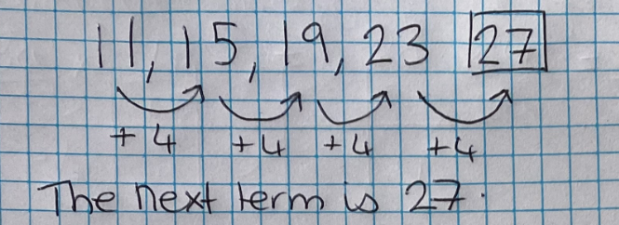
- Explain how you found your answer
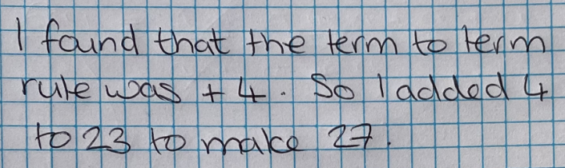

Generate number patterns.
Notes:
- Working shown and the answer is highlighted.
- Working shown – it is clear by continuing the sequence that 35 does not appear. Answer is stated as well as shown.
Example 1
- Write down the next term in this sequence:
5, 9, 13, 17, …
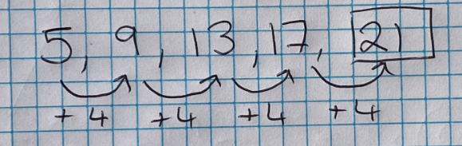
- Is 35 in this sequence?
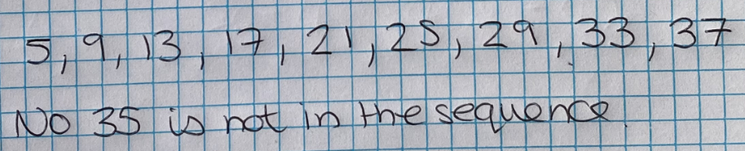

- Write down the next number in this sequence:
5,9,13,17,
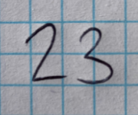
Notes:
- No effort to find the term-to-term rule and answer is incorrect.
- No reason. You would not receive the mark just for writing yes/no.
- Is 35 in this sequence?
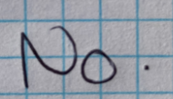

Example 2
The first term of a sequence is 5.
Note:
Rule applied correctly to the first term, and answer stated clearly.
The rule for continuing the sequence is: Multiply by 2 and subtract 1.
What are the next 2 terms?
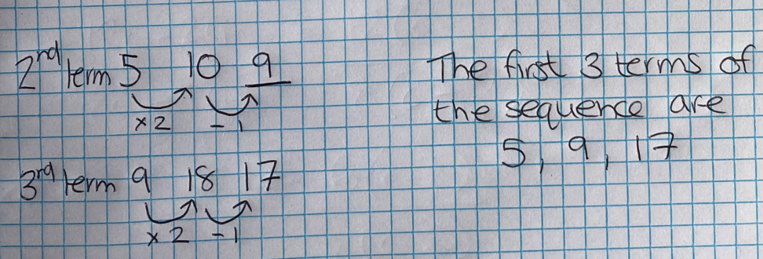

Note:
Student has not applied the rule to the first term.
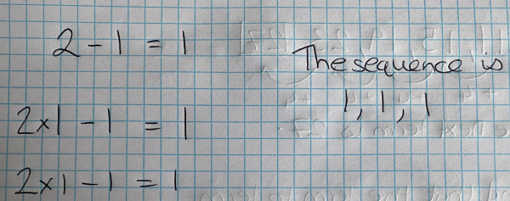
Substitution
Substitute y = 3 into the expression 2y + 1

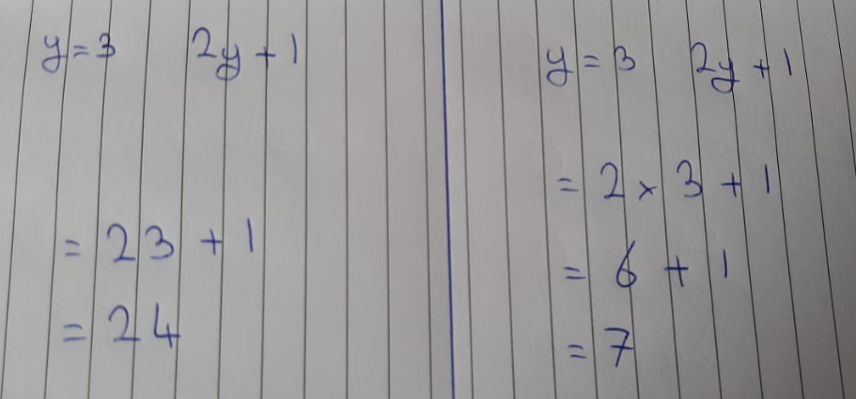

Generate sequences from a rule
- Write down the first 3 terms of the sequence with the nth term 3n – 1
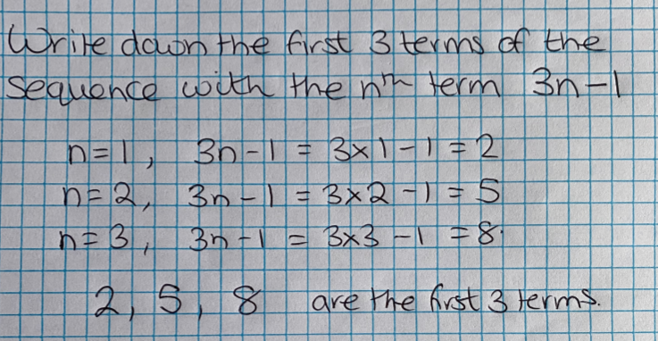
Note:
Working shown. Correct positions used (first term, n=1, second term, n = 2 etc).
First 3 terms listen.
- What is the 50th term?
Notes:
Working shown. Answer highlighted.
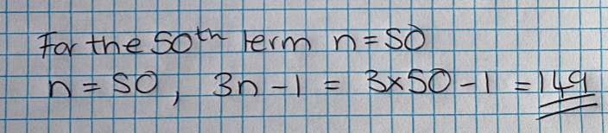

Collecting like terms.
Simplify the expression 4a + 3b – a + 7b + 4
Notes:
Like terms identified and calculated.
Answer given clear at the end including the constant
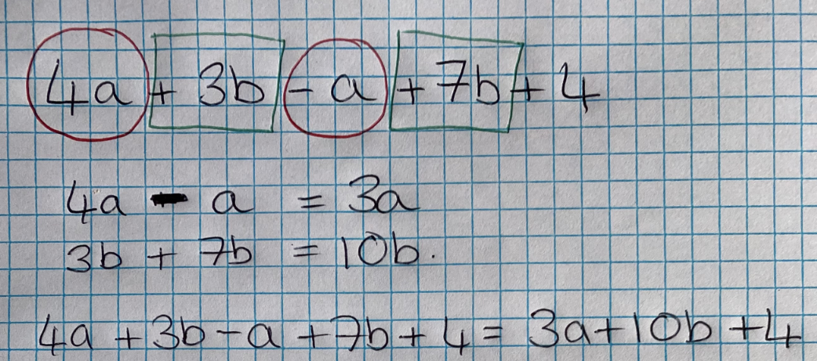
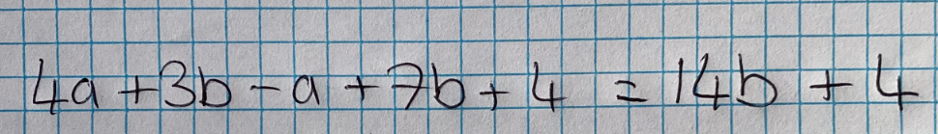
Notes:
No attempt to identify like terms. Variables have been merged.

Solving equations
Example 1
Solve x + 7 = 10
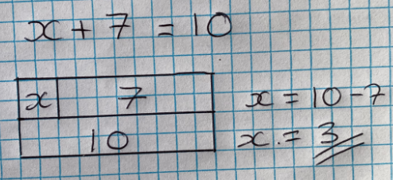
Notes:
Bar model used to identify what needs to be done to calculate x.
Example 2
Solve 3x + 7 = 1
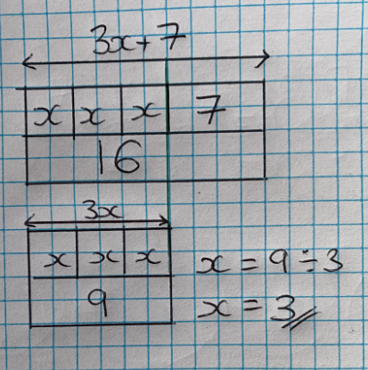
Notes:
The bar model was used to support the calculation. The answer was highlighted.

Forming algebraic expressions and equations
Nicola has y marbles.
Sean has 25 marbles.
Vicky has 10 marbles.
a) Write down an expression for the total number of marbles they have.
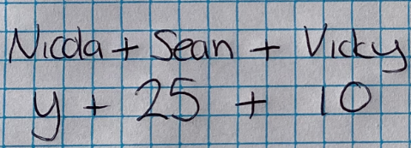
b) Altogether they have 55 marbles. Find how many marbles Nicola has.
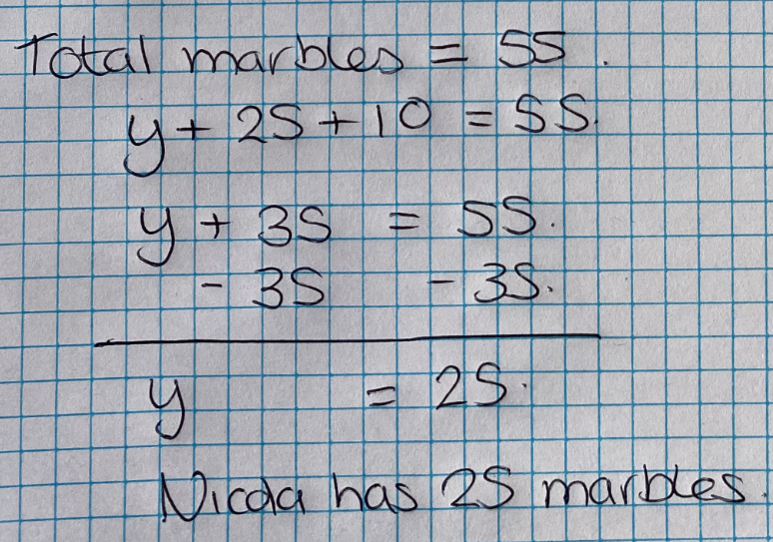
Notes:
The equation is formed and solved based on the expression formed above.

Retrieval Answers – Sequences.
Remember that for the exam you will have to use this knowledge to answer questions that involve reasoning and problem solving.

1. 8
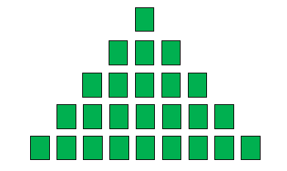
2 .
3. 13

4. 75, 70, 65

5. 13, 21

6. Yes, because it increases by the same amount each time.

7. Add four to the previous term.

8. Fibonacci Sequence

9. 13

10. Add 0.5 to the previous term.
Next term is 4.
Retrieval Answers – Algebraic Notation.
Remember that for the exam you will have to use this knowledge to answer questions that involve reasoning and problem solving
1. 9
2. 314
3. x 6 or + 25

4. 6f

5. x 5

6. 35

7. 19.5

8. 50

9. g

10. -3, 0, 5
No, it is not linear as it does not increase or decrease by the same amount each time.

Retrieval Answers – Equality and Equivalence.
Remember that for the exam you will have to use this knowledge to answer questions that involve reasoning and problem solving

1. 4
2. 16
3. 4 + 13 = 17
13 + 4 = 17
17 – 13 = 4
17 – 4 = 13
4. x = 18
5. x = 8
6. x = 240
7. 3, -3, 6, -6
3a, -3a, -6a, 6a
-3b², 6b²
a²
8. 6m, 2m + 4m, 10m – 4m, 2m x 3, 30m ÷ 5, 4m – m + 3m
9. 9a
10. 4b + 6c

Articles for Wider Reading and Flipped Learning.

Article 1

Al-Khwarizmi, the Father of Algebra
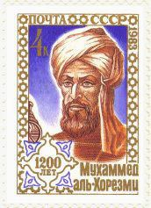
Al-Khwarizmi
Abu Ja'far Muhammad ibn Musa al-Khwarizmi lived in Baghdad, around 780 to 850 CE (or AD). He was one of the first to write about algebra (using words, not letters).
Around 825 he wrote the book "Hisab Al-jabr w’al-muqabala", from which we get the word algebra (meaning 'restoration of broken parts'). This book included many word problems, especially dealing with inheritance.
Al-Khwarizmi helped establish widespread use of Hindu-Arabic numbers:
1, 2, 3, ...
which replaced Roman numerals (common throughout Europe and the Middle East as a result of the spread of the Roman Empire), until then:
I, II, III, IV,...
The Hindu-Arabic system was much easier to use when performing mathematical operations, since it is a base-10 system. Ever tried to multiply using Roman numerals...?
This Islamic mathematician was also instrumental in encouraging the use of the number 0 as a place holder. For example, the "0" in the number 105 indicates there are no multiples of 10 in this number - the 0 is just separating the "1" (for hundreds) and the "5" (for 1's).

The House of Wisdom, Baghdad
Al-Khwarizmi was a scholar at the House of Wisdom in Baghdad. This group was interested in re-engaging with the brilliant work of the ancient Greeks, which had been lost and almost forgotten about, for centuries. Apart from translating the classic Greek texts, they published their own research on algebra, geometry, and astronomy.
The scholars were not simply producing academic works. They were trying to solve the problems of the day involving lawsuits, trade, measurement, and inheritance.

Al-Khwarizmi's Algebra
The algebra presented in the book "Hisab Al-jabr w’al-muqabala" used words for variables, so it was not as convenient as the algebra we use today.
"Al-jabr" means "completion" and "al-muqabala" means "balancing". His aim was to solve linear or quadratic equations by removing negatives using a process of balancing both sides of an equation. This is the same as what we do in algebra today.
From al-Khwarizmi's name came the word "algorithm".

Article 2

10 reasons for studying algebra.
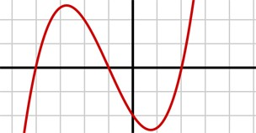
Sometimes it can seem hard work studying algebra. Hopefully at least some of the reasons below will help convince you that it is worthwhile in the end!

1. Algebra will help you in your career.
The fact is that you can’t get a good grade in your mathematics GCSE without some algebra. Getting a good maths GCSE opens up more career choices, access to college, university and some apprenticeships. If you study algebra beyond GCSE all the evidence shows that A-level maths and mathematical degrees help you earn more than you would otherwise. So, algebra helps you earn more and gives you more chance of being able to choose a career which you enjoy.

2. Algebra is a powerful tool.
One of the main reasons for algebra is that it allows you to take a situation and make it more general. For example take the humble triangle – because of algebra we have a formula which tells us the area of every triangle in the world. $A= \frac{1}{2} ×b×h$ (area equals times base times height). Formulae are powerful as they tell us rules which work in every single situation. Formulae have been discovered ranging from simple things like the area of a circle to Einstein’s famous formula for energy: $E=mc^{2}$. Formulae impact us in every area of our lives, from the price of our energy bills to how much getting a mortgage will cost. 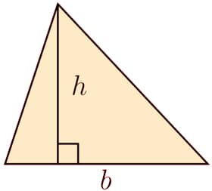

3. Algebra helps you think logically.
Studying algebra helps your mind to think logically and break down and solve problems. One day you might reach a point where you don’t use algebra on a daily basis. However, your brain will have been trained to think in a logical way, which will not only help you in the workplace, but also in daily life, when choosing which mobile phone contract to select, or trying to work out if you have paid the right amount of tax.

4. Modern technology needs algebra.
The fact is that all modern technology relies on mathematics and algebra – Google, the internet, mobile phones, satellites, and digital televisions wouldn’t exist without algebra. You are relying on other people having studied algebra when you use a phone or play a computer game and as technology is everywhere more and more people are needed to work behind the scenes with knowledge of mathematics and algebra. If you like algebra, then you are giving yourself a chance of getting a job in the rapidly expanding technology sector.

5. Algebra is a challenge which is worth facing.
Let’s face it – algebra can be hard and there will be a point for everyone when they find using algebra difficult. However, algebra can also give a great sense of achievement and for those who become good at it in school, it can give a real feeling of satisfaction every time a problem is solved. In fact, algebra can easily become the favourite area of mathematics for some pupils! Even it is a real challenge to you at school, try and talk to someone who struggled to get a grade C but finally managed it, or someone who has gone back to study maths later in life. Overcoming a difficult hurdle in life can feel worthwhile and says a lot about you as a person.

6. Algebra opens up other subjects.
There are a huge number of other subjects which require knowledge of algebra and mathematics. Here are just a few which at university will require algebra: biology, chemistry, physics, engineering, computer science, economics, food science, environmental science, medicine, dentistry, pharmacy, psychology and social sciences. Many of these subjects require a good knowledge of algebra found by studying A-level maths or A-level Further Maths (or equivalent).

7. Algebra helps us understand numbers better.
You might not realise it, but studying algebra helps you get better at solving problems which involve only numbers. If a pupil did not study any algebra, then it is likely that they would be worse at solving numerical problems, as their grasp of how numbers work would not be as good. So you can thank algebra every time you solve a tricky arithmetic problem!

8. Algebra helps you get the best deals.
Algebra can help you understand better how to make some big important financial choices in life. Without algebra it is difficult to understand compound interest and to really get a handle on how mortgages work or how debt repayments function. This could lead to some big mistakes if you choose the wrong mortgage deal, pension or loan. Having a basic grasp of algebra along with good numeracy and an understanding of percentages, could literally save you thousands of pounds. Martin Lewis from moneysavingexpert.com believes the average family can save £5,000 by getting the best deal on all their bills. There is no doubt that algebra and maths is vital to many of these calculations.

9. Algebra can be beautiful.
Believe it or not, but algebra can be really beautiful! Unfortunately, this is not necessarily obvious when you are first learning the basics of the subject. By the time you get a little bit further, perhaps studying GCSE higher paper or A-level maths and further maths, the elegance of algebra should be becoming more obvious.
G.H.Hardy (a famous 20th Century mathematician) wrote:
“Beauty is the first test: there is no permanent place in the world for ugly mathematics.”

10. Algebra is part of our culture.
Education is not just about learning a narrow set of information or skills which you will use every day in the future. Learning is also about being educated about a wide variety of topics, so that you can make sense of the world which you live in. Algebra has played such a big part in our history, (without it there would have been no industrial revolution, no man on the moon etc.) that we should at least know a bit about it, just like we learn about Shakespeare, or the history of the Roman empire.

