Business Studies
Knowledge Book

Student name: ………………………………….
Form: ………………………………………………..
Subject: …………………………………………….
Year group: …………………........................

Component 3: Promotion and Finance for Enterprise
Learning Aim B:
B6 Statement of financial position.
(Balance Sheet).
The Big Question
What actions can be taken to improve a statement of financial position using given figures?
GRADE DESCRIPTORS
To achieve a grade, a learner is expected to demonstrate these attributes across the essential content of the component. The principle of best fit will apply in awarding grades.
Level 1 Pass Learners demonstrate basic knowledge of the elements of promotion and financial records. They can make basic observations about given information and can identify different promotional and financial factors that have positive or negative impacts. They demonstrate a basic ability to interpret information to identify factors that could potentially affect the performance of an enterprise, such as relevant information from cash flow forecasts and statements. Learners are able to make basic recommendations for success.
Level 2 Pass Learners demonstrate knowledge and understanding of the elements of promotion and financial records and apply them in context. They are able to interpret given information to explain factors that could potentially affect the performance of an enterprise, including the impact of specific factors such as information from cash flow forecasts and statements. They can explain how different factors have positive or negative impacts. Learners can produce some realistic recommendations for success.
Level 2 Distinction Learners demonstrate a high level of knowledge and understanding of the elements of promotion and financial records and apply them in context. They demonstrate a high level of ability to interpret given information and can explain, in detail, the factors that could potentially affect the success of an enterprise, and how different promotional and financial factors have positive and negative impacts. Learners can produce clear recommendations for success, with clear, realistic and convincing justifications.

B6 Statement of financial position.
Learners will complete and interpret a statement of financial position using given figures, and suggest appropriate actions.
• Statement of financial position: shows the financial performance of an enterprise at a point in time.
• Categorise total assets and liabilities using a statement of financial position.

Knowledge Phase
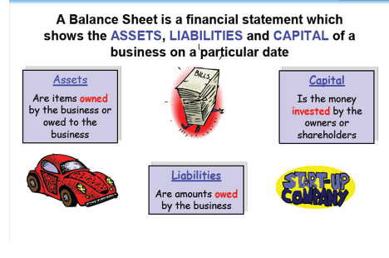
The key principle of a Balance Sheet

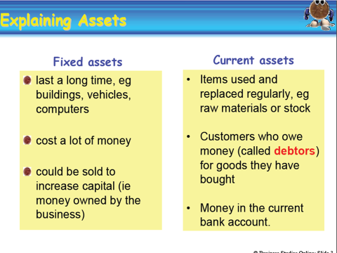
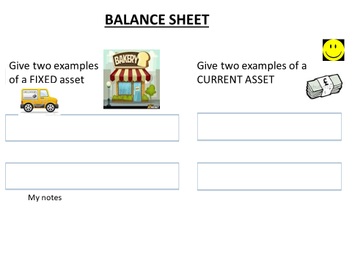

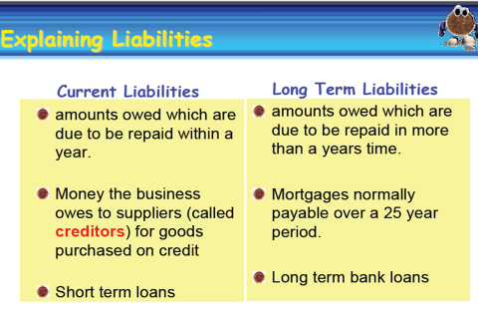

Activity.
1. Please explain the term ‘liability.’
………………………………………………………………………………………………………………………………………………………………………………………………………………………………………………

Which two of these are liabilities?
a. Equipment
b. Bank loan
c. Customers who owe money (debtors)
d. Overdraft.

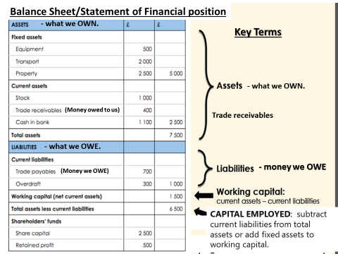

Calculating the Working Capital
Working capital (The cash the business has): Current Assets – Current Liabilites.

Capital Employed: Fixed Assets + Working Capital OR Total Assets – Current Liabilities.

Application Phase

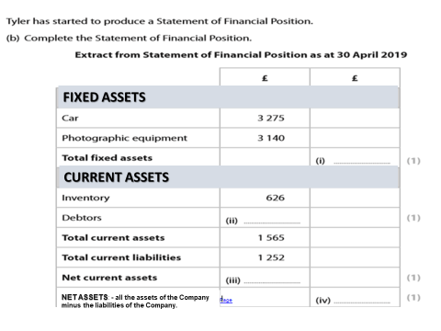
Consolidation Phase
ACTIVITY
Tyler wants to improve the financial management of his enterprise as it grows. He thinks that producing financial statements would help.
He is not sure what some of the terms mean in a statement of financial position.
State the meaning of the term ‘creditor’.
......................................................................................................................................................................................................
......................................................................................................................................................................................................
State the meaning of the term ‘capital’.
......................................................................................................................................................................................................
......................................................................................................................................................................................................
Tyler has started to produce a Statement of Financial Position.
Complete the Statement of Financial Position.
Extract from Statement of Financial Position as at 30 April 2019
Exam practice question
Tyler needs to calculate liquidity ratios to help with financial decisions.
He asks you to calculate these ratios based on the figures in the statement of financial position.
Current ratio = Current assets Current liabilities
Liquid capital ratio = Current assets – Inventory Current liabilities
Calculate the current ratio for Tyler’s enterprise.

Show your working

Calculate the liquid capital ratio for Tyler’s enterprise

Show your working

Tyler wants to improve the liquidity of his enterprise. He has looked at his statement of financial position to see what actions he could take to help him to do this.
Explain one action Tyler could take to improve the liquidity of his enterprise. ......................................................................................................................................................................................................
......................................................................................................................................................................................................
......................................................................................................................................................................................................
......................................................................................................................................................................................................
......................................................................................................................................................................................................
......................................................................................................................................................................................................
(Total for Activity 6 = 10 marks)

The Big Question
What are my questions an enterprise needs to ask when it is completing a
Statement of Financial Position?
- Have I got enough money in my business to pay off the debts?
- Is there enough money to carry on running the business?

- Can I reduce debtor terms?

Next Lesson
I’m greedy for knowledge – I always want more, tell me what happens if creditor (money that the business owes) terms are increased and if debtor (money owed to the business by customers) terms are reduced.

