KS3 ICT/CS

Year 7

Welcome to the ICT/CS department
Knowledge and Assessment Organiser

Student name: ………………………………….
Target grade:………………………………

How can I become an effective IT user?

Key Terms
Contents
Big Question and Small Question breakdown
Essential knowledge & tasks

Key vocabulary

Key word | Meaning of key word
Workstation
Network
Network resources
Network drives
Login
Username
Password
Office 365 and Teams
Server
Storage
Touch typing

Thinking point!
Each workstation in school has a cable behind it called a CAT 6 or Ethernet cable. This is used to connect to a patch panel which then connects to the servers in the IT support room.
You have a similar cable at home. Do you know what device it is connected to?

What’s the story?
I am Jeevan Kang and I am 13 years old so a year older than you. I have recently arrived from India having been educated in a small village with very little access to technology.
Coming to a school here I have been amazed by the vast amount of technology you use at your school!
As I am from a developing country there have been very little infrastructure built for ICT and many people now only use smartphones with 4G data rather than wi-fi connection due to limited power houses for electricity in the area. Therefore, I have had little experience of using ICT confidently and safely. That is why I have come to you for advice and guidance. I am amazed and yet terrified with the technology used by students in Wolverhampton. I am hoping I will receive the guidance on how to use some of the software available at your school and what I can do to use the technology safely and responsibly whilst at school and at home.
I am familiar with some of the basics of hardware that make up a computer system such as mouse, keyboard and monitor as we did have opportunity to use the computers once a month at my school. At that time Microsoft Office 2007 was available and our teacher did demonstrate some basic aspects of Microsoft Office Suite. I know it has changed a lot over the years so hopefully I will learn new tools and skills in Microsoft Office while I am in year 8 that will help me in many areas and subjects in school.

Thanks in advance for all your help and support.

Why does this matter?
- It is vital to be safe and responsible users of IT.
- It is important to know what makes up the school network.
- It important to know and use cloud computing effectively.
- It is good to have grounding on key skills in Microsoft Office.
- E-mail is a common communication method in places of work. It is important to know how to use e-mail effectively.

Curricular Concepts
Have you ever noticed how some of the things you study in one subject appear in another subject too?

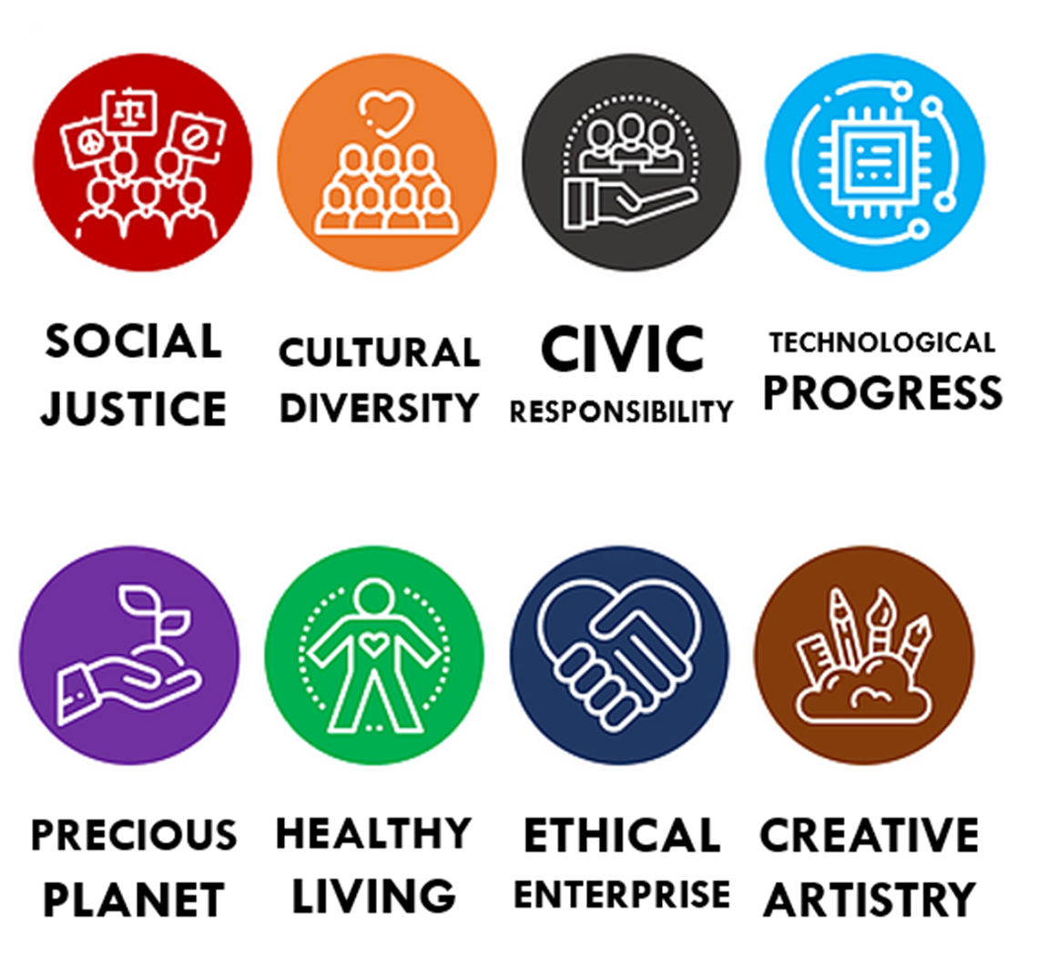
Students are able to understand their work more and remember more if there are clear links between subjects. Throughout your learning at Colton Hills, we will be asking you to think about some of the most important ideas in the world to enable you learning to be deeper than ever before. Look for these ‘curricular concepts’ in your learning.

What is my big question?
How do I send a good email?
What is touch typing and how will it help me?
What is on my workstation?

How do I access my online accounts?

How can I become an effective IT user?
What are the rules to remain safe when using IT?

What are the rules to remain safe when using IT?

Can you spot the 9 errors?
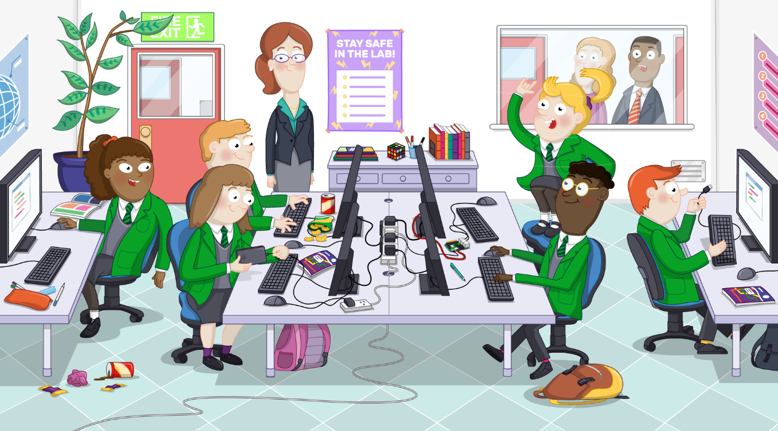

Why should we have rules in a computer classroom?

Are there any other rules you can think of?
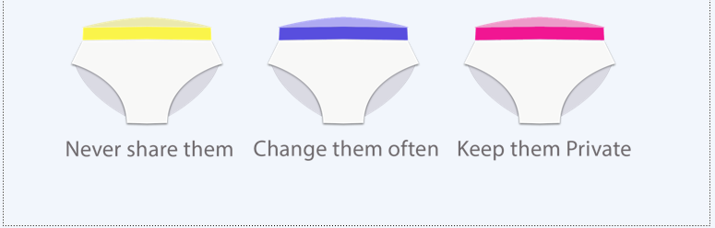
Create a memorable and secure password

Label the different parts of your username
Username:
Password should never be shared with anyone else.
What do you think will make a strong password? Add 3 points of your own.
- Mixture of numbers and letters.

How will you remember your password?
Add your password hint here:

What is on my workstation?

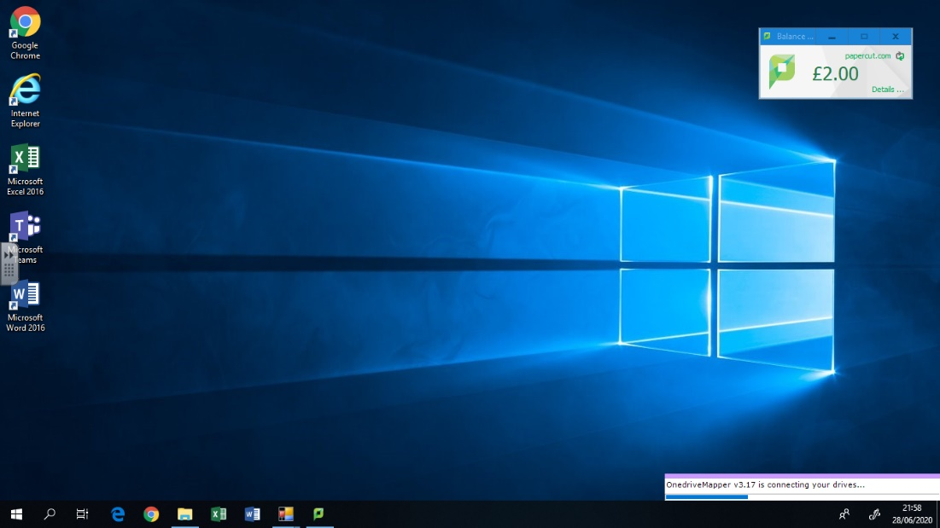

Did you know?
Your work is saved on a server and NOT on the workstation. This is a powerful machine that can hold 2 terabytes of storage. That’s equivalent to 2GB storage for every user in the school!
Every day the files you save are backed up. This means you should not lose your SAVED work!

Your teacher will share resources on the U drive.
You must save all YOUR OWN work in your own area. This is called the M drive.
How do I find the network drives?
Open the folder icon on the taskbar
Click on this.

Label the drives with the correct names.
Keep your work area organised
Saving documents and other files in FOLDERS with clear labelling is a good way to keep your work area organised. It also forms a good habit of organising your work before you begin your GCSE subjects!
Open the M drive
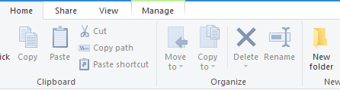
Choose folder on the home ribbon

A new folder will appear. Rename the folder as: YEAR 7
DOUBLE CLICK THE YEAR 7 FOLDER TO OPEN IT
Now create the following folders in the YEAR 7 folder;
- ICT_CS
- English
- Mathematics
- Science
- Technology
- History
- Geography
- RE
- German
- Art
Printers
You are given £1.00 credit to print each month.
This does not affect your lunch money.
- Open Microsoft Word
- Select file
- Choose print
What do you think the following printing options mean?
Student_Secure_B&W
Student_Secure_Colour

How can I become an effective IT user?
Complete the gaps to answer part of the big question:
My u……….. and p………… allows me to access different resources on the school’s n……… The school …….. gives me access to the n….….k d….…s The M dr….. is where I can ……………….. On the U drive the teacher can…….…..
When I log into a computer I can also send work to the p…….r. I am given a set number of credits to use each month.
Can you think of the main difference between a traditional system and ad hoc?
How do I access my online accounts?
- Where will the teacher upload their resources for you to use?

- Which drive should you save your own work on?

- What are the 2 options for printing your work?

What is Office 365 and Teams?

1. Open Chrome
2. Type in the following URL in to the address bar: www.office.com
3. Click the sign in button

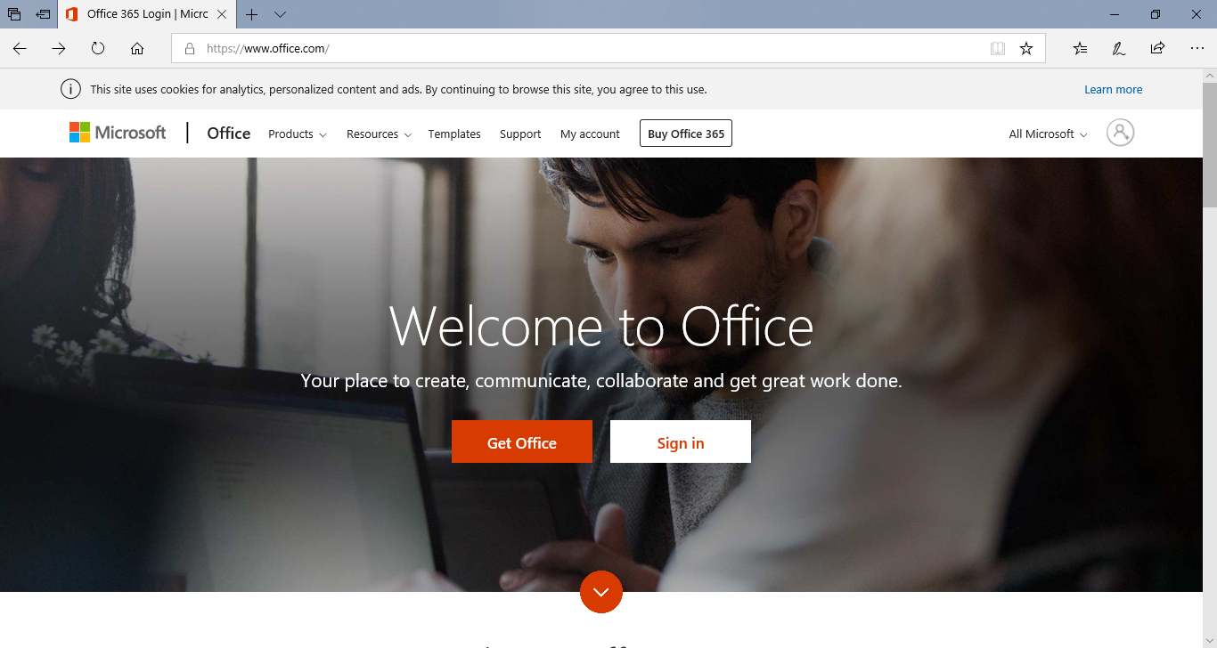
On the next page it will ask for your email address.
Type in your email address and press next.
Make a note of your username below for Office 365.
Office 365 username:

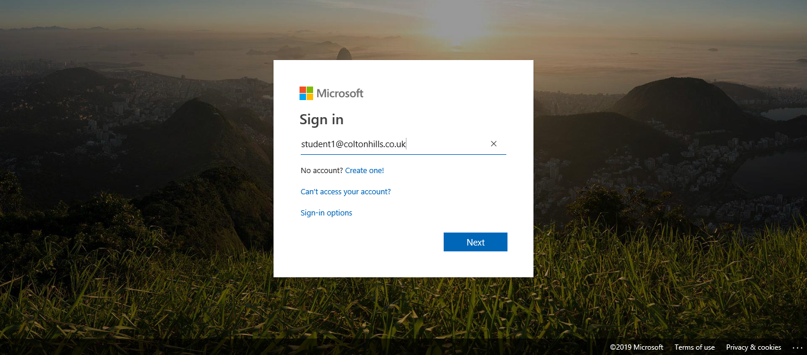
On the next page it will ask for your password.
Type in your password and press Sign in.
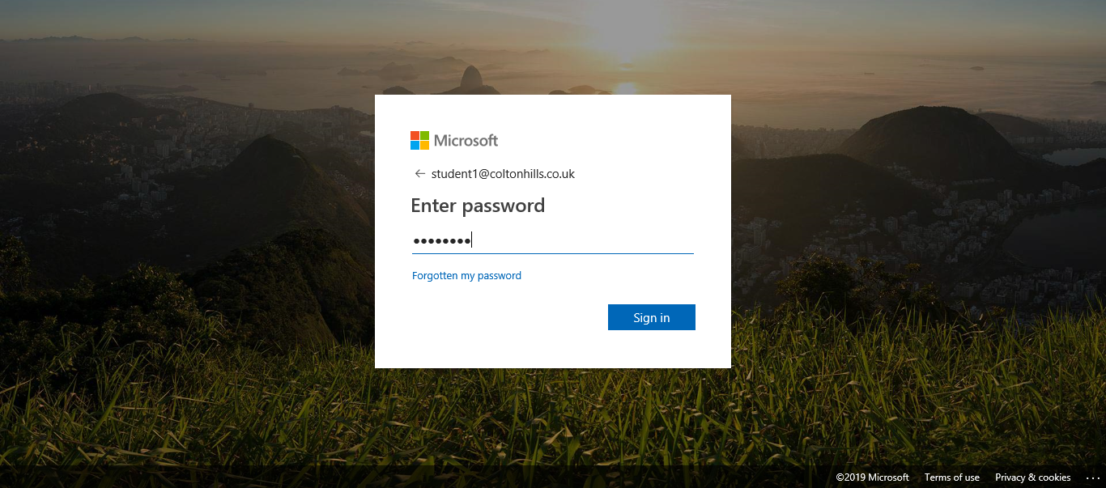
If prompted to reduce the number of times you are asked to sign in, click the Don’t show this again box.
Then click Yes.
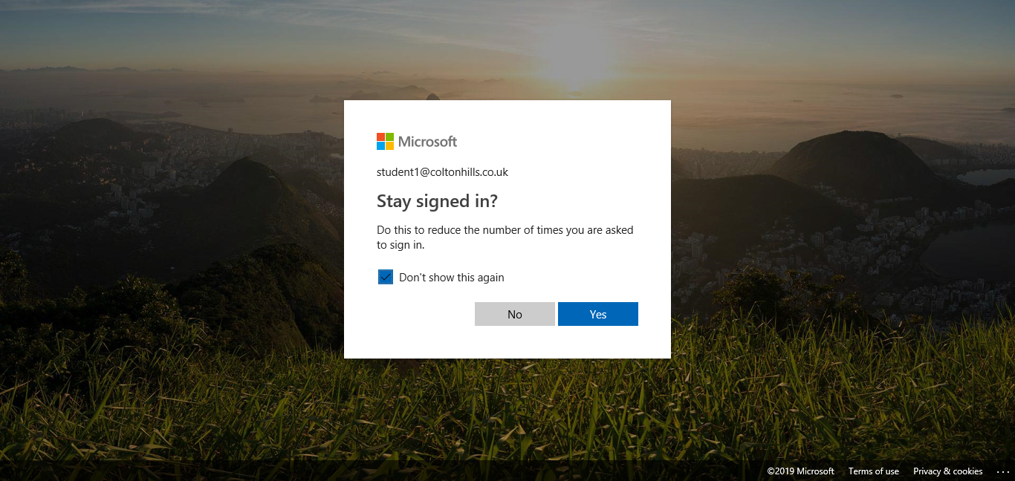

You are now logged in to your Office 365 account where you can access your online apps by clicking on them.
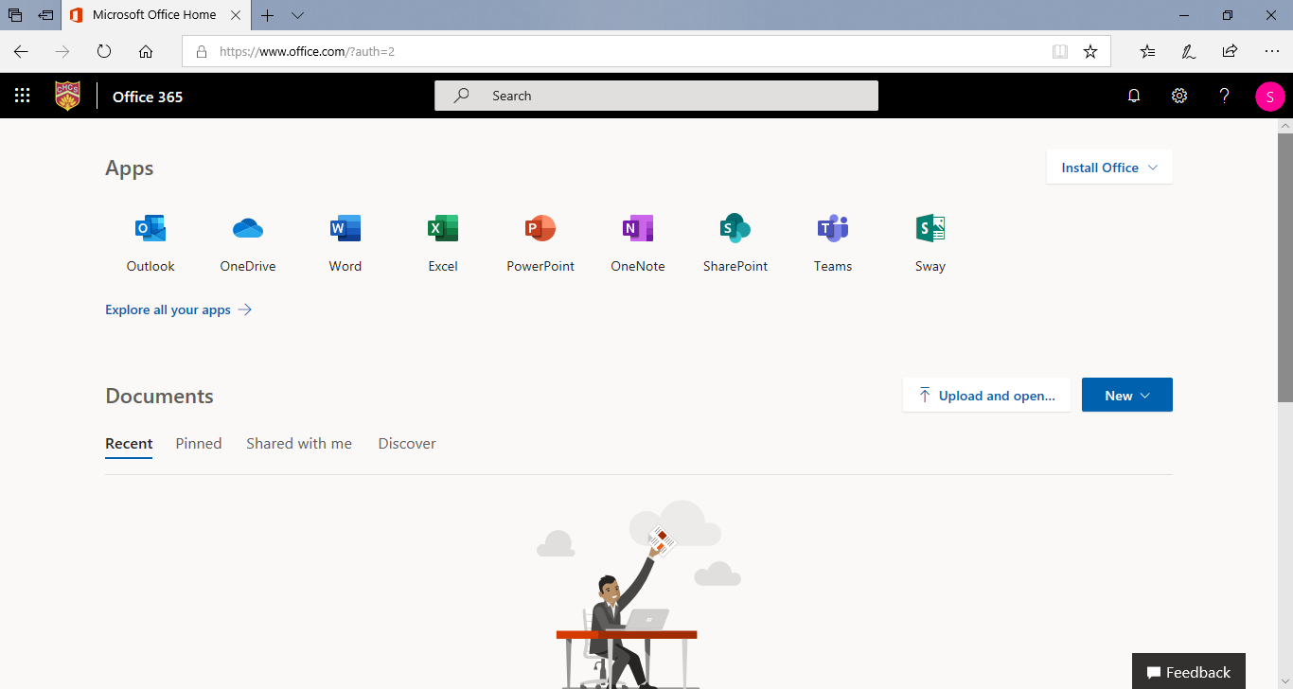

Teams
Choose

- Now you will be given your Team desktop. This is where all your class groups will be.
- Select Teams from left hand side menu, then click on the relevant class you are in.
- You will then be given a desktop for that class and you will see the conversation window. This will be where the teacher will put message for you related to the lesson

Click on Files, this is where you will see any files needed for your lessons or your homework.

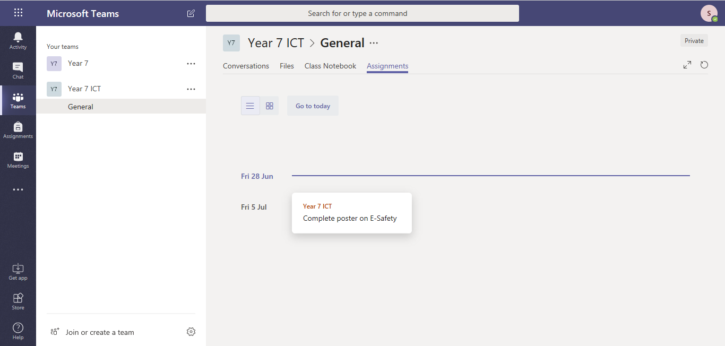
Click on Assignments. This will be where your teacher will put homework. Click on the homework and then you will see the details of what is needed to be done and if any files are required.
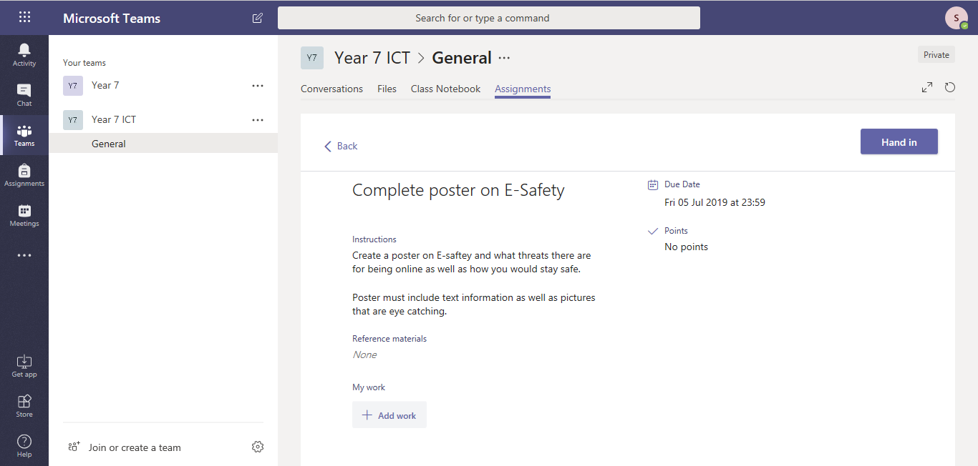
Once homework is completed, your teacher may wish you to have a printed copy or have the electronic version uploaded, which will also be done in this area.
To upload your work, you would click the Add work button then choose the file from its location and then click hand in.

Draw an arrow from the icon image to its correct description.
This app is used to create a spreadsheet. A spreadsheet can be used to organise finances, analyse data. A spreadsheet can be used to complete a number of different calculations.

This app is used to create presentations and has a number of tools and functions. However, like other Office 365 applications it has limited functions compared to the desktop version.

This app is used to send and receive emails. It has many other features that are useful such as calendar where you can also set meetings via Teams.

This app is used to save different files onto the Cloud where you have up to 1Tb of storage space.
This app can also be found on your desktop. It is where you can access the Teams set up for your classes. Your teacher for other subjects may also use this to Post messages or set work via assignments.

This app is used to create letters and other editing of word/image documents. However, like other Office 365 applications it has limited functions compared to the desktop version.

One Drive
OneDrive is the Microsoft cloud service that connects you to all your files. It lets you store and protect your files, share them with others, and get to them from anywhere on all your devices. When you use OneDrive with an account provided by your company or school, it's sometimes called "OneDrive for work or school."
Once you have successfully signed into Office 365 you will be presented with this screen:
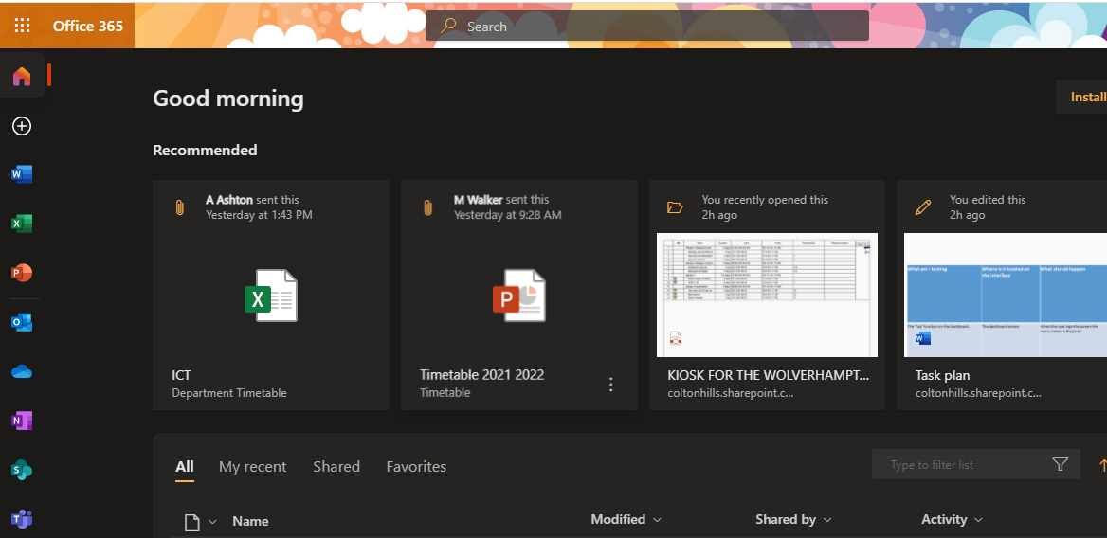

On the left-hand side, you need to click on the symbol that looks like a blue cloud.
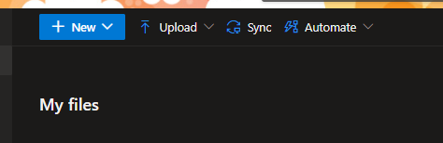
For now, we are just going to concentrate on the top section of OneDrive to create folders and upload files.
Creating folders
Click on the drop down arrow next to the word NEW
Select folder

Now replicate the folders you created for each subject on the school network drive.
Homework
Set up on OneDrive
Open the ICT_CS folder created on OneDrive
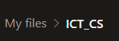
Then click on Word Document
Word will open on a new Tab.
Start by saving the Word file with a suitable name by clicking once on ‘Document – Saved’ on the blue banner. Re-name the file as ‘ICT Safety Poster Homework.
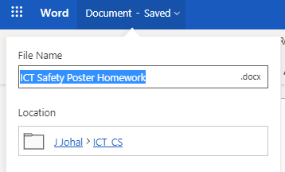
Name of file
Location of file. It should be in the ICT_CS folder
The ICT rules poster should be saved in the ICT_CS folder keeping your work organised!
Take your knowledge book home and use lesson 1 Rules in a computer room to create a poster on Microsoft Word.
Make sure you include:
- A suitable title
- All the rules written in your knowledge book.
- 3 suitable images

When complete use the instructions above to ‘hand in’ the homework on Teams. Remember you can use Office 365 Word to complete the poster!
How do I send a good email?
Did you know?
One drive Cloud storage can hold up to 1 Terabyte. 1Tb is equivalent to 500 hours of HD video!
What is this network drive used for?

Why is it important to create folders?

Where might your teacher set homework, Office 365 or Teams?

What is E-mail?
Email or e-mail is short for __________ mail.
It’s a modern method of: transmitting data, text files, digital photos, and audio and video files from one computer to another over the internet.

What are the advantages of e-mail?
1. It's free!
Once you’re online, there is no further expense.
2. Easy to reference
Sent and received messages and attachments can be stored safely, logically and reliably so you can keep them for later. It's a lot easier to organize emails than paper.
3. Easy to use
Once you’re set up, sending and receiving messages is simple. That goes for a host of other email functions. Data storage and contacts can be accessed quickly and easily.
4. Speed
Message to send? Done, under a second! Email is as fast a form of written communication as any.
5. Global
Web based email means you can access your messages anywhere online. Going overseas? Before you go, mail yourself a copy of your passport number, travel insurance details or your accommodation details.

What are the dis-advantages of e-mail?
1. Emotional responses
Some emails cause upset or anger. A reply in the heat of the moment can’t be easily taken back, but it can cause lasting damage.
2. Information overload
Too many people send too much information.
3. Misunderstandings
Emails from people who don’t take the time to read what they write before clicking ‘send’. Time is wasted, either to clarify or, worse, acting on a misinterpretation of the message.
4. Spam
Having to deal with spam and spoofs is one of the worst avoidable time wasters online. Use some anti-spam software.
5. Viruses
A virus could seriously affect your computer. If you want to know how to use email effectively, it's worth learning how to deal with these.

What makes a good email?

State if this is a GOOD or BAD email and why?

Did you know?
Probably the first email system of this type was MAILBOX, used at Massachusetts Institute of Technology from 1965. Another early program to send messages on the same computer was called SNDMSG.

State if this is a GOOD or BAD email and why?

Time to send an email!
- Login to Office 365, and choose

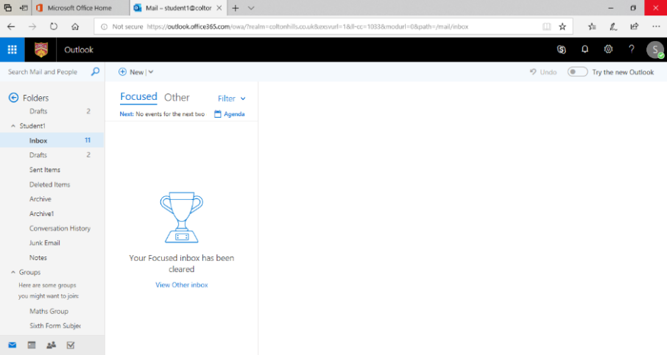
- Now you will be given your Inbox. This is where all your emails will arrive.
- To create a new email message, click on “new”

YOUR TEACHER WILL NOW GO THROUGH THE MAIN PARTS OF AN EMAIL.
Label the screen print of the email below.

Recipient- the main person the email is going to

Use the keywords below to help you label the email. The first one has been done for you.
Recipient – the main person the email is going to
CC
Carbon Copy – send email to another person also for their information
BCC
Blind Carbon Copy – send to another person but hide their email from other people
Attachment
Add a file such as document or picture
Subject
What is the email about
Formatting
Change font style.
Add bullet points

Create a professional looking email to your teacher about the homework task on The Rules poster. In your email discuss the following;
- The task set
- Did you find the homework easy or difficult? Explain your answer
- If you can, attach the homework to the email and send to your teacher.

Your teacher’s email address:

What is touch typing and how will it help me?
Touch typing can help you become a faster typist, improve your career prospects and pave the way for success in further education. But the benefits of touch typing extend beyond mastering the home keys and increasing your speed. When you learn to type with a multi-sensory and modular course, you strengthen reading and spelling skills at the same time as you gain confidence and motivation.
You will complete a series of activities on-line to help you build the confidence of using a keyboard without having to look for keys. Saving you time and help you with many other skills such as literacy, muscle and memory skills.
Start
Open www.typingclub.com
Register on the site using Office 365 e-mail address.
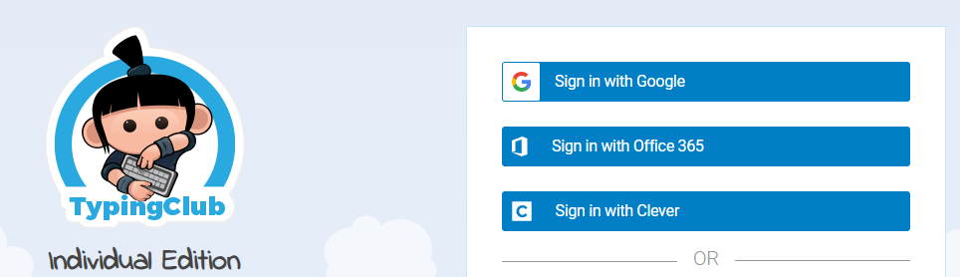
Make sure the language is set to UK.
Write your username and password at the back of your planner.
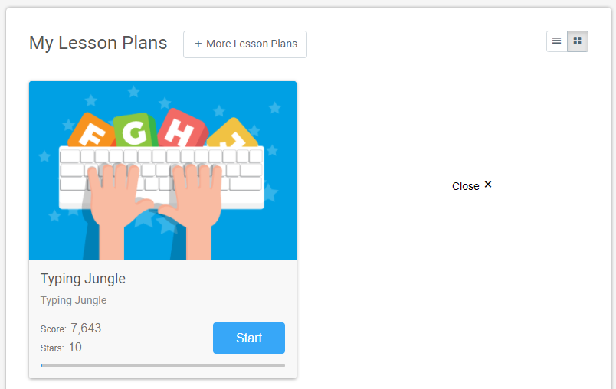
Begin the course
There are a series of lessons you will complete starting with the ‘home keys’ to help you become confident touch typist!
This is what the series of lessons will look once you have signed up!

Once you have signed up you are ready to go!

Did you know?
Evidence shows that learning to touch-type can be a particular benefit for children with dyslexia. ‘Some dyslexic students find typing easier than handwriting, as the tactile element of pressing the keyboard can help with managing difficult words,’ says Linda Eastap, education manager at the British Dyslexia Association
Did you know?
Average speed of most typists is approximately 41 words per minute with around 92% accuracy. The speed of writing with hand is often about 31 wpm for memorized material and 22 wpm if the material is copied.

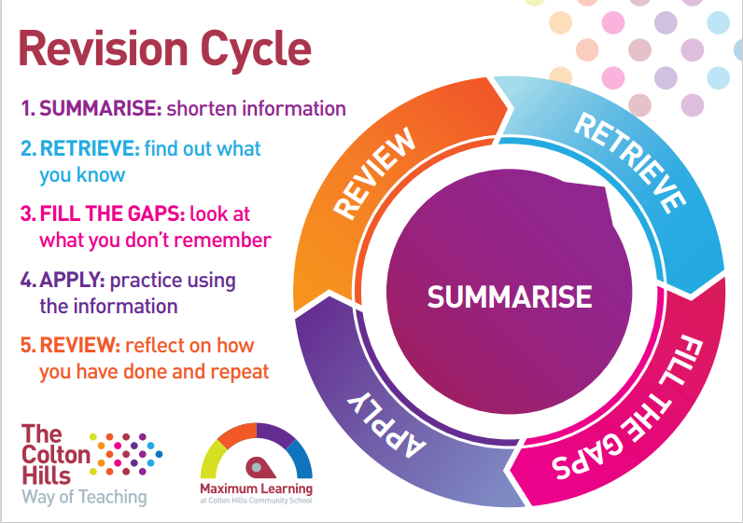

Retrieval for final Autumn 2 assessment
Retrieval practice is a strategy in which bringing information to mind enhances and boosts learning. Deliberately recalling information forces us to pull our knowledge “out” and examine what we know.
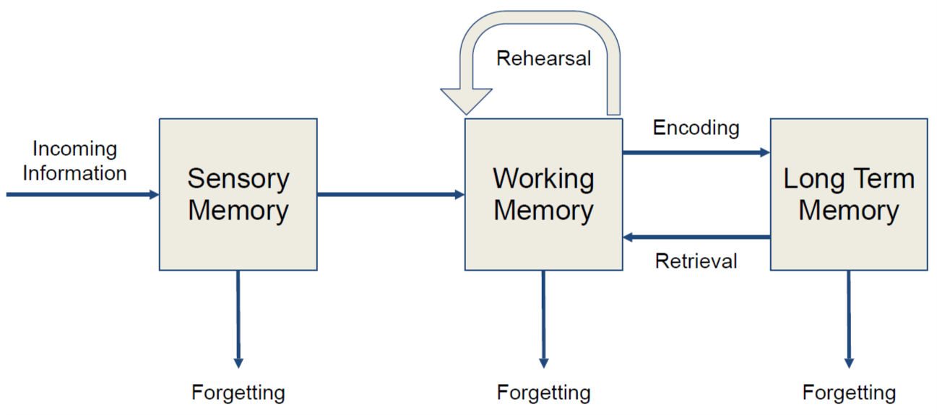

To help you revise for the final assessment it is a good idea to use a technique to help you revise key topics and concepts.
Mind mapping should be a collection of thoughts, ideas or information based around a theme, topic, or concept.
- Keep to single words of phrases.

- Use different colours for different sections to make them clear.

- Add images to give you something to associate.

- Group pieces of relevant information.

- Remember information could fit within more than one category so draw additional lines to link these ideas.
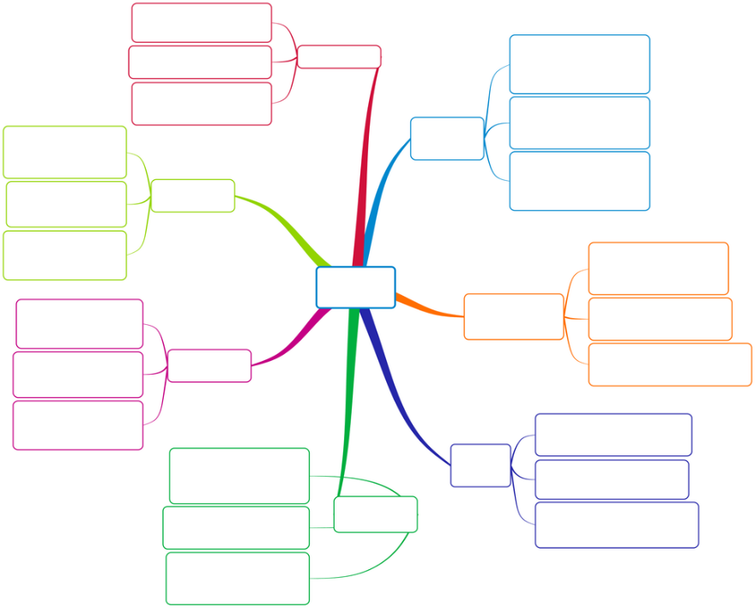

Mind map Autumn 1 learning

E-mail
Cloud
Autumn 1

