Dear Parent/Carer,
At Colton Hills Community School we believe that uniform plays a valuable role in contributing to the ethos, setting an appropriate tone, and instilling PRIDE in our students.
I am writing to inform you that from September 2022 there have been some changes to the ‘essential items’ in the uniform list, please see the table below.
You are welcome to purchase any of these items from either of our two suppliers. Both suppliers offer a payment scheme to make it easier for parents to purchase uniform items, and as well as their stores they offer online services.

Please note the prices are based on child sizes, and that VAT will be applied to adult sizes. We have included the prices for each supplier (RF=Ron Flowers Sportswear, L&L=Lads and Lasses). Images are for illustrative purposes only.
Lads and Lasses
50a Warstones Road
Penn
Wolverhampton
WV4 4LP
Tel: (01902) 334650
Email – ladsandlassessales@live.com
www.ladsandlassesschoolwear.co.uk
Ron Flowers Sportswear
28 Queen Street
Wolverhampton
WV1 3JW
Tel: (01902) 429490
www.ronflowerssports.com/

Item | Image | Essential/Optional | Cost
Grey Blazer with school logo | 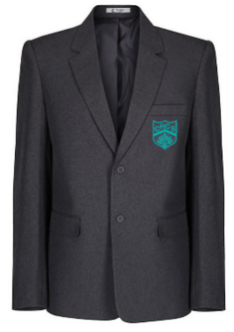  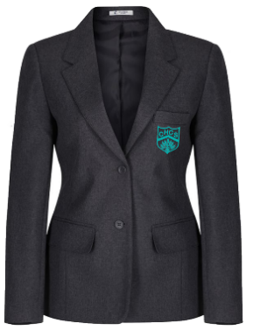 | Essential | L&L - £29.50  RF - £29.50
Grey Tartan Skirt | 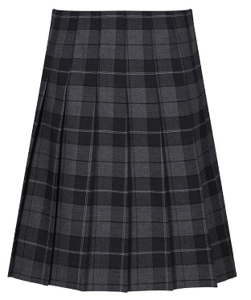 | Essential (or trouser) | L&L - £20.99  RF - £20.99
Grey Trouser with logo | 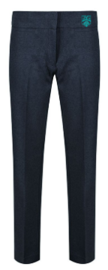  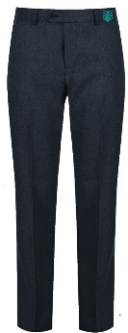 | Essential (or skirt) | L&L - £15.99  RF - £15.99
School tie with logo | 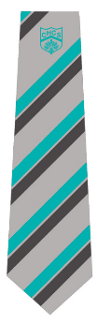 | Essential | L&L - £6.99  RF - £6.99

Grey V neck jumper with logo | 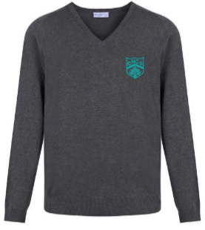 | Optional | L&L - £16.99  RF - £16.99
White shirt | 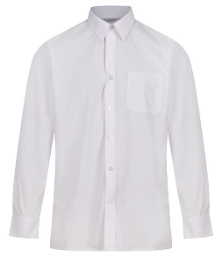 | Essential
Black/grey socks | N/A | Essential
Black/Grey tights | Plain tights, no patterns. | Optional (if wearing skirt, essential)
Black shoes | See below | Essential
Examples of acceptable shoes
The following examples show what types of shoe styles are acceptable and suitable to be worn with school uniform. They should be entirely black and leather or a leather style in appearance. They should not have any logos or writing on them. Trainers, canvas plimsolls/pumps, boots (long or ankle), high heels or sandals are not acceptable. Shoes should not be adorned with metallic trims or decorations.
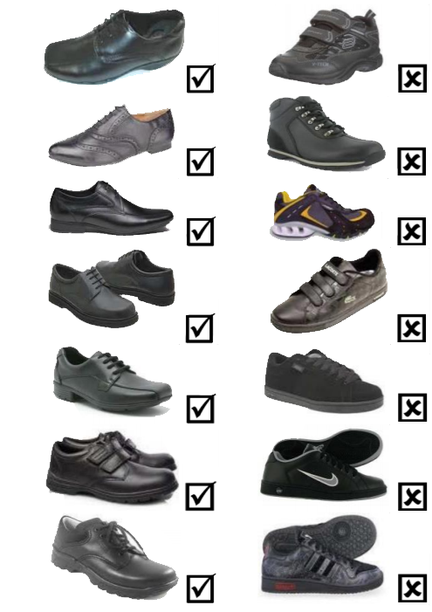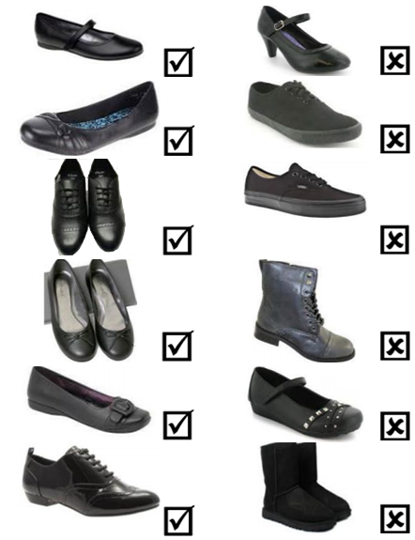
PE Kit
This is the list of all of the items that make up the PE Kit indicating where it is an essential item or an optional item. Please note the prices are based on child sizes, VAT will be applied to adult sizes. We have included the prices for each supplier (RF=Ron Flowers Sportswear, L&L=Lads and Lasses). Images are for illustrative purposes.
Item | Image | Essential/Optional | Cost
Black polo shirt with logo in house colour | 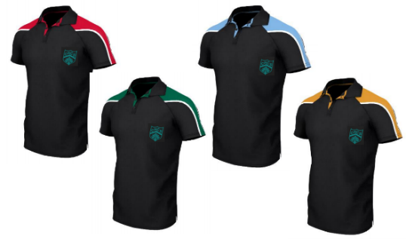 | Essential | L&L - £12.99  RF - £11.99
Black shorts with logo | 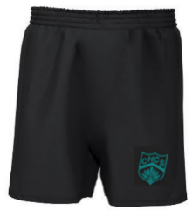 | Optional – but when we enter the summer months this item will be required if your child wishes to wear shorts. | L&L - £9.99  RF - £9.99
Black leggings with logo | 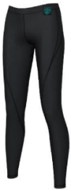 | Essential (or jogging bottoms below). | L&L - £15.99  RF - £15.99
Black jogging bottoms with logo | 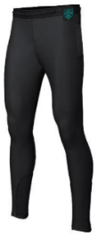 | Essential (or leggings above). | L&L - £18.99  RF - £18.99
Black mid layer top | 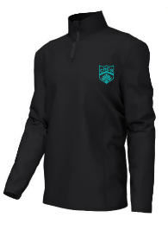 | Essential | L&L - £19.99  RF - £19.99
Black base layer | N/A | Optional
Trainers (not pumps or slip-on shoes) | N/A | Essential
Football boots | N/A | Optional
Black sports socks | N/A | Essential

I hope that this letter provides you with the information that you need but if you have any other questions, please contact the school and we will be happy to support.
I would like to take this opportunity to thank you for your continued support of the school.

Kind Regards

Mrs K Fox
Assistant Headteacher – Pastoral
Colton Hills Community School

